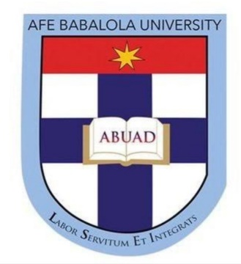

TITLE: Brief report of my activities during the covid-19 period for the past 3 months.

OYENIYI VICTOR OREOLUWA
19/ENG07/024

ENG 384
PETROLEUM ENGINEERING
COLLEGE OF ENIGINEERING
AFE BABALOLA UNIVERSITY ADO-EKITI (ABUAD)
JUNE 2020

Firstly, I will have to say the lockdown has been tiring and with the view of exam not in sight makes it frustrating for me who live based on plans, goals, activities planned ahead.
Staying home during this lockdown, have been composed of me reading my school books, other business books that would help my goal of being a top entrepreneur in the nearest future. Books like think like an entrepreneur, act like a CEO by Beverly jones, how to get from where you are to where you want to be by jack canfield amongst other books read by me.
Also, I read history books mostly on the history of Nigeria. It is important to know where you are coming from so as to know where you are going to.
Other activities being carried out by me includes cooking and also learning how to cook other dishes at home because I cook most time, going out with my dad to inspect our workers, working out daily and following my exercise routine.
Lastly I’ve been taking indoor learning classes on youtube since it’s not advisable to go out except extremely necessary because of this pandemic. Online youtube classes involved in includes learning how to code and learning an extra language which is French.
This is basically the summary of what I’ve been up to this past 3 months excluding sleep, watching television shows amongst other things I involve in to relax.

