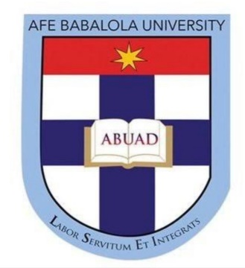

TITLE: SCENARIOS WHERE FORCE MAJURE CLAUSES CAN BE APPLICABLE TO CONTRACT IN MY ENGINEERING DISCIPLINE.

OYENIYI VICTOR OREOLUWA
19/ENG07/024

ENG 384
PETROLEUM ENGINEERING
COLLEGE OF ENIGINEERING
AFE BABALOLA UNIVERSITY ADO-EKITI (ABUAD)
JUNE 2020

Force majeure is a common clause in contracts that frees parties from legal obligation when an extraordinary event or circumstance occurs. Extraordinary events or circumstances could be war, strike, riot, crime, epidemic or an event described by the legal term ‘act of God’. In practice, most force majeure clauses do not excuse a party’s nonperformance entirely, but only suspend it for the duration of the force majeure.
As a petroleum engineer, force majeure will be applicable in cases of war, natural disaster.
In cases of war, exploration and exploitation will mostly come to a halt for the safety of workers and contracts agreed upon to be delivered on certain dates will be pushed beyond as war is a case that frees parties from legal obligations.
Natural disaster which is termed as an act of God in legal terms also frees parties from legal obligations for the time being. Disasters includes earthquakes, tsunami, hurricanes etc.

