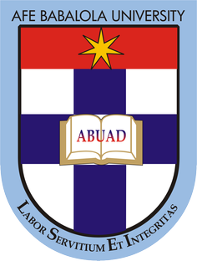

OKON PRECIOUS UTOMOBONG

17/ENG07/016

SUBMITTED TO
ENGR. DR.OYEBODE

AFE BABALOLA UNIVERSITY, ADO-EKITI, EKITI STATE.

IN PARTIAL COMPLETION OF THE CONTINUOUS ASSESSMENT (C.A) FOR THE ENGINEERING LAW AND MANAGERIAL ECONOMICS (ENG 384) COURSE. JUNE 22, 2020

SNAP TEST 1
During this COVID 19 period I took part in the following activities;
- I've been going to the gym to keep fit
- I’ve been attending Online lectures using the jitsi app, zoom, and LMS platform.
- I attempted assignments given by my lecturers on the LMS platform.
- I read my notes.
- I engaged in Social media activities.

