RENAL PHYSIOLOGY II
AMOO OLUWANIFEMI MICHAEL
18/MHS01/379
MEDICINE AND SURGERY (MBBS)
Assignment Questions
Q1. Discuss the pathophysiological process involves in renal failure?
Q2. With the aid of suitable diagrams discuss the types of dialysis you know?

Q1. Discuss the pathophysiological process involves in renal failure?
Most people know that a major function of the kidneys is to remove waste products and excess fluid from the body. These waste products and excess fluid are removed through the urine. The production of urine involves highly complex steps of excretion and re-absorption. This process is necessary to maintain a stable balance of body chemicals. The critical regulation of the body's salt, potassium and acid content is performed by the kidneys. The kidneys also produce hormones that affect the function of other organs. For example, a hormone produced by the kidneys stimulates red blood cell production. Other hormones produced by the kidneys help regulate blood pressure and control calcium metabolism.
The kidneys perform their life-sustaining job of filtering and returning to the bloodstream about 200 quarts of fluid every 24 hours. About two quarts are removed from the body in the form of urine, and about 198 quarts are recovered. The urine we excrete has been stored in the bladder for anywhere from 1 to 8 hours.
Renal Failure is defined as either kidney damage or a decreased glomerular filtration rate (GFR), once the loss of nephrons and reduction of functional renal mass reaches a certain point, the remaining nephrons begin a process of irreversible sclerosis that leads to a progressive decline in the GFRThe different stages of renal failure form a continuum. The stages of renal failure are classified as follows
- Stage 1: Kidney damage with normal or increased GFR (>90 mL/min/1.73 m ²)
- Stage 2: Mild reduction in GFR (60-89 mL/min/1.73 m ²)
- Stage 3a: Moderate reduction in GFR (45-59 mL/min/1.73 m ²)
- Stage 3b: Moderate reduction in GFR (30-44 mL/min/1.73 m ²)
- Stage 4: Severe reduction in GFR (15-29 mL/min/1.73 m ²)
- Stage 5: Kidney failure (GFR < 15 mL/min/1.73 m ² or dialysis)
By itself, measurement of GFR may not be sufficient for identifying stage 1 and stage 2 renal failure, because in those patients the GFR may in fact be normal or borderline normal. In such cases, the presence of one or more of the following markers of kidney damage can establish the diagnosis
- Albuminuria
- Urine sediment abnormalities
- Electrolyte and other abnormalities due to tubular disorders
- Histologic abnormalities
- Structural abnormalities detected by imaging
- History of kidney transplantation in such cases
Hypertension is a frequent sign of renal failure but should not by itself be considered a marker of it, because elevated blood pressure is also common among people without renal failure.
Signs and symptoms
Patients with renal failure are generally asymptomatic. Typically, it is not until stages 4-5 (GFR < 30 mL/min/1.73 m²) that endocrine/metabolic derangements or disturbances in water or electrolyte balance become clinically manifest.
Signs of metabolic acidosis in stage 5 renal failure include the following
- Loss of lean body mass
- Muscle weakness
- Protein energy malnutrition
Signs of alterations in the way the kidneys are handling salt and water in stage 5 include the following:
- Peripheral edema
- Pulmonary edema
- Hypertension
Anemia in renal failure is associated with the following:
- Fatigue
- Reduced exercise capacity
- Impaired cognitive and immune function
- Reduced quality of life
- Development of cardiovascular disease
- New onset of heart failure or the development of more severe heart failure
- Increased cardiovascular mortality
Screen adult patients with renal failure for depressive symptoms; self-report scales at initiation of dialysis therapy reveal that 45% of these patients have such symptoms, albeit with a somatic emphasis.
Management
Early diagnosis and treatment of the underlying cause and/or institution of secondary preventive measures is imperative in patients with renal failure. These may slow, or possibly halt, progression of the disease. The medical care of patients with renal failure should focus on the following:
- Delaying or halting the progression of renal failure: Treatment of the underlying condition, if possible, is indicated
- Diagnosing and treating the pathologic manifestations of renal failure
- Timely planning for long-term renal replacement therapy
The pathologic manifestations should be treated as follows:
- Anemia: When the hemoglobin level is below 10 g/dL, treat with erythropoiesis-stimulating agents (ESAs), which include epoetin alfa and darbepoetin alfa after iron saturation and ferritin levels are at acceptable levels
- Hyperphosphatemia: Treat with dietary phosphate binders and dietary phosphate restriction
- Hypocalcemia: Treat with calcium supplements with or without calcitriol
- Hyperparathyroidism: Treat with calcitriol or vitamin D analogues or calcimimetics
- Volume overload: Treat with loop diuretics or ultrafiltration
- Metabolic acidosis: Treat with oral alkali supplementation
- Uremic manifestations: Treat with long-term renal replacement therapy (hemodialysis, peritoneal dialysis, or renal transplantation)

Q2. With the aid of suitable diagrams discuss the types of dialysis you know?
Dialysis is the process of removing excess water, solutes, and toxins from the blood in people whose kidneys can no longer perform these functions naturally. This is referred to as renal replacement therapy. Dialysis is used as a temporary measure in either acute kidney injury or in those awaiting kidney transplant and as a permanent measure in those for whom a transplant is not indicated or not possible
Types of Dialysis
- Hemodialysis: In hemodialysis, the patient's blood is pumped through the blood compartment of a dialyzer, exposing it to a partially permeable membrane. The dialyzer is composed of thousands of tiny hollow synthetic fibers. The fiber wall acts as the semipermeable membrane. Blood flows through the fibers, dialysis solution flows around the outside of the fibers, and water and wastes move between these two solutions. The cleansed blood is then returned via the circuit back to the body. Ultrafiltration occurs by increasing the hydrostatic pressure across the dialyzer membrane. This usually is done by applying a negative pressure to the dialysate compartment of the dialyzer. This pressure gradient causes water and dissolved solutes to move from blood to dialysate and allows the removal of several liters of excess fluid during a typical 4-hour treatment.
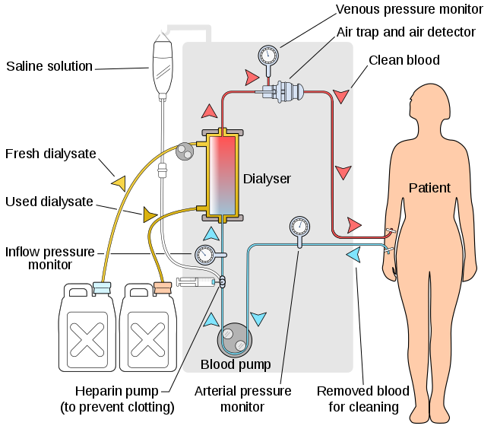

- Peritoneal Dialysis: is a type of dialysis which uses the peritoneum in a person's abdomen as the membrane through which fluid and dissolved substances are exchanged with the blood. It is used to remove excess fluid, correct electrolyte problems, and remove toxins in those with kidney failure. Peritoneal dialysis has better outcomes than hemodialysis during the first couple of years. Other benefits include greater flexibility and better tolerability in those with significant heart disease. Complications may include infections within the abdomen, hernias, high blood sugar, bleeding in the abdomen, and blockage of the catheter. Use is not possible in those with significant prior abdominal surgery or inflammatory bowel disease. It requires degree of technical skill to be done properly.
There are different types of peritoneal dialysis which includes:
- Continuous ambulatory peritoneal dialysis (CAPD): In CAPD, your abdomen is filled and drained multiple times each day. This method doesn’t require a machine and must be performed while awake.
- Continuous cycling peritoneal dialysis (CCPD): CCPD uses a machine to cycle the fluid in and out of your abdomen. It’s usually done at night while you sleep.
- Intermittent peritoneal dialysis (IPD): This treatment is usually performed in the hospital, though it may be performed at home. It uses the same machine as CCPD, but the process takes longer.
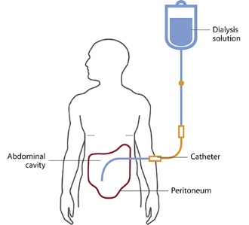

- Hemofiltration: Hemofiltration is a similar treatment to hemodialysis, but it makes use of a different principle. The blood is pumped through a dialyzer or hemofilter as in dialysis, but no dialysate is used. A pressure gradient is applied; as a result, water moves across the very permeable membrane rapidly, "dragging" along with it many dissolved substances, including ones with large molecular weights, which are not cleared as well by hemodialysis. Salts and water lost from the blood during this process are replaced with a "substitution fluid" that is infused into the extracorporeal circuit during the treatment. It is also called Continuous renal replacement therapy (CRRT).
