Name: Adelotan Rafiat Mojisola.
Matric No.: 17/MHS01/018.
Department: MBBS.
Level: 300.
Course Title: Histology of Special Senses and Neurohistology.
Course Code: ANA 305.
Question:
With the aid of a diagram, write an essay on the histology of an organ of Corti.
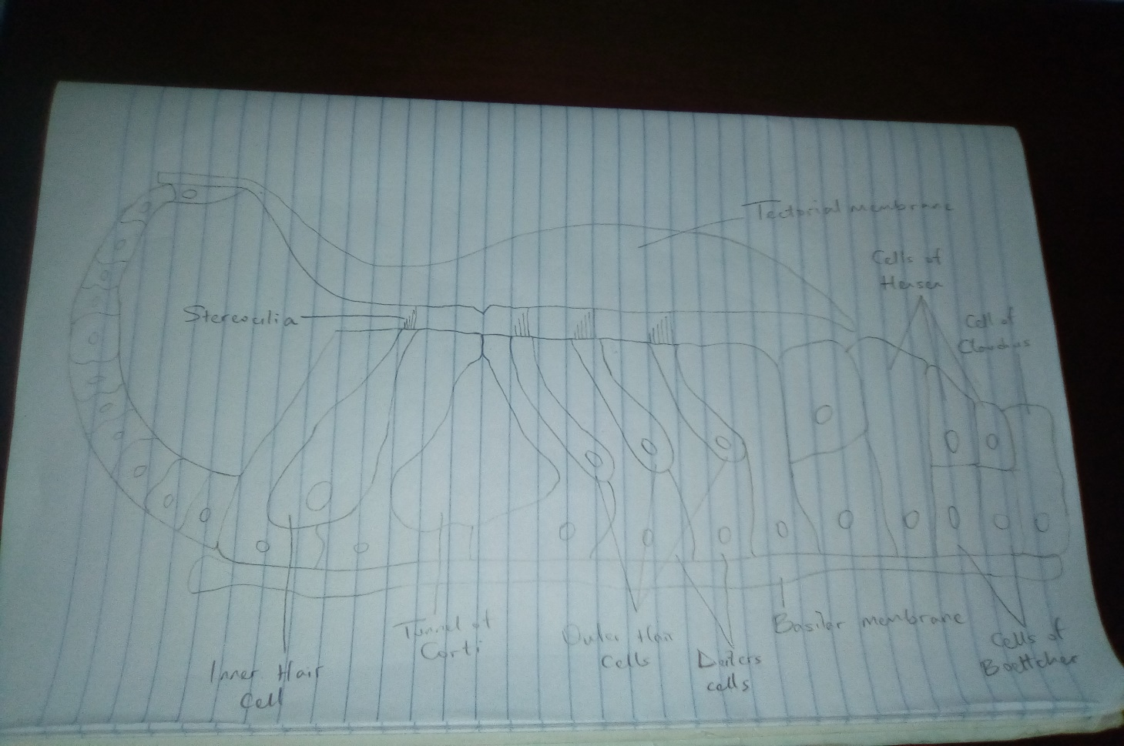

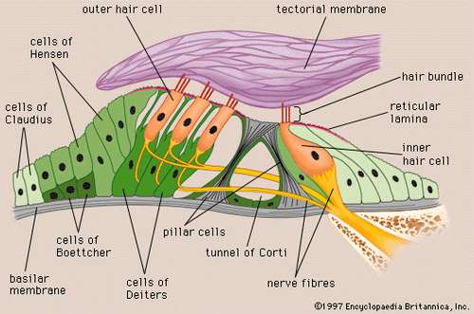

Organ of Corti
The organ of Corti is the receptor organ for hearing and is located in the mammalian cochlea. It is a specialized sensory epithelium that allows for the transduction of sound vibrations into neural signals. It was discovered in 1851 by Italian anatomist Alfonso Giacomo Gaspare Corti.
The organ of Corti is located in the scala media of the cochlea of the inner ear between the vestibular duct and the tympanic duct, and is composed of mechanosensory cells known as Hair Cells. Strategically positioned on the basilar membrane of the organ of Corti are 3 rows of Outer Hair Cells and 1 row of Inner Hair Cells.
- Outer Hair Cells:
The outer hair cells are smaller, cylindrical cells that serve a function as acoustic pre-amplifiers which improve frequency selectivity by allowing the organ of Corti to become attuned to specific frequencies, like those of speech or music. They are about 12,000 in number, disposed in 3 parallel lines.
Each outer hair cell is supported by a phalangeal cell of Deiters, which holds the base of the hair cell in a cup-shaped depression. From each Deiters cell, a projection extends upward to the stiff membrane, the reticular lamina, the covers the organ of Corti. The top of the hair cell is held firmly by the lamina, but the body is suspended in fluid that fills the space of Nuel and the tunnel of Corti.
These outer hair cells are connected to type II amyelinic neurons; these connections are very convergent. They also have an afference from superior olivary nucleus. They have contractile activity.
- Inner Hair Cells:
They are larger pear-shaped cells that are specialized in the mechanoelectrical transduction. There are about 3,500 inner hair cells disposed in one line along all the basilar membrane. These inner hair cells transduce sound from vibrations to neural signals via the shearing action of their stereocilia.
The inner hair cells are supported and enclosed by the inner phalangeal cells which rest on the thin outer portion of the spiral limbus called the tympanic lip. On the inner side of the inner hair cells and the cells that support them is a curved furrow called the inner sulcus which is lined by undifferentiated cuboidal cells.
The inner hair cells are connected to type I neuron peripheral fibers of spiral ganglion; these connections are very divergent.

Projecting from the tops of the hair cells are tiny finger-like projections known as Stereocilia, which are arranged in a graduated fashion. On the top of the inner hair cells, 40-60 stereocilia are arranged in 2 or more irregularly parallel rows. On the outer hair cells, about 100 stereocilia form a W pattern. The stereocilia are about 3-5µm in length. The longest stereocilia make contact with but do not penetrate the tectorial membrane.
Vibrations caused by sound waves bend the stereocilia on the hair cells via an electromechanical force. The hair cells convert mechanical energy into electrical energy that is transmitted to the central nervous system via the auditory nerve to facilitate audition.
The tectorial membrane is an acellular gelatinous structure that covers the top of the spiral limbus as a thin fibrillar layer, then becomes thicker as it extends outward over the inner sulcus and the reticular lamina.
Beyond the hair cells and the Deiters cells are 3 other types of epithelial cells which also act as supporting cells for the hair cells. They are the cells of Hensen, Claudius and Boettcher, each named after the 19th century anatomists who first described them.

