Name: Balogun Demilade
Matric No.: 17/MHS01/080
Dept.: MBBS
Level: 300
The organ of Corti is the receptor organ for hearing and is located in the mammalian cochlea. It is a specialized sensory epithelium that allows for the transduction of sound vibrations into neural signals. It was discovered by Italian anatomist Alfonso Corti.
The organ of Corti is located in the scala media of the cochlea of the inner ear between the vestibular duct and the tympanic duct, and is composed of mechanosensory cells known as hair cells.
Outer Hair Cells: The outer hair cells are small, cylindrical cells that function as acoustic pre-amplifiers. They are about 12,000 in number, disposed in 3 parallel lines. Each outer hair cell is supported by a phalangeal cell of Deiters, which holds the base of the hair cell in a cup-shaped depression. The outer hair cells are connected to type II amyelinic neurons; these connections are very convergent.
Inner Hair Cells: They are larger pear-shaped cells that are specialized in the mechanoelectrical transduction. There are about 3,500 inner hair cells disposed in one line along all the basilar membrane. They transduce sound from vibrations to neural signals via the shearing action of their stereocilia. The inner hair cells are connected to type I neuron peripheral fibers of spiral ganglion; these connections are very divergent.
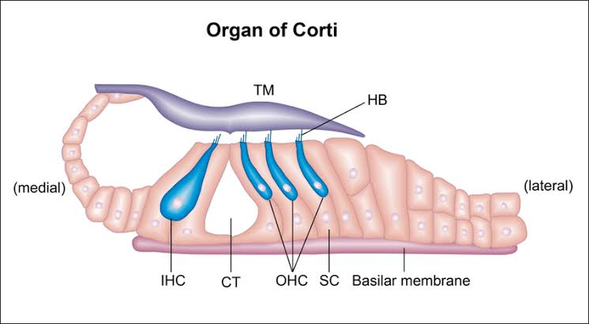

Projecting from the tops of the hair cells are tiny finger-like projections known as Stereocilia, which are arranged in a graduated fashion. On the top of the inner hair cells, 40-60 stereocilia are arranged in 2 or more irregularly parallel rows. On the outer hair cells, about 100 stereocilia form a W pattern. The stereocilia are about 3-5µm in length. The longest stereocilia make contact with but do not penetrate the tectorial membrane.
Vibrations caused by sound waves bend the stereocilia on the hair cells via an electromechanical force. The hair cells convert mechanical energy into electrical energy that is transmitted to the central nervous system via the auditory nerve to facilitate audition.
The tectorial membrane is an acellular gelatinous structure that covers the top of the spiral limbus as a thin fibrillar layer, then becomes thicker as it extends outward over the inner sulcus and the reticular lamina.
Beyond the hair cells and the Deiters cells are 3 other types of epithelial cells which also act as supporting cells for the hair cells. They are the cells of Hensens, Claudius and Boettcher.

