NAME: AKINPELU ABOLAJI OLUWASEGUNFUNMI
MATRIC NO: 17/MHS01/044
COURSE TITLE: HISTOLOGY OF SPECIAL SENSES AND NEUROHISTOLOGY
COURSE CODE: ANA 305
ASSIGNMENT

QUESTION
With the aid of a diagram, write an essay on the histology of an organ of Corti.

DEFINITION
The Organ of Corti is a part of the cochlea and it mediates the sense of hearing transducing pressure waves to action potentials. This structure is localized in the scala media and it is formed by a series of hair cells, nervous terminations of spiral ganglion and supporting cells.
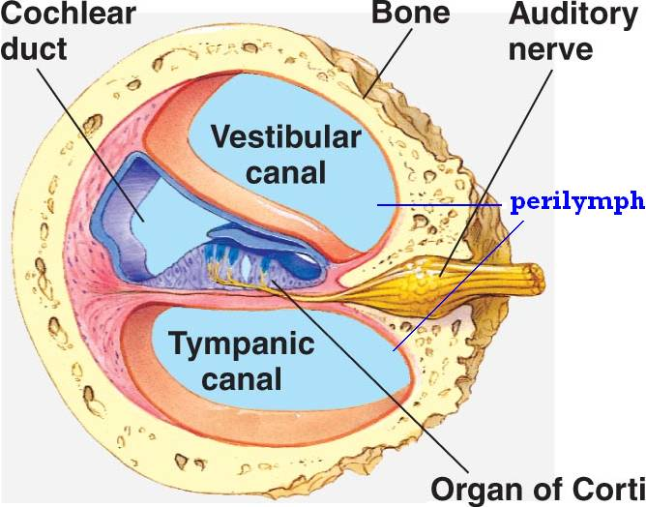

The scala media, or cochlear duct, is located between scala tympani and scala vestibuli and it is filled with endolymph. This structure is delimited by the basilar membrane and Reissner’s membrane. The Organ of Corti covers the basilar membrane and it is under the tectorial membrane, an acellular gel into which hair cell stereocilia are immersed. The peripheral process of acoustic nerve fibers provides synaptic connections between hair cells and cochlear nucleus.
The upper portion of the cochlear duct is formed by the stria vascularis, which contains numerous capillary loops and small blood vessels and produces endolymph.
Organ of Corti consists of different types of cells:
*Inner hair cells
*Outer hair cells
*Supporting cells

Inner Hair Cell
These cells are specialized in the mechanoelectrical transduction. There are almost 3500 cells disposed in one line along all the basilar membrane. They are connected to type I neuron peripheral fibers of spiral ganglion, these connection are very divergent (10/1). The luminal part of the cell is immerged in endolymph, the basal one is immerged in normal extracellular fluid. The luminal portion is formed by bundles of stereocilia (inner-ear), whose tips are connected by filamentous structures called tip-links.
Outer Hair Cell
These cells are acoustical pre-amplifiers. They are almost 12000, disposed in three parallel lines. These cells are connected to type II amyelinic neurons, the connections are very convergent. They have also an afference from superior olivary nucleus. They have contractile activity.
Supporting Cells
These cells are of four different types: Corti pillars, Hensen cells, Deiters cells and Claudius cells.

