AGBEDE OLUWANIFEMI JANET.
17/mhs01/032
300l MBBS
HISTOLOGY OF SPECIAL SENSES AND NEUROHISTOLOGY .

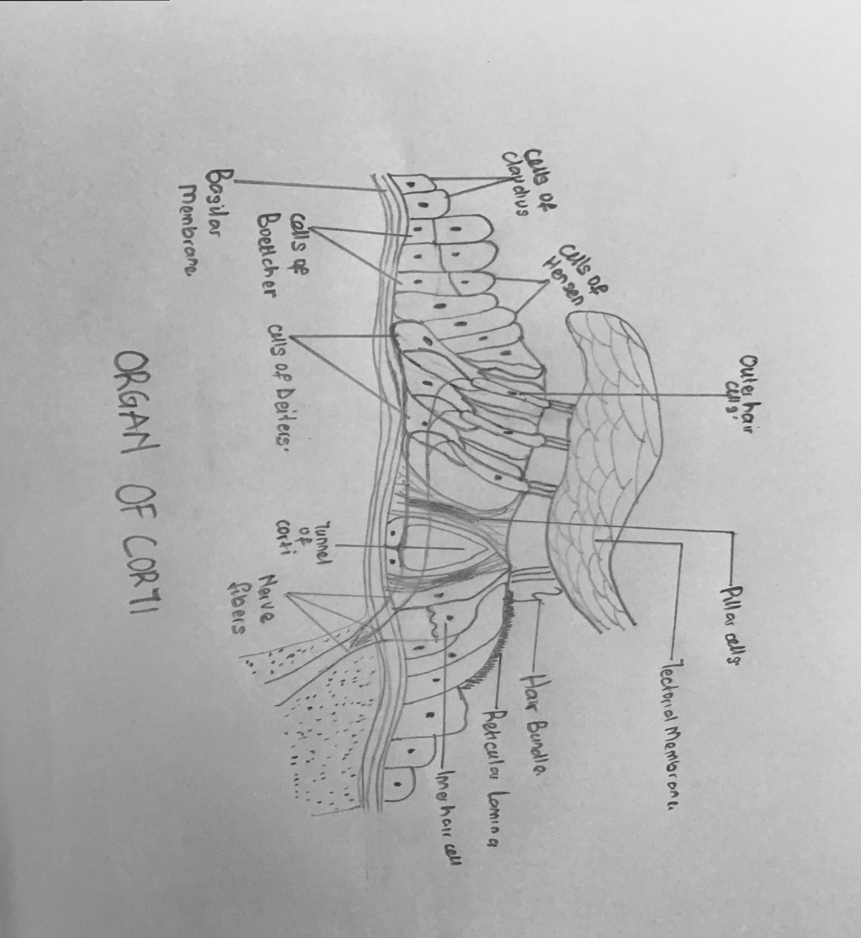
QUESTION: WITH THE AID OF A DIAGRAM WRITE AND ESSAY ON THE HISTOLOGY OF THE ORGAN OF CORTI.

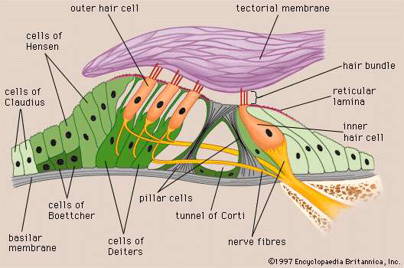

The organ of Corti is a specialized sensory epithelium that allows for the transduction of sound vibrations into neural signals. The organ of Corti itself is located on the basilar membrane, it rests on the basilar membrane and consists of supporting cells and specialized type of nerve cells called hair cells which are of two types.:
- A single row of inner hair cells numbering about 3500 and measuring about 12 micrometers in diameter.
- Three to four rows of outer hair cells numbering about 12000 and measuring about 8 micrometers.
Protruding from each hair cells are stereocilia. The tectorial membrane lies above the stereocilia. Shearing motion between the the basilar membrane and tectorial me,brave causes the stereocilia to be displaced.

Organ of Corti: supporting cells.

- Inner and outer pillar cells (IP and OP).
- They are tall cells with wide bases and apical ends.
- They are shaped like an elongated “I”.
- They are attached to the basilar membrane and each one arises from a broad base.
- They support the hair cells of the organ of Corti.
- The medial wall of the inner tunnel of Corti is formed by inner pillar cells.
- The lateral wall of the of the inner tunnel of Corti is formed by outer pillar cells.

- Outer phalangeal cells.
- They are tall columnar cells attached to the basilar membrane.
- They have a cup shaped apex.
- They support the basilar portions of the outer hair cells along with the bundles off efferent and afferent never fibers which pass between them on their way to the hair cells.
- They are found below the hair cells.

- Inner phalangeal cells.
- They are located deep to the inner pillar cells.
- They completely surround they inner hair cells they support.

- Border cells.
- These cells delineate the inner border of the organ of Corti.
- They are slender cells that support the inner aspects of the organ of Corti.

- Cells of hensen.
- The cells of hensen define the outer border of the organ of Corti.
- They are tall cells.
- They lie between the outer phalangeal cells and shorter cells of Claudius which rests on the underlying cells of boettcher.
The space of Nuel is a fluid-filled gap around the unsupported regions of the outer hair cells that connects with the inner tunnel.

Organ of Corti: hair cells.
- Inner hair cells.
- They are single rows of cells supported by inner phalangeal cells.
- They extend the inner limit of the entire length of organ of corti.
- The inner hair cells are short.
- Their nucleus is centrally placed.
- These cells have stereocilia(V-shaped) but lack kinocilium.
- Nasal aspect of these cells synapse with afferent cochlear nerve.

- Outer hair cells.
- Outer hair cells are supported by outer phalangeal cells.
- They are located near the outer limit of the organ of Corti.
- They are elongated cylindrical cells.
- Their nuclei are located near their bases.
- They have stereocilia (W-shaped)
- They synapse with afferent and efferent nerve fibers on its base
- They are arranged in rows of three or four along the entire length of this organ.

