Name: James Vivian chidera

Matric no: 18/mhs02/096

Course code: PHS212

Department: Nursing science

1. Discuss the somatosensory pathway.

A somatosensory system is a part of the [sensory nervous system](/wiki/Sensory_nervous_system" \o "Sensory nervous system).

The somatosensory system is distributed throughout all major parts of our body. It is responsible for sensing touch, temperature, posture, limb position, and more. It includes both sensory receptor neurons in the periphery (eg., skin, muscle, and organs) and deeper neurons within the central nervous system.

A somatosensory pathway consist of three neurons: 1. Primary, 2. secondary, 3. tertiary.

1. The primary neuron is a type of [pseudounipolar neuron](/wiki/Pseudounipolar_neuron" \o "Pseudounipolar neuron) and always has its [cell body](/wiki/Cell_body" \o "Cell body) in the [dorsal root ganglion](/wiki/Dorsal_root_ganglion" \o "Dorsal root ganglion) of the [spinal nerve](/wiki/Spinal_nerve" \o "Spinal nerve) with a peripheral [axon](/wiki/Axon" \o "Axon)innervating touch [mechanoreceptors](/wiki/Mechanoreceptor" \o "Mechanoreceptor) and a central axon synapsing on the second-order neuron. If the somatosensory pathway is in parts of the head or neck not covered by the cervical nerves, the first-order neuron will be the [trigeminal nerve ganglia](/wiki/Trigeminal_ganglion" \o "Trigeminal ganglion) or the ganglia of other sensory [cranial nerves](/wiki/Cranial_nerves" \o "Cranial nerves)).
2. The secondary neuron has its [cell body](/wiki/Cell_body" \o "Cell body) either in the spinal cord or in the brainstem. This neuron's ascending [axons](/wiki/Axons" \o "Axons)will cross ([decussate](/wiki/Decussate" \o "Decussate)) to the opposite side either in the [spinal cord](/wiki/Spinal_cord" \o "Spinal cord) or in the [brainstem](/wiki/Brainstem" \o "Brainstem).

3. In the case of touch and certain types of pain, the tertiary neuron has its [cell body](/wiki/Cell_body" \o "Cell body) in the [ventral posterior nucleus](/wiki/Ventral_posterior_nucleus" \o "Ventral posterior nucleus) of the thalamus and ends in the [postcentral gyrus](/wiki/Postcentral_gyrus" \o "Postcentral gyrus) of the [parietal lobe](/wiki/Parietal_lobe" \o "Parietal lobe) in the [primary somatosensory cortex](/wiki/Primary_somatosensory_cortex" \o "Primary somatosensory cortex).

Photoreceptors, similar to those found in the [retina](/wiki/Retina" \o "Retina) of the [eye](/wiki/Eye" \o "Eye), detect potentially damaging [ultraviolet radiation](/wiki/Ultraviolet_radiation" \o "Ultraviolet radiation) ([ultraviolet A](/wiki/Ultraviolet_A" \o "Ultraviolet A) specifically), inducing increased production of [melanin](/wiki/Melanin" \o "Melanin) by [melanocytes](/wiki/Melanocytes" \o "Melanocytes). Thus tanning potentially offers the skin rapid protection from DNA damage and sunburn caused by [ultraviolet radiation](/wiki/Ultraviolet_radiation" \o "Ultraviolet radiation) . However, whether this offers protection is debatable, because the amount of melanin released by this process is modest in comparison to the amounts released in response to DNA damage caused by [ultraviolet B](/wiki/Ultraviolet_B" \o "Ultraviolet B) radiation.

The primary somatosensory area of the human cortex is located in the postcentral gyrus of the parietal lobe. The postcentral gyrus is the location of the primary somatosensory area, the area of the cortex dedicated to the processing of touch information. At this location there is a map of sensory space referred to as a sensory homunculus.

A cortical homunculus is the brain’s physical representation of the human body; it is a neurological map of the anatomical divisions of the body. The surface area of cortex dedicated to a body part correlates with the amount of somatosensory input from that area.

For example, there is a large area of cortex devoted to sensation in the hands, while the back requires a much smaller area. Somatosensory information involved with proprioception and posture is processed in the cerebellum.

### **Functions**

The somatosensory system functions in the body’s periphery, spinal cord, and the brain.

* Periphery: Sensory receptors (i.e., thermoreceptors, mechanoreceptors, etc.) detect the various stimuli.
* Spinal cord: Afferent pathways in the spinal cord serve to pass information from the periphery and the rest of the body to the brain.
* Brain: The postcentral gyrus contains Brodmann areas (BA) 3a, 3b, 1, and 2 that make up the somatosensory cortex. BA3a is involved with the sense of relative position of neighboring body parts and the amount of effort being used during movement. BA3b is responsible for distributing somatosensory information to BA1 and shape and size information to BA2.

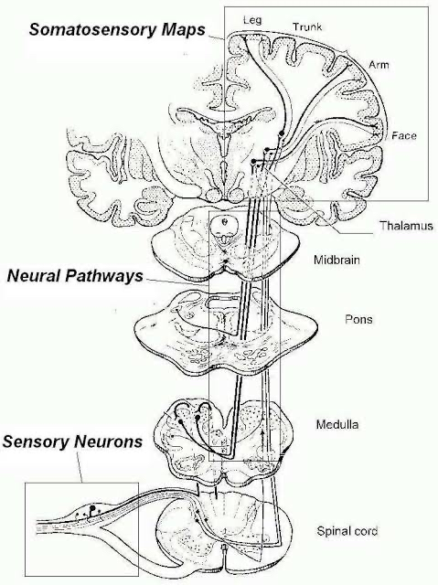

Note

A somatosensory pathway will typically have three neurons: primary, secondary, and tertiary.

The cell bodies of the three neurons in a typical somatosensory pathway are located in the dorsal root ganglion, the spinal cord, and the thalamus.

A major target of somatosensory pathways is the postcentral gyrus in the parietal lobe of the cerebral cortex.

A major somatosensory pathway is the dorsal column–medial lemniscal pathway.

The postcentral gyrus is the location of the primary somatosensory area that takes the form of a map called the sensory homunculus.

Key Terms

parietal lobe: A part of the brain positioned superior to the occipital lobe and posterior to the frontal lobe that integrates sensory information from different modalities and is particularly important for determining spatial sense and navigation.

reticular activating system: A set of connected nuclei in the brain responsible for regulating wakefulness and sleep-to-wake transitions.

postcentral gyrus: A prominent structure in the parietal lobe of the human brain that is the location of the primary somatosensory cortex, the main sensory receptive area for the sense of touch.

thalamus: Either of two large, ovoid structures of gray matter within the forebrain that relay sensory impulses to the cerebral cortex.

A somatosensory pathway will typically have three long neurons: primary, secondary, and tertiary. The first always has its cell body in the dorsal root ganglion of the spinal nerve.

**Dorsal root ganglion: Sensory nerves of a dorsal root ganglion are depicted entering the spinal cord**

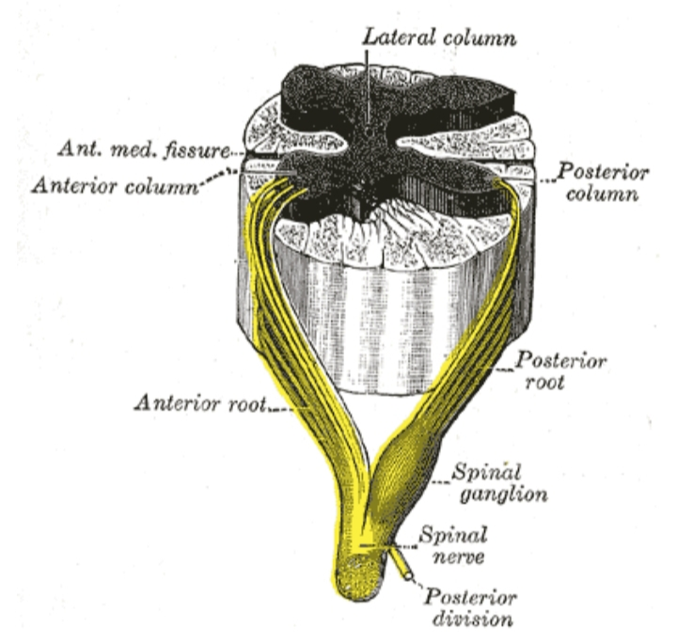

The second has its cell body either in the spinal cord or in the brainstem; this neuron’s ascending axons will cross to the opposite side either in the spinal cord or in the brainstem. The axons of many of these neurons terminate in the thalamus, and others terminate in the reticular activating system or the cerebellum.

In the case of touch and certain types of pain, the third neuron has its cell body in the ventral posterior nucleus of the thalamus and ends in the postcentral gyrus of the parietal lobe.

In the periphery, the somatosensory system detects various stimuli by sensory receptors, such as by mechanoreceptors for tactile sensation and nociceptors for pain sensation. The sensory information (touch, pain, temperature, etc.,) is then conveyed to the central nervous system by afferent neurons, of which there are a number of different types with varying size, structure, and properties.

Generally, there is a correlation between the type of sensory modality detected and the type of afferent neuron involved. For example, slow, thin, unmyelinated neurons conduct pain whereas faster, thicker, myelinated neurons conduct casual touch.