NAME: AKINBODE OLAJUMOKE ADESOLA
DEPARTMENT: NURSING SCIENCE
MATRIC NUMBER: 18/SCI05/002
COURSE CODE: PHS 212
COURSE TILTLE: PHYSIOLOGY

General Organization of the Somatosensory System
The somatosensory system is composed of the neurons that make sensing touch, temperature, and position in space possible.
The somatosensory system is distributed throughout all major parts of our body. It is responsible for sensing touch, temperature, posture, limb position, and more. It includes both sensory receptor neurons in the periphery (eg., skin, muscle, and organs) and deeper neurons within the central nervous system.
Structure
A somatosensory pathway will typically consist of three neurons: primary, secondary, and tertiary.
- In the periphery, the primary neuron is the sensory receptor that detects sensory stimuli like touch or temperature. The cell body of the primary neuron is housed in the dorsal root ganglion of a spinal nerve or, if sensation is in the head or neck, the ganglia of the trigeminal or cranial nerves.
- The secondary neuron acts as a relay and is located in either the spinal cord or the brainstem. This neuron’s ascending axons will cross, or decussate, to the opposite side of the spinal cord or brainstem and travel up the spinal cord to the brain, where most will terminate in either the thalamus or the cerebellum.
- Tertiary neurons have cell bodies in the thalamus and project to the postcentral gyrus of the parietal lobe, forming a sensory homunculus in the case of touch. Regarding posture, the tertiary neuron is located in the cerebellum.
Processing
The primary somatosensory area of the human cortex is located in the postcentral gyrus of the parietal lobe. The postcentral gyrus is the location of the primary somatosensory area, the area of the cortex dedicated to the processing of touch information. At this location there is a map of sensory space referred to as a sensory homunculus.
A cortical homunculus is the brain’s physical representation of the human body; it is a neurological map of the anatomical divisions of the body. The surface area of cortex dedicated to a body part correlates with the amount of somatosensory input from that area.
For example, there is a large area of cortex devoted to sensation in the hands, while the back requires a much smaller area. Somatosensory information involved with proprioception and posture is processed in the cerebellum.

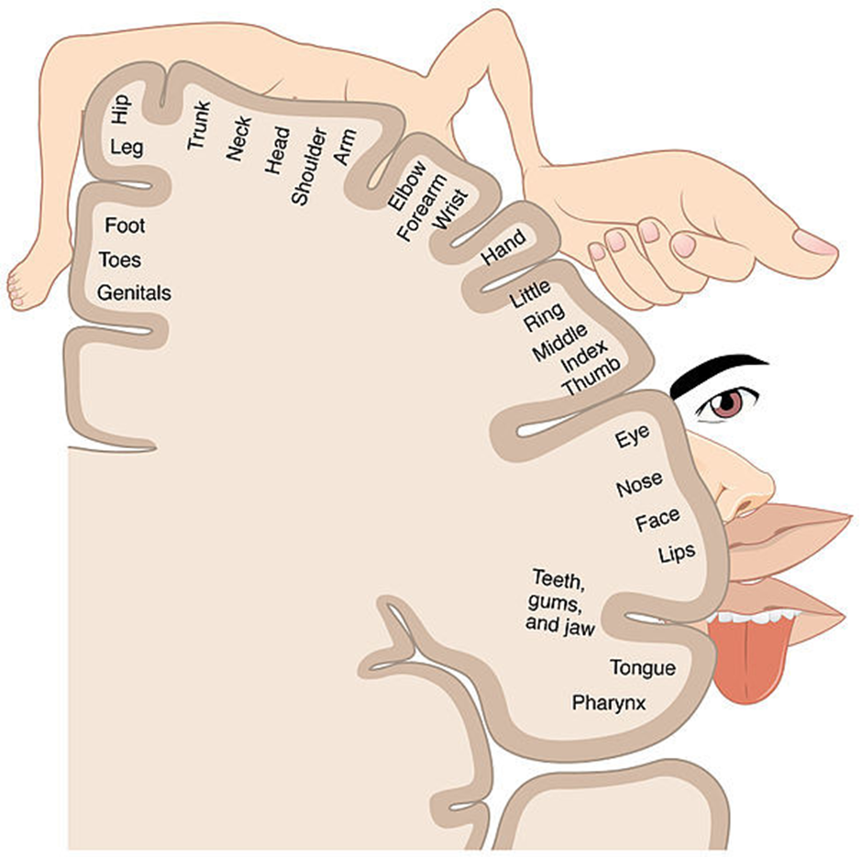Homunculus: Image representing the cortical sensory homunculus. It shows how the anatomical portions of the body, such as the tongue, elbow, and hip, are mapped out on the homunculus. The surface area of cortex dedicated to a body part correlates with the amount of somatosensory input from that area.
Functions
The somatosensory system functions in the body’s periphery, spinal cord, and the brain.
Periphery: Sensory receptors (i.e., thermoreceptors, mechanoreceptors, etc.) detect the various stimuli.
Spinal cord: Afferent pathways in the spinal cord serve to pass information from the periphery and the rest of the body to the brain.
Brain: The postcentral gyrus contains Brodmann areas (BA) 3a, 3b, 1, and 2 that make up the somatosensory cortex. BA3a is involved with the sense of relative position of neighboring body parts and the amount of effort being used during movement. BA3b is responsible for distributing somatosensory information to BA1 and shape and size information to BA2.
Tactile Sensation
Touch is sensed by mechanoreceptive neurons that respond to pressure in various ways.
DA mechanoreceptor is a sensory receptor that responds to mechanical pressure or distortion. For instance, in the periodontal ligament, there are mechanoreceptors that allow the jaw to relax when biting down on hard objects; the mesencephalic nucleus is responsible for this reflex.
In the skin, there are four main types in glabrous (hairless) skin:
- Ruffini endings.
- Meissner’s corpuscles.
- Pacinian corpuscles.
- Merkel’s discs.
There are also mechanoreceptors in hairy skin. The hair cells in the cochlea are the most sensitive mechanoreceptors, transducing air pressure waves into nerve signals sent to the brain.
Cutaneous Mechanoreceptors
Cutaneous mechanoreceptors are located in the skin, like other cutaneous receptors. They provide the senses of touch, pressure, vibration, proprioception, and others.
A somatosensory pathway will typically have three long neurons: primary, secondary, and tertiary. The first always has its cell body in the dorsal root ganglion of the spinal nerve.
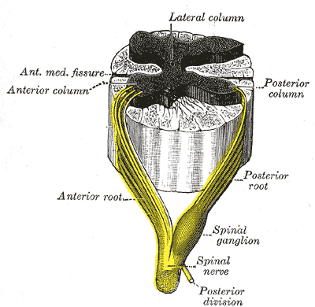
Dorsal root ganglion: Sensory nerves of a dorsal root ganglion are depicted entering the spinal cord.
The second has its cell body either in the spinal cord or in the brainstem; this neuron’s ascending axons will cross to the opposite side either in the spinal cord or in the brainstem. The axons of many of these neurons terminate in the thalamus, and others terminate in the reticular activating system or the cerebellum.
In the case of touch and certain types of pain, the third neuron has its cell body in the ventral posterior nucleus of the thalamus and ends in the postcentral gyrus of the parietal lobe.
In the periphery, the somatosensory system detects various stimuli by sensory receptors, such as by mechanoreceptors for tactile sensation and nociceptors for pain sensation. The sensory information (touch, pain, temperature, etc.,) is then conveyed to the central nervous system by afferent neurons, of which there are a number of different types with varying size, structure, and properties.
Generally, there is a correlation between the type of sensory modality detected and the type of afferent neuron involved. For example, slow, thin, unmyelinated neurons conduct pain whereas faster, thicker, myelinated neurons conduct casual touch.
Ascending Pathways
In the spinal cord, the somatosensory system includes ascending pathways from the body to the brain. One major target within the brain is the postcentral gyrus in the cerebral cortex. This is the target for neurons of the dorsal column–medial lemniscal pathway and the ventral spinothalamic pathway.
Note that many ascending somatosensory pathways include synapses in either the thalamus or the reticular formation before they reach the cortex. Other ascending pathways, particularly those involved with control of posture, are projected to the cerebellum, including the ventral and dorsal spinocerebellar tracts.
- Another important target for afferent somatosensory neurons that enter the spinal cord are those neurons involved with local segmental reflexes.
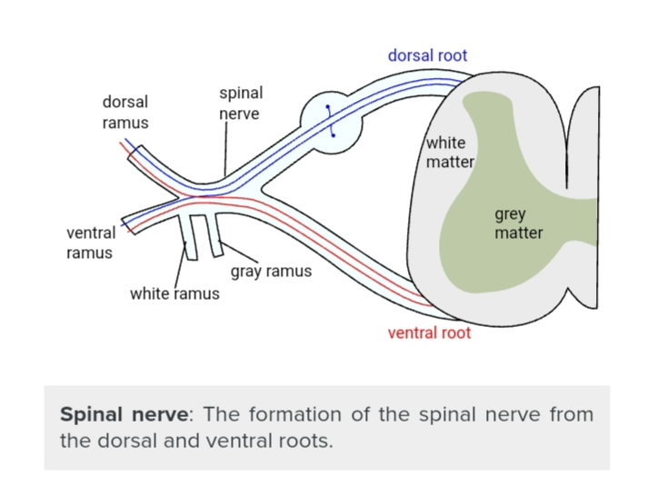

Parietal Love: Primary Somatosensory Area
The primary somatosensory area in the human cortex is located in the postcentral gyrus of the parietal lobe. This is the main sensory receptive area for the sense of touch.
Like other sensory areas, there is a map of sensory space called a homunculus at this location. Areas of this part of the human brain map to certain areas of the body, dependent on the amount or importance of somatosensory input from that area.
For example, there is a large area of cortex devoted to sensation in the hands, while the back has a much smaller area. Somatosensory information involved with proprioception and posture also target an entirely different part of the brain, the cerebellum.
Thalamus
The thalamus is a midline symmetrical structure within the brain of vertebrates including humans; it is situated between the cerebral cortex and midbrain, and surrounds the third ventricle.
Its function includes relaying sensory and motor signals to the cerebral cortex, along with the regulation of consciousness, sleep, and alertness.

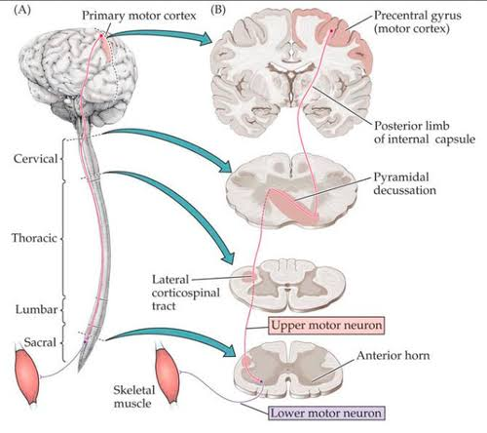
somatosensory pathway

somatosensory pathway

