NAME: OYELADE ESTHER KOREDE
MATRIC-NUMBER: 18/MHS02/172
DEPARTMENT: NURSING
COURSE CODE: PHY 212

Somatosensory Pathways

Introduction
The somatosensory pathway is composed of three neurons located in the dorsal root ganglion, the spinal cord, and the thalamus. A somatosensory pathway will typically have three neurons: primary, secondary, and tertiary. The cell bodies of the three neurons in a typical somatosensory pathway are located in the dorsal root ganglion, the spinal cord, and the thalamus. A major target of somatosensory pathways is the postcentral gyrus in the parietal lobe of the cerebral cortex. A major somatosensory pathway is the dorsal column–medial lemniscal pathway. The postcentral gyrus is the location of the primary somatosensory area that takes the form of a map called the sensory homunculus.

Definition of Terms
- Parietal lobe: A part of the brain positioned superior to the occipital lobe and posterior to the frontal lobe that integrates sensory information from different modalities and is particularly important for determining spatial sense and navigation.
- Reticular activating system: A set of connected nuclei in the brain responsible for regulating wakefulness and sleep-to-wake transitions.
- Postcentral gyrus: A prominent structure in the parietal lobe of the human brain that is the location of the primary somatosensory cortex, the main sensory receptive area for the sense of touch.
- Thalamus: Either of two large, ovoid structures of gray matter within the forebrain that relay sensory impulses to the cerebral cortex.
A somatosensory pathway will typically have three long neurons: primary, secondary, and tertiary. The first always has its cell body in the dorsal root ganglion of the spinal nerve.
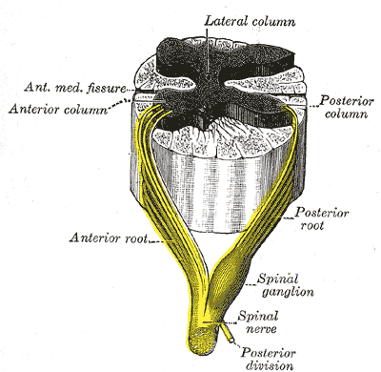
Dorsal root ganglion: Sensory nerves of a dorsal root ganglion are depicted entering the spinal cord.
The second has its cell body either in the spinal cord or in the brainstem; this neuron’s ascending axons will cross to the opposite side either in the spinal cord or in the brainstem. The axons of many of these neurons terminate in the thalamus, and others terminate in the reticular activating system or the cerebellum.
In the case of touch and certain types of pain, the third neuron has its cell body in the ventral posterior nucleus of the thalamus and ends in the postcentral gyrus of the parietal lobe.
In the periphery, the somatosensory system detects various stimuli by sensory receptors, such as by mechanoreceptors for tactile sensation and nociceptors for pain sensation. The sensory information (touch, pain, temperature, etc.,) is then conveyed to the central nervous system by afferent neurons, of which there are a number of different types with varying size, structure, and properties.
Generally, there is a correlation between the type of sensory modality detected and the type of afferent neuron involved. For example, slow, thin, unmyelinated neurons conduct pain whereas faster, thicker, myelinated neurons conduct casual touch.

Parietal Lobe: Primary Somatosensory Area
The primary somatosensory area in the human cortex is located in the postcentral gyrus of the parietal lobe. This is the main sensory receptive area for the sense of touch.
Like other sensory areas, there is a map of sensory space called a homunculus at this location. Areas of this part of the human brain map to certain areas of the body, dependent on the amount or importance of somatosensory input from that area.
For example, there is a large area of cortex devoted to sensation in the hands, while the back has a much smaller area. Somatosensory information involved with proprioception and posture also target an entirely different part of the brain, the cerebellum.

Cortical Homunculus
This is a pictorial representation of the anatomical divisions of the primary motor cortex and the primary somatosensory cortex; namely, the portion of the human brain directly responsible for the movement and exchange of sensory and motor information of the body.
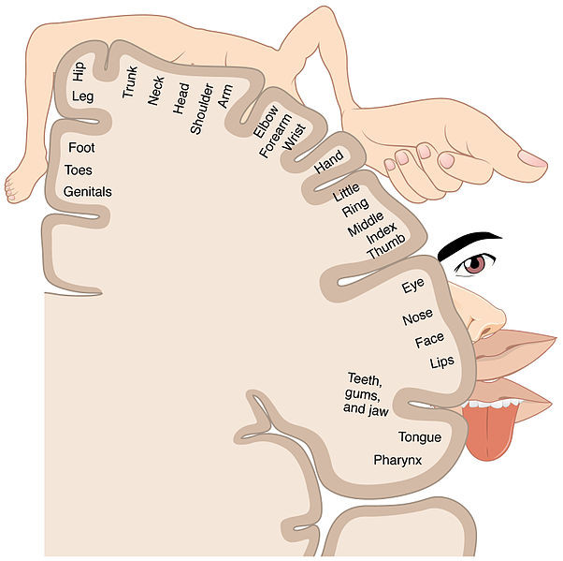
Homunculus: Image representing the cortical sensory homunculus.

Thalamus
The thalamus is a midline symmetrical structure within the brain of vertebrates including humans; it is situated between the cerebral cortex and midbrain, and surrounds the third ventricle.
Its function includes relaying sensory and motor signals to the cerebral cortex, along with the regulation of consciousness, sleep, and alertness.

Thalamic nuclei: The ventral posterolateral nucleus receives sensory information from the body.
Sensations from the skin, muscles, and internal organs of the body are transmitted to the central nervous system via axons that enter via spinal nerves. Somatosensory information from the head and face is carried to the brain primarily via cranial nerve V, the trigeminal nerve. The cell bodies of these somatosensory receptors are located in clusters called dorsal root ganglia and cranial nerve ganglia.

Ascending Pathways
In the spinal cord, the somatosensory system includes ascending pathways from the body to the brain. One major target within the brain is the postcentral gyrus in the cerebral cortex. This is the target for neurons of the dorsal column–medial lemniscal pathway and the ventral spinothalamic pathway.
Note that many ascending somatosensory pathways include synapses in either the thalamus or the reticular formation before they reach the cortex. Other ascending pathways, particularly those involved with control of posture, are projected to the cerebellum, including the ventral and dorsal spinocerebellar tracts.
Another important target for afferent somatosensory neurons that enter the spinal cord are those neurons involved with local segmental reflexes.
Spinal nerve: The formation of the spinal nerve from the dorsal and ventral roots.
The Major Somatosensory Pathways.
The major somatosensory pathways are:
- Posterior column-medial lemniscal (DCML) pathway which;
- Conveys proprioception, vibration sense, and fine discriminative touch
- Decussation is in the lower medulla
- Anterolateral pathways;
- Include the spinothalamic tract and other associated tracts that convey pain, temperature sense, and crude touch
- Anterior commissure of the spinal cord

Main Long Tracts of the Central Nervous System
Pathways | Function | Name (and level) of decussation
Lateral corticospinal tract | Motor | Pyramidal decussation (cervicomedullary junction)
Posterior column-medial lemniscal pathway | Sensory (vibration: proprioception, fine touch) | Internal arcuate fibers (lower medulla)
Anterolateral pathways | Sensory (pain, temperature, crude touch) | Anterior commissure (spinal cord)

Two separate somatosensory pathways transmit information about sensations that are tightly localized (fine touch of the exteroceptive system & kinesthesia of the proprioceptive system) and poorly localized (temperature and pain of the exteroceptive system).
Fine touch ascends via the segment of spinal cord white matter called the dorsal columns (the dorsal-column medial-lemniscal system), whereas diffuse somatosensory information ascends via the spinothalamic tract of the spinal cord (the anterolateral system). Each pathway projects to distinct areas of the thalamus and somatosensory cortex located in parietal lobe.
Posterior column-medial lemniscal (DCML) pathway
The dorsal-column medial-lemniscal system begins with somatosensory axons entering the spinal cord via the dorsal root and ascending in the dorsal columns ipsilaterally. The first synapse point for this pathway is in the dorsal column nuclei located in the medulla. The axons of neurons originating in the dorsal column nuclei decussate (cross over), ascending via the medial lemniscus to the contralateral ventral posterior thalamic nucleus (VPN). Somatosensory fibers of the trigeminal nerve (CN V), carrying information from the contralateral side of the face and head, also synapse in the VPN. The majority of VPN neurons project to the primary somatosensory cortex (SI), the remaining project to the secondary somatosensory cortex (SII) of the posterior parietal lobe.
Anterolateral pathways
The anterolateral system (denoted in the figure by the red pathway) begins with somatosensory axons entering the spinal cord via the dorsal root and synapsing upon entry. The majority of these second-order axons decussate, and ascend to the brain via the anterolateral portion of the spinal cord white matter. This ascending system is composed of three separate tracts, the spinothalamic tract, the spinoreticular tract, and the spinotectal tract. The spinothalamic tract projects to the ventral posterior nucleus of the thalamus. This tract is involved in the perception of touch, temperature, and sharp pain. The spinoreticular tract projects to the brain stem reticular formation on its way to the parafasicular nucleus and intralaminar nucleus of the thalamus (not shown). This pathway seems to be selectively involved in the perception of deep, chronic pain. The spinotectal tract projects to the tectum of midbrain. This tract is likely involved in some aspect of pain perception. The tracts of the anterolateral system project to both the primary and secondary somatosensory cortex, and to more posterior locations within the parietal lobe.
The selective area of skin innervated by the left and right dorsal roots of a particular spinal nerve is called a dermatome. The surface of the body has been mapped according to these dermatomes. It is important to note, however, that in reality the boundaries of these somatosensory regions overlap each other by approximately half of their width. Damage to a single dorsal root, therefore, produces slight loss of sensation. Both the sensation type and region of body represented are kept somewhat separate along all levels of the somatosensory pathway.
REFERENCES
Restak, R.M. (1988). The mind. Toronto: Bantam Books.
National Academy of Sciences. (1998, January 9). 1998 National Academy of Sciences awards. [Press Release]. Washington D.C. Retrieved August 17, 2000 from the World Wide Web: https://psych.athabascau.ca/html/Psych402/Biotutorials/28/part1.html
Somatic Sensory Pathways. (May 25, 2020). Medicine LibreTexts. Retrieved from: https://med.libretexts.org/Bookshelves/Anatomy_and_Physiology/Book%3A_Anatomy_and_Physiology_(Boundless)/12%3A_Peripheral_Nervous_System/12.3%3A_The_Somatosensory_System/12.3D%3A__Somatic_Sensory_Pathways

