NAME: BEN HORSFALL BOBBY
MATRIC NUMBER: 18/MHS02/055
DEPARTMENT : NURSING 200L
COURSE: PHS 212

Assignment : Elucidate the pathway involved Taste

The term "taste" should be restricted to the perceived outcome of stimulating the receptor cells of taste buds located on the surface of the tongue. This sense of taste, or gustation, is similar to the sense of smell (olfaction) in that stimuli interact chemically with the receptors during the encoding process. Tasted substances must dissolve in saliva before they can interact with the taste receptors. Saliva then holds the dissolved chemicals close to the collections of receptor cells, called taste buds. The performance of taste buds deteriorates rapidly in the absence of saliva. The chemical taste receptors are located buried within the "bumps" (called papillae) that cover the surface of the tongue. In addition to increasing the surface area for taste buds, the papillae create an abrasive surface that helps to hold food within the mouth.
Four qualities of taste that have emerged from the research on this system are sweetness, saltiness, bitterness, and sourness. Most vertebrates are sensitive to these four taste qualities, but some species differences in sensitivity do exist. In addition, taste preferences may differ within and across species. For example, various members of the feline family from domestic cats to lions and tigers do not perceive sweetness. Humans and rodents like both sucrose and saccharin, but dogs reject saccharin. Humans differ both in their sensitivity to the taste qualities and in their taste preferences. Taste buds are lost with advancing age, and therefore taste thresholds increase with age. Children, with their highly sensitive sense of taste, are often intolerant of spicy foods. There are also differences in taste preference across adults of similar age. Some find particular tastes offensive, while others do not. It is commonly thought that the four taste qualities are encoded by four unique receptors, and that the relative activity in these receptors results in the ultimate perception of taste. The evidence in favor of this hypothesis is, however, uncertain. A description of recent findings concerning the mechanisms underlying taste perception is provided in the advanced section.
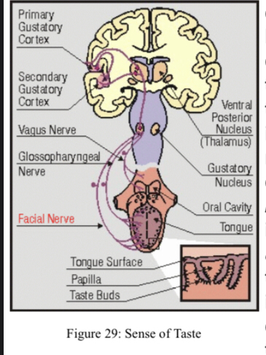
Gustation is needed to monitor the substances gaining entry into the digestive system, an ability that can be essential to survival. Sweetness is clearly linked with the experience of eating food and gaining nutritive sources of energy. Saltiness and bitterness, however, may be linked to the detection of substances of life sustaining and life threatening qualities, respectively. Wounds that cause bleeding may deplete "salty" sodium reserves at a rapid rate. Because this ion is essential to sustain life.

Special Senses: Taste (Gustation)
Taste (Gustation)
Taste, or gustation, is a sense that develops through the interaction of dissolved molecules with taste buds. Currently five sub- modalities (tastes) are recognized, including sweet, salty, bitter, sour, and umami (savory taste or the taste of protein). Umami is the most recent taste sensation described, gaining acceptance in the 1980s. Further research has the potential to discover more sub-modalities in this area, with some scientists suggesting that a taste receptor for fats is likely.
Taste is associated mainly with the tongue, although there are taste (gustatory) receptors on the palate and epiglottis as well. The surface of the tongue, along with the rest of the oral cavity, is lined by a stratified squamous epithelium. In the surface of the tongue are raised bumps, called papilla, that contain the taste buds. There are three types of papilla, based on their appearance: vallate, foliate, and fungiform.

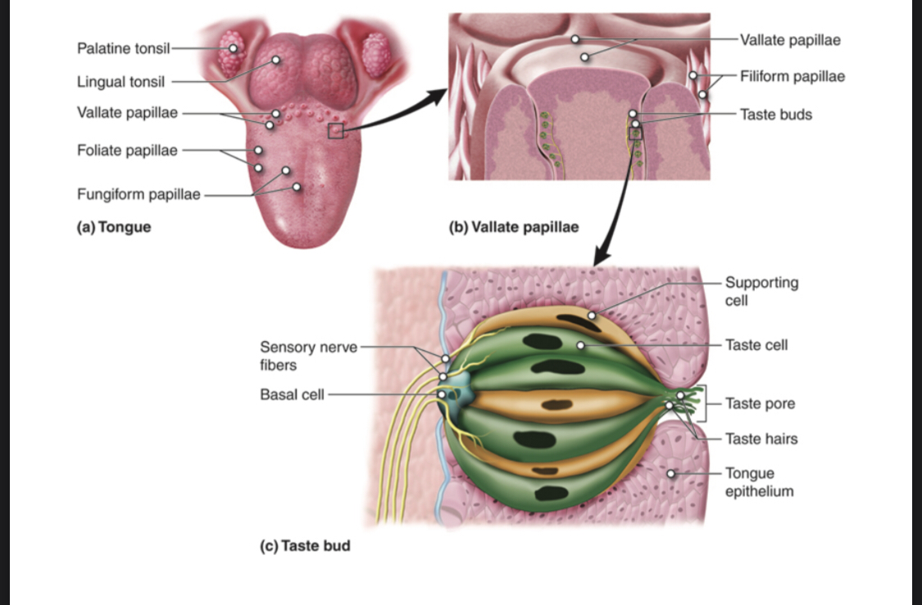
Structures Associated with Taste. The tongue is covered with papillae (a), which contain taste buds (b and c). Within the taste buds are specialized taste cells (d) that respond to chemical stimuli dissolved in the saliva and, in turn, activate sensory nerve fibers in the facial and glossopharyngeal nerves.
The number of taste buds within papillae varies, with each bud containing several specialized taste cells (gustatory receptor cells) for the transduction of taste stimuli. These receptor cells release neurotransmitters when certain chemicals in ingested substances (such as food) are carried to their surface in saliva. Neurotransmitter from the gustatory cells can activate the sensory neurons in the facial and glossopharyngeal cranial nerves.
Primary Taste Sensations
As previously mentioned, five dierent taste sensations are currently recognized. The first, salty, is simply the sense of Na+ concentration in the saliva. As the Na+ concentration becomes high outside the taste cells, a strong concentration gradient drives their diusion into the cells. This depolarizes the cells, leading them to release neurotransmitter.
The sour taste is transduced similar to that of salty, except that it is a response to the H+ concentration released from acidic substances (those with low pH), instead of a response to Na+. For example, orange juice, which contains citric acid, will taste sour because it has a pH value of about 3. Of course, it is often sweetened so that the sour taste is masked. As the concentration of the hydrogen ions increases because of ingesting acidic compounds, the depolarization of specific taste cells increases.
The other three tastes; sweet, bitter and umami are transduced through G-protein coupled cell surface receptors instead of the direct diusion of ions like we discussed with salty and sour. The sweet taste is the sensitivity of taste cells to the presence of glucose dissolved in the saliva. Molecules that are similar in structure to glucose will have a similar eect on the sensation of sweetness. Other monosaccharides such as fructose or artificial sweeteners like aspartame (NutrasweetTM), saccharine, or sucralose (SplendaTM) will activate the sweet receptors as well. The anity for each of these molecules varies, and some will taste “sweeter” than glucose because they bind to the G-protein coupled receptor dierently.
The bitter taste can be stimulated by a large number of molecules collectively known as alkaloids. Alkaloids are essentially the opposite of acids, they contain basic (in the sense of pH) nitrogen atoms within their structures. Most alkaloids originate from plant sources, with common examples being hops (in beer), tannins (in wine), tea, aspirin, and similar molecules. Coee contains alkaloids and is slightly acidic, with the alkaloids contributing the bitter taste to coee. When enough alkaloids are contained in a substance it can stimulate the gag reflex. This is a protective mechanism because alkaloids are often produced by plants as a toxin to deter infectious microorganisms and plant eating animals. Such molecules may be toxic to animals as well, so we tend to avoid eating bitter foods. When we do eat bitter foods, they are often combined with a sweet component to make them more palatable (cream and sugar in coee, for example).
The taste known as umami is often referred to as the savory taste. The name was created by the Japanese researcher who originally described it. Like sweet and bitter, it is based on the activation of G-protein coupled receptors, in this case by amino acids, especially glutamine. Thus, umami might be considered the taste of proteins, and is most associated with meat containing dishes.

Gustatory Nerve Impulses
Once the taste cells are activated by molecules liberated from the things we ingest, they release neurotransmitters onto the dendrites of sensory neurons. These neurons are part of the facial and glossopharyngeal cranial nerves, as well as a component within the vagus nerve dedicated to the gag reflex. The facial nerve connects to taste buds in the anterior third of the tongue. The glossopharyngeal nerve connects to taste buds in the posterior two thirds of the tongue. The vagus nerve connects to taste buds in the extreme posterior of the tongue, verging on the pharynx, which are more sensitive to noxious stimuli like bitterness.
Axons from the three cranial nerves carrying taste information travel to the medulla. From there much of the information is carried to the thalamus and then routed to the primary gustatory cortex, located near the inferior margin of the post-central gyrus. It is the primary gustatory cortex that is responsible for our sensations of taste. And, although this region receives significant input from taste buds, it is likely that it also receives information about the smell and texture of food, all contributing to our overall taste experience. The nuclei in the medulla also send projections to the hypothalamus and amygdalae, which are involved in autonomic reflexes such as gagging and salivation.

