MATRIC Number:17/mhs01/021
DEPARTMENT: Medicine and surgery
COURSE:Renal physiology assignment
COURSE CODE: PHS 303
1.Discuss the pathophysiological process involved in renal failure.
Chronic kidney disease is the main cause of renal failure and could be mild, moderate or severe. It is common mostly in elderly people but is also common in young people. Renal failure may be caused by multiple conditions including those which are due to direct hemodynamic or nephrotoxic constants. Renal ischemia and a direct effect to a nephrotoxicant agent are usually a basis for renal damage occurrence. Once the loss of nephrons and reduction of functional renal mass reaches a certain point, the remaining nephrons begin a process of irreversible sclerosis that leads to a progressive decline in the Glomerular filtration rate which is the rate at which plasma is filtered through the glomerulus. Sepsis, hypotensive shock ,hyperparathyroidism are symptoms of chronic renal failure. Renal functional impairment is maintained by a number of factors which includes persistent renal vasoconstriction, tubular obstruction, leakage of filtrate across damaged tubular epithelium and a reduction in glomerular capillary permeability. However, the more severe the injury, regeneration is incomplete and nephron mass can be replaced by scar tissue, leading to chronic renal failure. Some pathophysiological conditions involved in chronic kidney failure include glomerulosclerosis and tubulointerstitial fibrosis, microvascular capillary rarefaction, hypoxia and tubular atrophy, hypertension, hypertensive nephrosclerosis These changes lead to the loss of renal filtrative capacity and ultimately to end-stage renal disease.

2.With the aid of suitable diagrams discuss the types of dialysis you know.

What is dialysis?
The kidneys filter your blood by removing waste and excess fluid from your body. This waste is sent to the bladder to be eliminated when you urinate. Dialysis performs the function of the kidneys if they’ve failed. kidney failure occurs when the kidneys are performing at only 10 to 15 percent of their normal function. Dialysis is a treatment that filters and purifies the blood using a machine. This helps keep your fluids and electrolytes in balance when the kidneys can’t do their job.
Properly functioning kidneys prevent extra water, waste, and other impurities from accumulating in your body. They also help control blood pressure and regulate the levels of chemical elements in the blood. These elements may include sodium and potassium. Your kidneys even activate a form of vitamin D that improves the absorption of calcium. When your kidneys can’t perform these functions due to disease or injury, dialysis can help keep the body running as normally as possible. Without dialysis, salts and other waste products will accumulate in the blood, poison the body, and damage other organs. However, dialysis isn’t a cure for kidney disease or other problems affecting the kidneys.
There are three different types of dialysis.

Hemodialysis
Hemodialysis is the most common type of dialysis. This process uses an artificial kidney (hemodialyzer) to remove waste and extra fluid from the blood. The blood is removed from the body and filtered through the artificial kidney. The filtered blood is then returned to the body with the help of a dialysis machine.
To get the blood to flow to the artificial kidney, your doctor will perform surgery to create an entrance point (vascular access) into your blood vessels. The three types of entrance points are:
- Arteriovenous (AV) fistula. This type connects an artery and a vein. It’s the preferred option.
- AV graft. This type is a looped tube.
- Vascular access catheter. This may be inserted into the large vein in your neck.
Both the AV fistula and AV graft are designed for long-term dialysis treatments. People who receive AV fistulas are healed and ready to begin hemodialysis two to three months after their surgery. People who receive AV grafts are ready in two to three weeks. Catheters are designed for short-term or temporary use.
Hemodialysis treatments usually last three to five hours and are performed three times per week. However, hemodialysis treatment can also be completed in shorter, more frequent sessions.Most hemodialysis treatments are performed at a hospital, doctor’s office, or dialysis center. The length of treatment depends on your body size, the amount of waste in your body, and the current state of your health. After you’ve been on hemodialysis for an extended period of time, your doctor may feel that you’re ready to give yourself dialysis treatments at home.
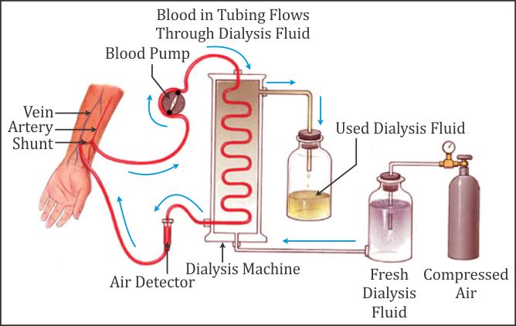

DIAGRAM OF HEMODIALYSIS

Peritoneal dialysis
Peritoneal dialysis involves surgery to implant a peritoneal dialysis (PD) catheter into your abdomen. The catheter helps filter your blood through the peritoneum, a membrane in your abdomen. During treatment, a special fluid called dialysate flows into the peritoneum. The dialysate absorbs waste. Once the dialysate draws waste out of the bloodstream, it’s drained from your abdomen.This process takes a few hours and needs to be repeated four to six times per day. However, the exchange of fluids can be performed while you’re sleeping or awake.
There are numerous different types of peritoneal dialysis. The main ones are:
- Continuous ambulatory peritoneal dialysis (CAPD). In CAPD, your abdomen is filled and drained multiple times each day. This method doesn’t require a machine and must be performed while awake.
- Continuous cycling peritoneal dialysis (CCPD). CCPD uses a machine to cycle the fluid in and out of your abdomen. It’s usually done at night while you sleep.
- Intermittent peritoneal dialysis (IPD). This treatment is usually performed in the hospital, though it may be performed at home. It uses the same machine as CCPD, but the process takes longer.
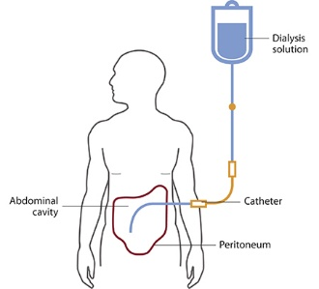

DIAGRAM OF PERITONEAL DIALYSIS

Continuous renal replacement therapy (CRRT)
This therapy is used primarily in the intensive care unit for people with acute kidney failure. It’s also known as hemofiltration. A machine passes the blood through tubing. A filter then removes waste products and water. The blood is returned to the body, along with replacement fluid. This procedure is performed 12 to 24 hours a day, generally every day.

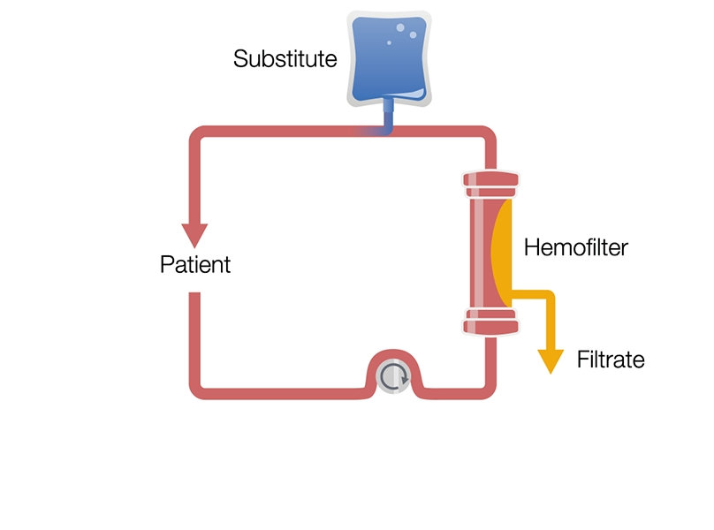
DIAGRAM OF CONTINUOUS RENAL REPLACEMENT THERAPY

While all three forms of dialysis can save your life, they also carry certain risks.

Risks associated with hemodialysis
Hemodialysis risks include:
- low blood pressure
- anemia, or not having enough red blood cells
- muscle cramping
- difficulty sleeping
- itching
- high blood potassium levels
- pericarditis, an inflammation of the membrane around the heart
- sepsis
- bacteremia, or a bloodstream infection
- irregular heartbeat
- sudden cardiac death, the leading cause of death in people undergoing dialysis

Risks associated with peritoneal dialysis
Peritoneal dialysis is associated with an increased risk for infections in or around the catheter site in the abdominal cavity. For example, after catheter implantation, a person can experience peritonitis. Peritonitis is an infection of the membrane lining the abdominal wall.
Other risks include:
- abdominal muscle weakening
- high blood sugar due to the dextrose in the dialysate
- weight gain
- hernia
- fever
- stomach pain

Risks associated with CRRT
The risks associated with CRRT include:
- infection
- hypothermia
- low blood pressure
- electrolyte disturbances
- bleeding
- delayed renal recovery
- weakening of bones
- anaphylaxis
Those who undergo long-term dialysis treatments are also at risk of developing other medical conditions, including amyloidosis. This disease can occur when amyloid proteins produced in bone marrow build up in organs such as the kidneys, liver, and heart. This usually causes joint pain, stiffness, and swelling.
Some people may also develop depression after receiving a diagnosis of long-term kidney failure.

Are there any alternatives to dialysis?
Dialysis is time-consuming and expensive. Not everyone chooses it, particularly if they’re experiencing severe, acute kidney failure.
If you decide not to pursue dialysis, there are other treatment options that may help manage your symptoms. One of these options is anemia management. When the kidneys are working properly, the hormone erythropoietin (EPO) is produced naturally in the body. To help with an under-functioning kidney, you can get an injection of EPO every week.
Maintaining good blood pressure can help slow the deterioration of your kidney. Drink fluids to avoid dehydration. Talk to your doctor before taking any anti-inflammatory drugs, including ibuprofen (Advil) and diclofenac (Solaraze, Voltaren).
A kidney transplant is another option for some people. It’s also a long-term commitment. Talk to your doctor to see if a transplant is right for you. You might not be a good candidate for a kidney transplant if you:
- smoke
- heavily use alcohol
- are obese
- have an untreated mental health condition

How do I prepare for dialysis?
Before your first dialysis treatment, your doctor will surgically implant a tube or device to gain access to your bloodstream. This is typically a quick operation. You should be able to return home the same day.
It’s best to wear comfortable clothing during your dialysis treatments. Also follow your doctor’s instructions. These may include fasting for a certain amount of time before the treatment.

What types of dialysis can be performed at home?
Both hemodialysis and peritoneal dialysis can be performed at home. Peritoneal dialysis can be performed alone, while hemodialysis requires a partner. The partner can be a friend or family member, or you can opt to hire a dialysis nurse.
With either type of treatment, you’ll receive thorough training from a medical professional beforehand

