NAME: IRERUKE EMMANUELLA OGHENETEGA
MATRIC NUMBER: 17/MHS01/163
LEVEL: 300
DEPARTMENT: MBBS
COURSE TITLE: HISTOLOGY OF SPECIAL SENSES AND NEUROHISTOLOGY
COURSE CODE: ANA 305
ASSIGNMENT TITLE: HISTOLOGY OF THE EAR

Question
With the aid of a diagram, write an essay on the histology of an organ of Corti
The Organ of Corti is an organ of the inner ear located within the cochlea which contributes to audition. The Organ of Corti includes three rows of outer hair cells and one row of inner hair cells. Vibrations caused by sound waves bend the stereocilia on these hair cells via an electromechanical force. The hair cells convert mechanical energy into electrical energy that is transmitted to the central nervous system via the auditory nerve to facilitate audition.
The organ of Corti is a specialized sensory epithelium that allows for the transduction of sound vibrations into neural signals. The organ of Corti itself is located on the basilar membrane. The organ of Corti rests on the basilar membrane and contains two types of hair cells: inner hair cells and outer hair cells. Inner hair cells transduce sound from vibrations to neural signals via the shearing action of their stereocilia. Outer hair cells serve a function as acoustic pre-amplifiers which improve frequency selectivity by allowing the organ of Corti to become attuned to specific frequencies, like those of speech or music. The fibrous tectorial membrane rests on top of the stereocilia or the outer hair cells. Mutations in a alpha-tectorin, which encodes a protein specific to the tectorial membrane, cause deafness.
Organ of Corti consists of different types of cells:
Inner hair cells
Outer hair cells
Supporting cells
Inner Hair Cell
These cells are specialized in the mechanoelectrical transduction. There are almost 3500 cells disposed in one line along all the basilar membrane. They are connected to type I neuron peripheral fibers of spiral ganglion, these connection are very divergent (10/1). The luminal part of the cell is immerged in endolymph, the basal one is immerged in normal extracellular fluid. The luminal portion is formed by bundles of stereocilia(inner_ear), whose tips are connected by filamentous structures called tip-links.
Outer Hair Cell
These cells are acoustical pre-amplifiers. They are almost 12000, disposed in three parallel lines. These cells are connected to type II amyelinic neurons, the connections are very convergent. They have also an afference from superior olivary nucleus. They have contractile activity.
Supporting Cells
These cells are of four different types: Corti pillars, Hensen cells, Deiters cells and Claudius cells.
ABNORMALITIES
The organ of Corti can be damaged by excessive sound levels, leading to noise-induced impairment. The most common kind of hearing impairment, sensorineural hearing loss, includes as one major cause the reduction of function in the organ of Corti. Specifically, the active amplification function of the outer hair cells is very sensitive to damage from exposure to trauma from overly-loud sounds or to certain ototoxic drugs. Once outer hair cells are damaged, they do not regenerate, and the result is a loss of sensitivity and an abnormally large growth of loudness (known as recruitment) in the part of the spectrum that the damaged cells serve.
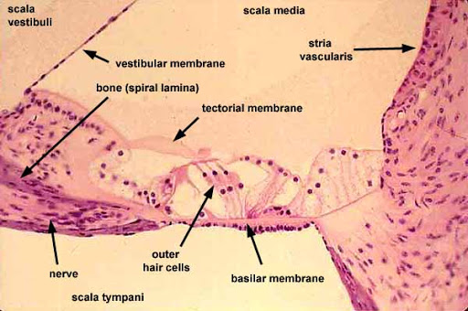
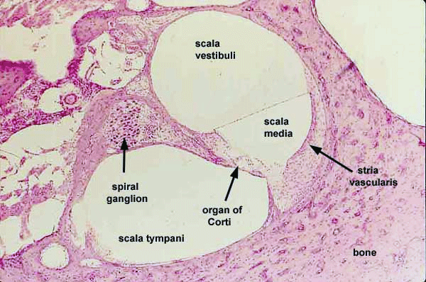
HISTOLOGICAL DIAGRAMS SHOWING THE ORGAN OF CORTI

