Name: EKEADAH Adaeze .c.
Matric no.: 17/mhs01/107
Department: MBBS
Level: 300

Histology of the organ of corti
The Organ of Corti is a part of the cochlea which mediates the sense of hearing transducing pressure waves to action potentials. It is localized in the scala media and formed by a series of hair cells, nervous terminations of spiral ganglion and supporting cells.

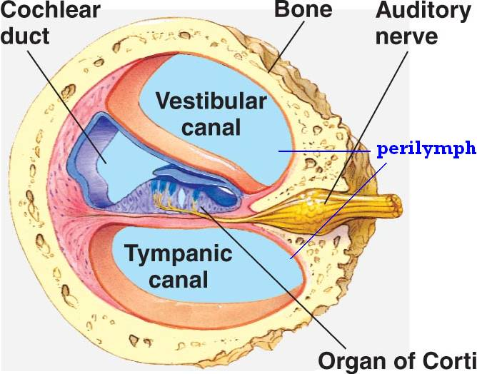
GROSS ANATOMY
The scala media (or cochlear duct) is located between scala tympani and scala vestibule filled with endolymph. It is delimited by the basilar membrane and Reissner’s membrane. It covers the basilar membrane and under the tectorial membrane, an acellular gel into which hair cell (stereocilia) are immersed. The peripheral process of acoustic nerve fibers provides synaptic connections between hair cells and cochlear nucleus.
The upper portion of the cochlear duct is formed by the stria vascularis, which contains numerous capillary loops and small blood vessels and produces endolymph.

HISTOLOGY
It consists of different types of cells:
1) Inner hair cells
2) Outer hair cells
3) Supporting cells
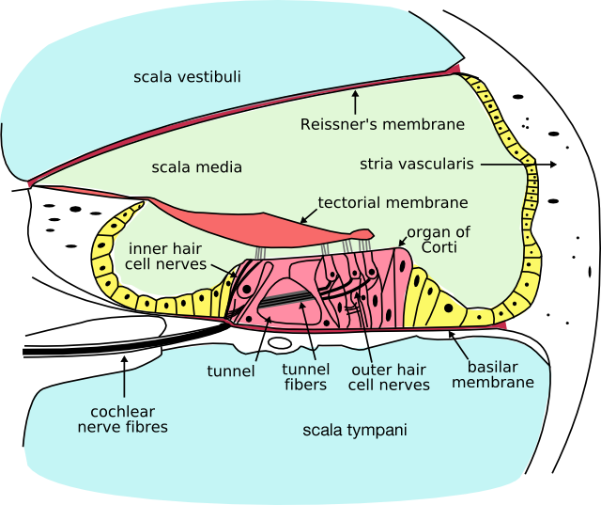

Inner Hair Cell
These cells are specialized in the mechanoelectrical transduction, there are almost 3500 cells disposed in one line along all the basilar membrane. They are connected to type I neuron peripheral fibers of spiral ganglion, these connection are very divergent (10/1). The luminal part of the cell is immerged in endolymph, the basal one is immerged in normal extracellular fluid. The luminal portion is formed by bundles of stereocilia (inner ear), whose tips are connected by filamentous structures called tip-links.

Outer Hair Cell
These cells are acoustical pre-amplifiers, they are almost 12000 disposed in three parallel lines. These cells are connected to type II amyelinic neurons, the connections are very convergent. They have also an afference from superior olivary nucleus I.e. they have contractile activity.

Supporting Cells
These cells are of four different types:
- Corti pillars: cells forming the outer and inner walls of the tunnel in the spiral organ.

- Hensen cells: they are layers of tall cells arranged in the organ of Corti in the cochlea which are part of the supporting cells lie on the outer hair cells. They are seen with a wide upper part and a lower narrow part with column like cells. One of its significant morphologic feature is the lipid droplets (which are most noticeable at the third and fourth turns of the cochlear), the droplets are thought to have association with the auditory process because they are parallel to the innervation. One significant structure found among these cells and the hair cells are the gap junctions, they are made of connexins which serve important function in distribution and connection between cells, the gaps enable the long distance of electric communication.

- Deiters cells: they are described as having an elongated body (spanning from the basilar membrane (BM) to the reticular lamina) and holding the base of the outer hair cells (OHCs) at their cup-shaped middle regions, each cell is usually divided into two portions apical and basal.
- The apical portion consists of a thin branch (the phalangeal process) which extends from the mid-region of the cell to the reticular lamina where it fill the spaces between the OHCs
- The basal portion which extends from the region cradling the base of the OHCs to the BM contains the nucleus and most of the organelles. It has been usually described as having a polygonal cylindrical shape with a basal region significantly more slender than the mid-cell region, and others like an upside-down truncated cone, with the smaller base contacting the BM in a very narrow area next to the feet of the outer pillar cells

- Claudius cells: they extend from Hensen's cells to the spiral prominence epithelium forming the outer sulcus. They are in direct contact with the endolymph of the cochlear duct, they are sealed via tight junctions that prevent flow of endolymph between them.

Endolymph
It fills the scala media and it is produced by stria vascularis. Potassium secreted into it by the stria vascularis enters the hair cells through apical mechanosensitive channels which is recycled back to the stria vascularis through supporting cells and fibrocytes of the spiral ligament for another round of secretion. Hair cells and stria vascularis are tied together in a "push-pull" or "pump-leak" balance that determines endocochlear potential (EP +85mV), Endolymph composition and ultimately the sensivity and stability of hair cells and hearing over a lifetime.

The evolutionary strategy of using potassium receptors currents is due to the fact that it reduces metabolic requirements because it has a passive outflow from hair cells to the basal membrane, instead of active sodium extrusion.

SENSE OF HEARING
This involves translating pressure waves of perilymph and endolymph to electrical signal and acoustic sensation.
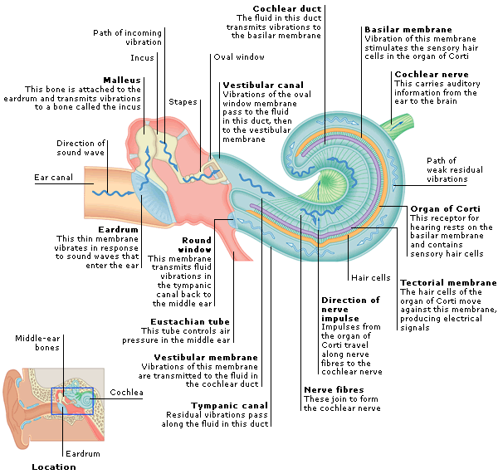
Sound waves are really vibrations in the air around us which are collected by the pinna on each side of our head and are funnelled into the ear canals. These sound waves make the eardrum vibrate, the eardrum is so sensitive to sound vibrations in the ear canal that it can detect even the faintest sound as well as replicating even the most complex of sound vibration patterns.
The eardrum vibrations caused by sound waves move the ossicles (malleus, incus and stapes) in the middle ear transferring the sound vibrations into the cochlea of the inner ear, the stapes sits in a membrane-covered window in the bony wall which separates the middle ear from the cochlea of the inner ear. As it vibrates, the fluids in the cochlea move in a wave-like manner, stimulating the microscopically small ‘hair cells’.
The ‘hair cells’ in the cochlea are tuned to respond to different sounds based on their pitch or frequency of sounds. High-pitched sounds will stimulate ‘hair cells’ in the lower part of the cochlea and low-pitched sounds in the upper part of the cochlea, when each ‘hair cell’ detects the pitch or frequency of sound, it generates nerve impulses which travel instantaneously along the auditory nerve.
These nerve impulses follow a complicated pathway in the brainstem before arriving at the hearing centres of the brain(the auditory cortex), This is where the streams of nerve impulses are converted into meaningful sound.

