ASSIGNMENT
QUESTION: WITH THE AID OF A DIAGRAM, WRITE AN ESSAY ON THE ORGAN OF CORTI.

The organ of Corti, or spiral organ, is the receptor organ for hearing and is located in the mammalian cochlea. This highly varied strip of epithelial cells allows for transduction of auditory signals into nerve impulses' action potential. Transduction occurs through vibrations of structures in the inner ear causing displacement of cochlear fluid and movement of hair cells at the organ of Corti to produce electrochemical signals.

Organ of Corti
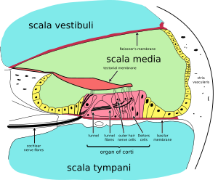
A cross section of the cochlea illustrating the organ of Corti.

The organ of Corti is a specialized sensory epithelium that allows for the transduction of sound vibrations into neural signals. The organ of Corti itself is located on the basilar membrane. The organ of Corti rests on the basilar membrane and contains two types of hair cells: inner hair cells and outer hair cells. Inner hair cells transduce sound from vibrations to neural signals via the shearing action of their stereocilia. Outer hair cells serve a function as acoustic pre-amplifiers which improve frequency selectivity by allowing the organ of Corti to become attuned to specific frequencies, like those of speech or music. The fibrous tectorial membrane rests on top of the stereocilia or the outer hair cells. Mutations in a alpha-tectorin, which encodes a protein specific to the tectorial membrane, cause deafness.

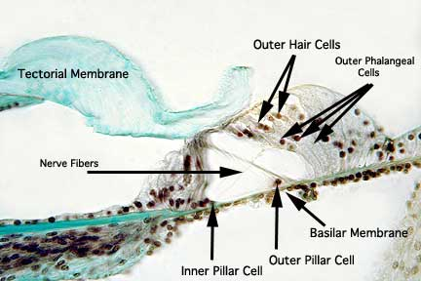
This Photo by Unknown Author is licensed under CC BY-SA

