NAME: Osuagwu Oluomachi Joline
MATRIC NO: 17/MHS01/274
WITH THE AID OF A DIAGRAM, WRITE AN ESSAY ON THE HISTOLOGY OF AN ORGAN OF CORTI.

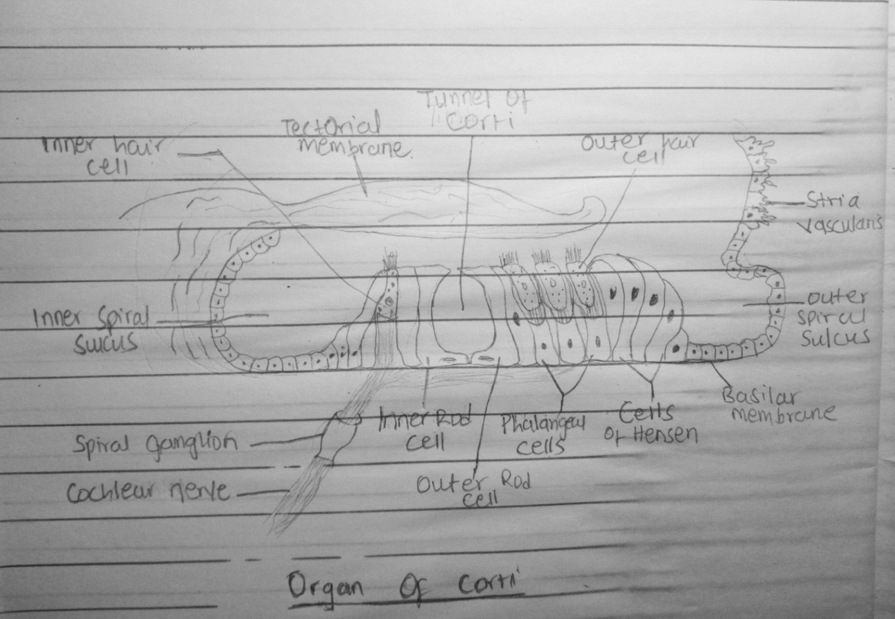

The organ of corti is also called the spiral organ of corti because (like other structures in the cochlea) it extends in a spiral manner through the turns of the cochlea. In sections it is seen to be placed on the basilar membrane. The organ of corti contains;
- A single row of inner hair cells.
- Three rows of outer hair cells that have steriocilia (but no kinocilium) on their apical border and synapse with bipolar neurons of the cochlear(spiral) ganglion of CNVIII
- Supporting cells: pillar cells, phalangeal cells, border cells, cells of hensen.
The cells of the spiral organ are covered from above by a gelatinous mass called the membrana tectoria and they enclose a triangular cavity called the tunnel of Corti (or cuniculum internum). The base of the tunnel lies over the basilar membrane. It has a sloping inner wall that is formed by internal rod cells; and a sloping outer wall that is formed by external rod cells.
The inner hair cell is supported by tall cells lining the tympanic lip of the internal spiral sulcus. On the outer side of each external rod cell there are three or four outer hair cells. Still more externally the outer spiral sulcus is lined by cubical cells (cells of Claudius). A narrow space the cuniculum externum intervenes between the outermost hair cells and the cells of Hensen. A third space, the cuniculum medium (or space of Nuel) lies between the outer rod cell and the outer hair cells. The spaces are filled with perilymph (or cortilymph).

