NAME: STANLEY DANIEL CHIDUBEM.

MATRIC NO.: 18/MHS01/339.

COLLEGE: MEDICINE AND HEALTH SCIENCES.

DEPARTMENT: MEDICINE AND SURGERY (200 LVL).

Course Code: ICBCS

Assignment Title: Cardiovascular Physiology assignment.

ASSIGNMENT: Question:
- Discuss the long-term regulation of mean arterial blood pressure.
- Write short notes on the following:
- Pulmonary circulation
- Circle of Willis
- Splanchnic circulation
- Coronary circulation
- Cutaneous circulation
- Discuss the cardiovascular adjustment that occurs during exercise.

Answers:
Question 1: Long-term regulation of mean arterial blood pressure:
In each cardiac cycle arterial blood pressure fluctuates between diastolic and systolic pressure. However, the body behaves from day to day as if it regulated the mean arterial blood pressure, which is the average between diastolic and systolic pressures. Such regulation is achieved by interdependent adjustments of only 3 parameters: Heart rate (HR), ventricular stroke volume (SV) and total peripheral vascular resistance (TPVR). These are related as follows: HR - SV = Cardiac Output (CO); CO - TPVR = Mean Arterial Blood Pressure. The regulatory system includes stretch-sensitive sensors, central nervous integrators/evaluators and neuro-humoral effector mechanisms. Central nervous integration and evaluation of incoming signals occurs mostly in the pons/medulla regions of the midbrain. The most important effector mechanisms are the parasympathetic and sympathetic divisions of the autonomic nervous system, the renin-angiotensin system and vasopressin.
- Long-term regulation involves mainly the regulation of extracellular fluid volume by pressure natriuresis mechanisms residing in the kidney and by widespread actions of angiotensin
- Studies in hypertensives have suggested that the long-term-controlled variable is not
arterial blood pressure, but the balance between intake and output of fluid and electrolytes. If the kidney requires a higher perfusion pressure to achieve that balance then daily blood pressure regulation occurs around an appropriately higher set point.

There are several physiological mechanisms that regulate blood pressure in the long-term, the first of which is the renin-angiotensin-aldosterone system (RAAS).
Renin-Angiotensin-Aldosterone System (RAAS): Renin is a peptide hormone released by the granular cells of the juxtaglomerular apparatus in the kidney. It is released in response to:
- Sympathetic stimulation:
Reduced sodium-chloride delivery to the distal convoluted tubule, Decreased blood flow to the kidney.
Renin facilitates the conversion of angiotensinogen to angiotensin I which is then converted to angiotensin II using angiotensin-converting enzyme (ACE). Angiotensin II is a potent vasoconstrictor. It acts directly on the kidney to increase sodium reabsorption in the proximal convoluted tubule. Sodium is reabsorbed via the sodium-hydrogen exchanger. Angiotensin II also promotes release of aldosterone. ACE also breaks down a substance called bradykinin which is a potent vasodilator. Therefore, the breakdown of bradykinin potentiates the overall constricting effect. Aldosterone promotes salt and water retention by acting at the distal convoluted tubule to increase expression of epithelial sodium channels. Furthermore, aldosterone increases the activity of the basolateral sodium-potassium ATP-ase, thus increasing the electrochemical gradient for movement of sodium ions.
More sodium collects in the kidney tissue and water then follows by osmosis. This results in decreased water excretion and therefore increased blood volume and thus blood pressure.
Anti-Diuretic Hormone (ADH):
The second mechanism by which blood pressure is regulated is release of Anti Diuretic Hormone (ADH) from the OVLT of the hypothalamus in response to thirst or an increased plasma osmolarity.
- ADH acts to increase the permeability of the collecting duct to water by inserting aquaporin channels (AQP2) into the apical membrane.
- It also stimulates sodium reabsorption from the thick ascending limb of the loop of Henle. This increases water reabsorption thus increasing plasma volume and decreasing osmolarity.

Further Control of Blood Pressure: Other factors that can affect long-term regulation of blood pressure are natriuretic peptides. These include:
Atrial natriuretic peptide (ANP) is synthesized and stored in cardiac myocytes. It is released when the atria are stretched, indicating of high blood pressure.
ANP acts to promote sodium excretion. It dilates the afferent arteriole of the glomerulus, increasing blood flow (GFR). Moreover, ANP inhibits sodium reabsorption along the nephron. Conversely, ANP secretion is low when blood pressure is low.
Prostaglandins act as local vasodilators to increase GFR and reduce sodium reabsorption. They also act to prevent excessive vasoconstriction triggered by the sympathetic nervous and renin-angiotensin-aldosterone systems.

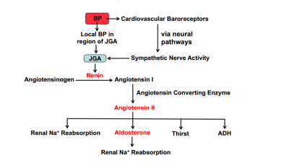
Diagram of Long-term regulation of mean arterial blood pressure
Question 2;
- Pulmonary Circulation:
The pulmonary circulation is the portion of the circulatory system which carries deoxygenated blood away from the right ventricle, to the lungs, and returns oxygenated blood to the left atrium and ventricle of the heart. The major role of pulmonary circulation is respiratory gas exchange. Therefore, to facilitate this role, pulmonary circulation is a low-pressure, high-flow system. Pulmonary circulation can accommodate any changes in blood flow due to relative passivity and the ability to recruit unperfused vessels.
Pulmonary circulation is the movement of blood from the heart to the lungs for oxygenation, then back to the heart again. Oxygen-depleted blood from the body leaves the systemic circulation when it enters the right atrium through the superior and inferior venae cava. The blood is then pumped through the tricuspid valve into the right ventricle. From the right ventricle, blood is pumped through the pulmonary valve and into the pulmonary artery. The pulmonary artery splits into the right and left pulmonary arteries and travel to each lung.
At the lungs, the blood travels through capillary beds on the alveoli where gas exchange occurs, removing carbon dioxide and adding oxygen to the blood. Gas exchange occurs due to gas partial pressure gradients across the alveoli of the lungs and the capillaries interwoven in the alveoli. The oxygenated blood then leaves the lungs through pulmonary veins, which returns it to the left atrium, completing the pulmonary circuit. As the pulmonary circuit ends, the systemic circuit begins.

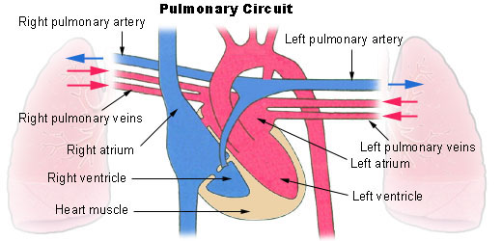
Diagram of pulmonary circulation. Oxygen-rich blood is shown in red; oxygen-depleted blood in blue.

- Circle of Willis:
The circle of Willis (also called Willis' circle, loop of Willis, cerebral arterial circle, and Willis polygon) is a circulatory anastomosis that supplies blood to the brain and surrounding structures, it is named after Thomas Willis (1621–1675), an English Physician. The Circle of Willis is the joining area of several arteries at the bottom (inferior) side of the brain. At the Circle of Willis, the internal carotid arteries branch into smaller arteries that supply oxygenated blood to over 80% of the cerebrum. The circle of Willis is formed by two group of arteries - the internal carotid arteries and two vertebral arteries. These arteries provide the anterior and posterior circulation of the brain respectively. The circle of Willis acts to provide collateral blood flow between the anterior and posterior circulations of the brain, protecting against ischemia in the event of vessel disease or damage in one or more areas.
For full explanation visit- https://www.youtube.com/watch?v=zbF2o0bmYhA
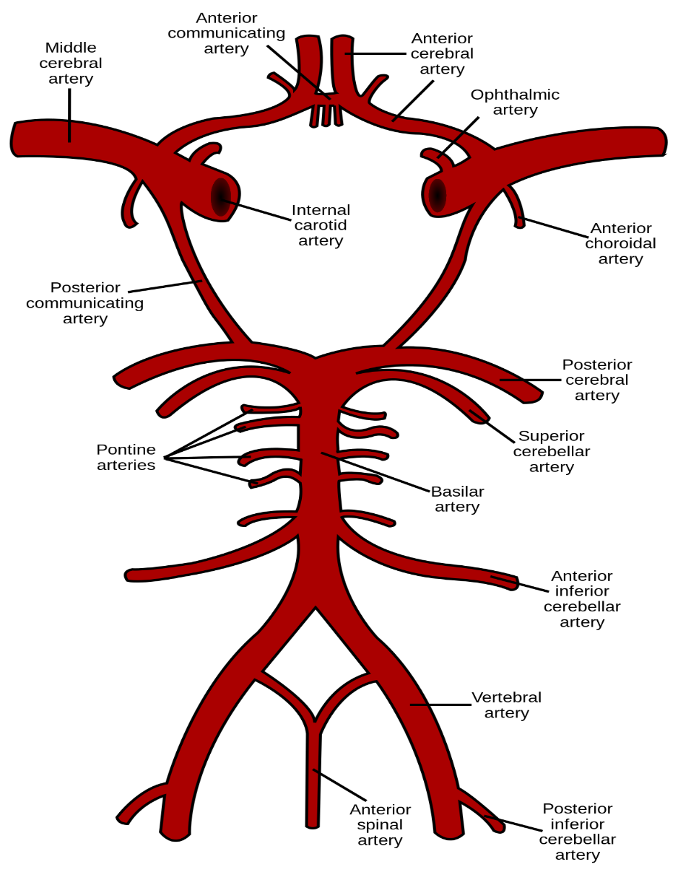
Diagram of the circle of Willis.
- Splanchnic Circulation:
The splanchnic circulation consists of the blood supply to the gastrointestinal tract, liver, spleen, and pancreas. It consists of two large capillary beds partially in series. The term ‘splanchnic circulation’ describes the blood flow to the abdominal gastrointestinal organs including the stomach, liver, spleen, pancreas, small intestine, and large intestine. It comprises three major branches of the abdominal aorta; the coeliac artery; superior mesenteric artery (SMA); and inferior mesenteric artery (IMA). The hepatic portal circulation delivers the majority of the blood flow to the liver.
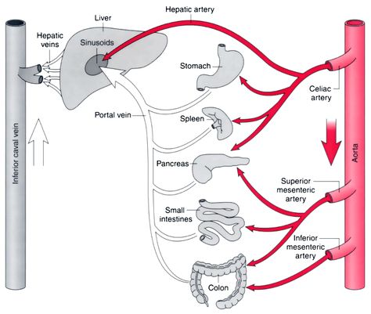
Diagram of splanchnic Circulation.

- Coronary Circulation: This is the circulation of blood in the blood vessels that supply the heart muscle (myocardium). Coronary arteries supply oxygenated blood to the heart muscle, and cardiac veins drain away the blood once it has been deoxygenated. Because the rest of the body, and most especially the brain, needs a steady supply of oxygenated blood that is free of all but the slightest interruptions, the heart is required to function continuously. Therefore its circulation is of major importance not only to its own tissues but to the entire body and even the level of consciousness of the brain from moment to moment. Interruptions of coronary circulation quickly cause heart attacks (myocardial infarctions), in which the heart muscle is damaged by oxygen starvation. Such interruptions are usually caused by ischemic heart disease (coronary artery disease) and sometimes by embolism from other causes like obstruction in blood flow through vessels. This is part of the systemic circulatory system that supplies blood to and provides drainage from the tissues of the heart. In the human heart, two coronary arteries arise from the aorta just beyond the semilunar valves; during diastole, the increased aortic pressure above the valves forces blood into the coronary arteries and thence into the musculature of the heart. Deoxygenated blood is returned to the chambers of the heart via coronary veins; most of these converge to form the coronary venous sinus, which drains into the right atrium. The heart normally extracts 70 to 75 percent of the available oxygen from the blood in coronary circulation, which is much more than the amount extracted by other organs from their circulations—e.g., 40 percent by resting skeletal muscle and 20 percent by the liver. Obstruction of a coronary artery, depriving the heart tissue of oxygen-rich blood, leads to death of part of the heart muscle (myocardial infarction) in severe cases, and total heart failure and death may ensue.
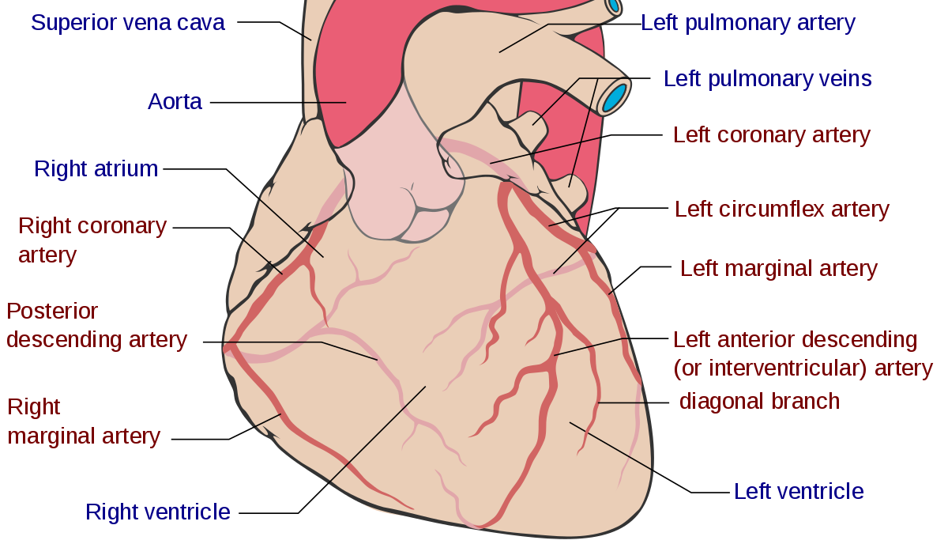
- Cutaneous Circulation:
The cutaneous circulation is the circulation and blood supply of the skin. The skin is not a very metabolically active tissue and has relatively small energy requirements, so its blood supply is different to that of other tissues. Some of the circulating blood volume in the skin will flow through will flow through arteriovenous anastomoses (AVAs) instead of capillaries. AVAs serve a role in temperature regulation.
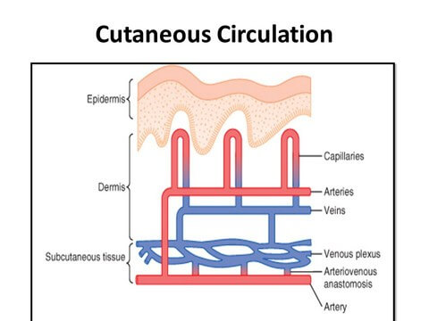

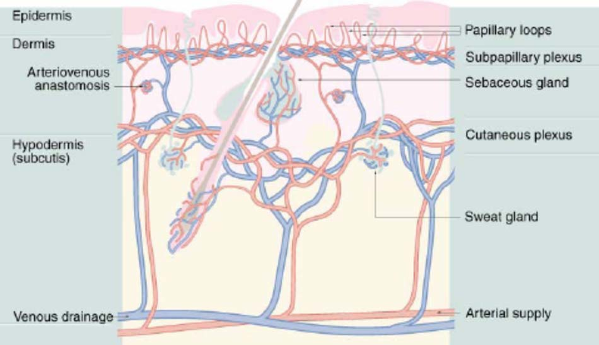
Question 3: Cardiovascular adjustment that occurs during exercise.
The integrated response to severe exercise involves fourfold to fivefold increases in cardiac output, which are due primarily to increases in cardiac rate and to a lesser extent to augmentation of stroke volume. The increase in stroke volume is partly due to an increase in end-diastolic cardiac size (Frank-Starling mechanism) and secondarily due to a reduction in end-systolic cardiac size. The full role of the Frank-Starling mechanism is masked by the concomitant tachycardia. The reduction in end-systolic dimensions can be related to increased contractility, mediated by beta adrenergic stimulation. Beta adrenergic blockade prevents the inotropic response, the decrease in end-systolic dimensions, and approximately 50% of the tachycardia of exercise.
The enhanced cardiac output is distributed preferentially to the exercising muscles including the heart. Blood flow to the heart increases four-fold to fivefold as well, mainly reflecting the augmented metabolic requirements of the myocardium due to near maximal increases in cardiac rate and contractility. Blood flow to the inactive viscera (e.g., kidney and gastrointestinal tract) is maintained during severe exercise in the normal dog. It is suggested that local autoregulatory mechanisms are responsible for maintained visceral flow in the face of neural and hormonal autonomic drive, which acts to constrict renal and mesenteric vessels and to reduce blood flow. However, in the presence of circulatory impairment, where oxygen delivery to the exercising muscles is impaired as occurs to complete heart block where normal heart rate increases during exercise are prevented, or in congestive right heart failure, where normal stroke volume increases during exercise are impaired, or in the presence of severe anemia, where oxygen-carrying capacity of the blood is limited, visceral blood flows are reduced drastically and blood is diverted to the exercising musculature. Thus, visceral flow is normally maintained during severe exercise as long as all other compensatory mechanisms remain intact. However, when any other compensatory mechanism is disrupted (even the elimination of splenic reserve in the dog), reduction and diversion of visceral flow occur.
The cardiovascular system provides the link between pulmonary ventilation and oxygen usage at the cellular level. During exercise, efficient delivery of oxygen to working skeletal and cardiac muscles is vital for maintenance of ATP production by aerobic mechanisms. The equine cardiovascular response to increased demand for oxygen delivery during exercise contributes largely to the over 35-fold increases in oxygen uptake that occur during submaximal exercise. Cardiac output during exercise increases greatly owing to the relatively high heart rates that are achieved during exercise. Heart rate increases proportionately with workload until heart rates close to maximal are attained. It is remarkable that exercise heart rates six to seven times resting values are not associated with a fall in stroke volume, which is maintained by splenic contraction, increased venous return, and increased myocardial contractibility. Despite the great changes in cardiac output, increases in blood pressure during exercise are maintained within relatively smaller limits, as both pulmonary and systemic vascular resistance to blood flow is reduced. Redistribution of blood flow to the working muscles during exercise also contributes greatly to the efficient delivery of oxygen to sites of greatest need. Higher work rates and oxygen uptake at submaximal heart rates after training imply an adaptation due to training that enables more efficient oxygen delivery to working muscle. Such an adaptation could be in either blood flow or arteriovenous oxygen content difference. Cardiac output during submaximal exercise does not increase after training, but studies using high-speed treadmills and measurement of cardiac output at maximal heart rates may reveal improvements in maximal oxygen uptake due to increased stroke volumes, as occurs in humans. Improvements in hemoglobin concentrations in blood during exercise after training are recognized, but at maximal exercise, hypoxemia may reduce arterial oxygen content. More effective redistribution of cardiac output to muscles by increased capillarization and more efficient oxygen diffusion to cells may also be an important means of increasing oxygen uptake after training.
