NAME: CHINENYE CHIDNMA MARY-JOSEPHINE
LEVEL: 300 MBBS
Assignment Title: HISTOLOGY OF EAR
Course Title: Histology of Special Senses and Neurohistology
Course Code: ANA 305
Question
With the aid of a diagram, write an essay on the histology of an organ of Corti

HISTOLOGY OF THE ORGAN OF CORTI

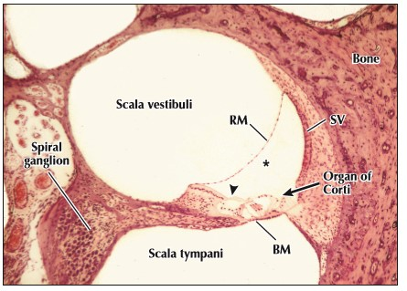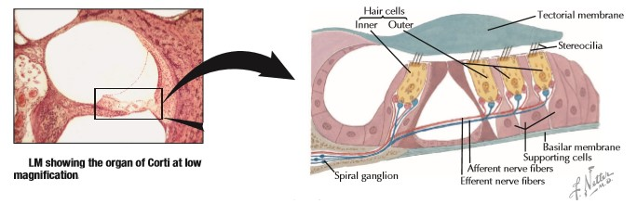

The organ of Corti in the cochlear duct is exquisitely designed for its role in auditory sensation. Lying on the basilar membrane, it is composed of hair cells, which have a complex organization, with several types of columnar supporting cells. Hair cells are arranged segmentally in two groups on the sides of an inner tunnel. A group of typically rounded inner hair cells is in one row; a group of outer hairs cells, usually more cylindrical, forms three rows. Ultrastructural criteria identify two different types of hair cells (I and II). Hair cells are polarized and bear apical stereocilia that project into the lumen of the endolymph-filled cochlear duct. Bases of hair cells are embedded in recesses formed by neighboring supporting cells that are rich in cytoskeletal components. Synapsing with these bases are afferent and efferent nerve terminals of cranial nerve VIII. Also, some supporting cells at the outer part of the organ of Corti produce the tectorial membrane, into which tips of stereocilia of the tallest outer hair cells project. The tectorial membrane, a gelatinous, resilient cuticular sheet that extends over hair cells, is made of glycoprotein in which are embedded 4-nm
microfilaments made of a protein that resembles keratin. Endolymph in the cochlear duct is like intracellular fluid, but perilymph in adjacent scalae vestibuli and tympani is chemically more similar to extracellular or cerebrospinal fluid.

CLINICAL POINT
Tinnitus:
Perception of noises (e.g., buzzing, hissing, ringing) in the ear associated with no acoustic signal in the external environment—is a common and often distressing clinical condition that may severely impact quality of life. It may be pulsatile or continuous, occur in one or both ears, and is especially prevalent in people with noise-induced or age-related (presbycusis) hearing loss. It may be related to a variety of somatic (e.g., acoustic neuroma, otosclerosis) or psychological (e.g., anxiety, insomnia, depression) disorders and may be caused by ototoxicity caused by certain medications (e.g., salicylates). Although pathogenic mechanisms remain obscure, aberrant neural activity generated at different levels of the auditory system may cause it. Stress management and tinnitus retraining sound therapy are often effective treatment strategies.

