NAME: SADIQ AYOTOMIWA S.
MATRIC NUMBER: 17/MHS01/290
COURSE: ANA 305
ASSIGNMENT: With the aid of diagram, write an essay on the histology of organ of Corti.

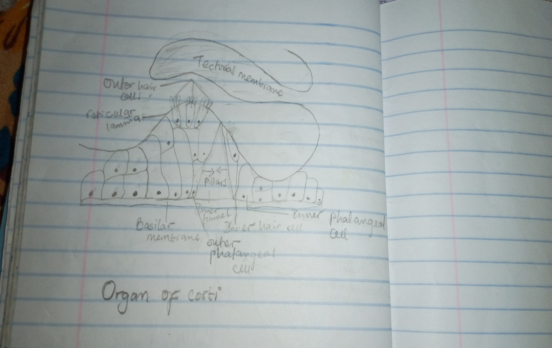

The organ of Corti also known as spiral organ is a specialized sensory epithelium that allows for the transduction of sound vibrations into neural signals. It consists of hair cells and other epithelial structures supported by the basilar membrane. The sensory hair cells have precisely arranged v-shaped bundles of rigid stereocilia; each loses its single larger kinocilium during development. Two major types of hair cells are present;
- Outer hair cells, about 12,000 in total, occur in three rows near the saccule, increasing to five rows near the apex of the cochlea. Each columnar outer hair cell bears a v-shaped bundle of stereocilia.
- Inner hair cells are shorter and form a single row of about 3500 cells, each with a single more linear array of shorter stereocillia.
Both outer and inner hair cells have synaptic connections with the inner row of cells more heavily innervated. The cell bodies of the afferent bipolar neurons constitute the spiral ganglion located in the bony core of the modiolus.
Two major types of columnar supporting cells are attached o the basilar membrane in the organ of corti. They are the inner and outer phalangeal cells. They extend apical processes that intimately surround and support the basolateral parts of both inner and outer hair cells and the synaptic nerve endings. The apical ends of phalangeal cells are joined to those of the hair cells by tight zonulae occludens, forming an apical plate across the spiral organ through which the stereocilia bundles project into endolymph.
The organ of Corti also has Pillar cells that are stiffened by heavy bundles of keratin and outline a triangular space, the inner tunnel also plays a role in sound transmission.
On the outer hair cells the tips of the tallest stereocilia are embedded in the gel-like Tectorial membrane. It is an acellular layer that extends over the organ of corti from the connective tissue around the modiolus. The tectorial membrane consist of fine bundles of collagen (types II, V, IX, and XI) associated with proteoglycans and forms during the embroyonic period from secretion of cells lining this region.
CLINICAL SIGNIFICANCE
The organ of Corti can be damaged by excessive sound levels, leading to noise-induced impairment. The most common kind of hearing impairment, sensorineural hearing loss, includes as one major cause the reduction of function in the organ of Corti. Specifically, the active amplification function of the outer hair cells is very sensitive to damage from exposure to trauma from overly-loud sounds or to certain ototoxic drugs. Once outer hair cells are damaged, they do not regenerate, and the result is a loss of sensitivity and an abnormally large growth of loudness (known as recruitment) in the part of the spectrum that the damaged cells serve.

