OKE SUCCESS OLUWASEYI
17/MHS01/243
MEDICINE AND SURGERY
NEUOHITOLOGY ASSIGNMENT – AN ESSAY ON THE HISTOLOGY OF THE ORGAN OF CORTI

The ORGAN OF CORTI or SPIRAL ORGAN is a part of the cochlea and is a specialized sensory epithelium. This structure is localized in the scale media and it is formed by a series of hair cell, nervous terminations of spiral ganglion and supporting cells. This highly varied strip of epithelial cells allows for transduction of auditory signals into nerve impulses (action potential). Transduction occurs through vibrations of structures in the inner ear causing displacement of cochlear fluid and movement of hair cells at the organ of corti to produce electrochemical signals. Italian anatomist ALFONSO GIACOMO GASPERE CORTI (1822-1876) discovered the organ of corti in 1851. Organ of corti consists of different types of cells:
Inner Hair Cells
Outer Hair Cells
Supporting cells
INNER HAIR CELLS
These cells are specialized in the mechanoelectrical transduction. There are almost 3500 cells disposed in one line along all the basilar membrane. They are connected to TYPE I neuron peripheral fibers of spiral ganglion, these connection are very divergent. The luminal part of the cell is immerged in endolymph, the basal one is immerged in the normal extracellular fluid. The luminal portion is formed by bundles of stereocilia whose tips are connected by filamentous structures called tip-links.
OUTER HAIR CELLS
These cells are acoustical pre-amplifiers. They are almost 12,000 disposed in three parallel lines. These cells are connected to type II amyelinic neurons, the connections are very convergent. They have also an afference from superior olivary nucleus. They have contractile activity.
SUPPORTING CELLS
These cells are of four different types: Corti Pillars, Hensen Cells, Deiters Cells and Claudius cells.
Projecting from the tops of the hair cells are tiny finger like projections called STEROCILIA, which is arranged in a graduated fashion with the shortest stereocilia on the outer rows and longest in the center. This gradation is thought to be the most important anatomic feature of the organ of corti because this allows the sensory cells superior tuning capability.

FUNCTIONS OF THE ORGAN OF CORTI
The function of the organ of corti is to change (transduce) auditory signals and minimize the hair cells’ extraction of sound energy. It is the auricle and middle ear that act as mechanical transformers and amplifiers so that the sound waves end up with amplitudes 22 times greater than when they entered the ear.
AUDITORY TRANSDUCTION
In normal hearing, the majority of the auditory signals that reach the organ of corti in the first place come from the outer ear. Sound waves enter through the auditory anal and vibrate the tympanic membrane, also known as the eardrum, which vibrates three small ossicles. As a result, the attached oval window moves and causes movement of the round window, which leads to displacement of the cochlear fluid. However, the stimulation can happen also via direct vibration of the cochlea from the skull.
The organ of Corti, surrounded in potassium rich fluid endolymph, lies on the basilar membrane at the base of the Scala media. Under the organ of corti is the scala tympani and above it, the scala vestibuli. Both structures exist in a low potassium fluid called perilymph. Due to those stereocilia being in the midst of a high concentration of potassium, once their cation channels are pulled open, potassium ions as well as calcium ions flow into the top of the hair cell. With this influx of positive ions the Internal Hair Cells become depolarized, opening voltage-gated calcium channels at the basolateral region of the hair cells and triggering the release of the neurotransmitter glutamate. An electrical signal is then sent through the auditory nerve and into the auditory cortex of the brain as a neural message.
COCHLEAR AMPLIFICATION
The organ of corti is also capable of modulating the auditory signal. The outer hair cells can amplify the signal through a process called electromotility where they increase movement of the basilar and tectorial membranes and therefore increase deflection of stereocilia in the Inner hair Cells.
A crucial piece to this cochlear amplification is the motor protein prestin, which changes shape based on the voltage potential inside of the hair cell. When the cell is depolarized, prestin shortens, and because it is located on the membrane of Outer Hair Cells it then pulls on the basilar membrane and increasing how much the membrane is deflected, creating a more intense effect on the Inner Hair cells. When the cell hyperpolarizes prestin lengthens and eases tension on the Inner Hair Cells, which decreases the neural impulses to the brain. In this way, the hair cell itself is able to modify the auditory signal before it even reaches the brain.

DEVELOPMENT OF THE ORGAN OF CORTI
The organ of corti, develops after the formation and growth of the cochlear duct. The inner and outer hair cells then differentiate into their appropriate positions and are followed by the organization of the supporting cells. Development and growth of the organ of Corti relies on specific genes to undergo such differentiation. Specifically, the cochlear duct growth and the formation of hair cells within the organ of Corti. Mutations in the genes expressed in or near the organ of corti before differentiation of hair cells will result in a disruption in the differentiation, and potential malfunction of, the organ of Corti.

CLINICAL SIGNIFICANCE
The Organ of Corti can be damaged by excessive sound levels, leading to NOISE-INDUCED IMPAIRMENT. The most common kind of hearing impairment, SENSORINEURAL HEARING LOSS, includes as one major cause the reduction of function in the Organ of Corti. Specifically, the active amplication function of the Outer Hair Cells is very sensitive to damage from exposure to trauma from overly-loud sounds or to certain Oxotoxic drugs. Once the Outer hair cells are damaged, they do not regenerate. This results in loss of sensitivity and an abnormal growth of loudness (known as recruitment) in the part of the spectrum that the damaged cells serve.

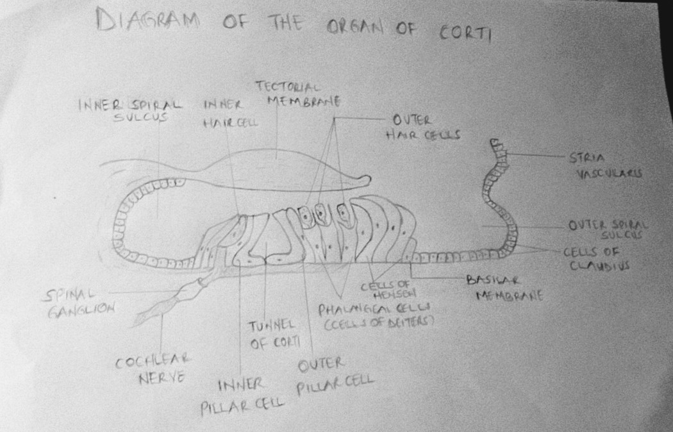s

