Green Grace Igbogi

18/mhs07/021

Pharmacology

200 level

Phs 212 Assignment

Question
Discuss the Somatosensory pathways

Somatosensory Pathway

A somatosensory pathway will typically have three neurons: primary, secondary, and tertiary. The cell bodies of the three neurons in a typical somatosensory pathway are located in the dorsal root ganglion, the spinal cord, and the thalamus. ... A major somatosensory pathway is the dorsal column–medial lemniscal pathway.
- Sensory receptors housed in the dorsal root ganglia project to secondary neurons of the spinal cord that decussate and project to the thalamus or cerebellum.
- Tertiary neurons project to the postcentral gyrus of the parietal lobe, forming a sensory homunculus.
- A sensory homunculus maps sub-regions of the cortical postcentral gyrus to certain parts of the body.

A somatosensory pathway will typically consist of three neurons: primary, secondary, and tertiary.
- In the periphery, the primary neuron is the sensory receptor that detects sensory stimuli like touch or temperature. The cell body of the primary neuron is housed in the dorsal root ganglion of a spinal nerve or, if sensation is in the head or neck, the ganglia of the trigeminal or cranial nerves.
- The secondary neuron acts as a relay and is located in either the spinal cord or the brainstem. This neuron’s ascending axons will cross, or decussate, to the opposite side of the spinal cord or brainstem and travel up the spinal cord to the brain, where most will terminate in either the thalamus or the cerebellum.
- Tertiary neurons have cell bodies in the thalamus and project to the postcentral gyrus of the parietal lobe, forming a sensory homunculus in the case of touch. Regarding posture, the tertiary neuron is located in the cerebellum.

Processing
The primary somatosensory area of the human cortex is located in the postcentral gyrus of the parietal lobe. The postcentral gyrus is the location of the primary somatosensory area, the area of the cortex dedicated to the processing of touch information. At this location there is a map of sensory space referred to as a sensory homunculus.
A cortical homunculus is the brain’s physical representation of the human body; it is a neurological map of the anatomical divisions of the body. The surface area of cortex dedicated to a body part correlates with the amount of somatosensory input from that area.
For example, there is a large area of cortex devoted to sensation in the hands, while the back requires a much smaller area. Somatosensory information involved with proprioception and posture is processed in the cerebellum.

Functions
The somatosensory system functions in the body’s periphery, spinal cord, and the brain.
- Periphery: Sensory receptors (i.e., thermoreceptors, mechanoreceptors, etc.) detect the various stimuli.
- Spinal cord: Afferent pathways in the spinal cord serve to pass information from the periphery and the rest of the body to the brain.
- Brain: The postcentral gyrus contains Brodmann areas (BA) 3a, 3b, 1, and 2 that make up the somatosensory cortex. BA3a is involved with the sense of relative position of neighboring body parts and the amount of effort being used during movement. BA3b is responsible for distributing somatosensory information to BA1 and shape and size information to BA2.

Tactile Sensation
Touch is sensed by mechanoreceptive neurons that respond to pressure in various ways.

A mechanoreceptor is a sensory receptor that responds to mechanical pressure or distortion. For instance, in the periodontal ligament, there are mechanoreceptors that allow the jaw to relax when biting down on hard objects; the mesencephalic nucleus is responsible for this reflex.
In the skin, there are four main types in glabrous (hairless) skin:
- Ruffini endings.
- Meissner’s corpuscles.
- Pacinian corpuscles.
- Merkel’s discs.
There are also mechanoreceptors in hairy skin. The hair cells in the cochlea are the most sensitive mechanoreceptors, transducing air pressure waves into nerve signals sent to the brain.

Cutaneous Mechanoreceptors
Cutaneous mechanoreceptors are located in the skin, like other cutaneous receptors. They provide the senses of touch, pressure, vibration, proprioception, and others. They are all innervated by Aβ fibers, except the mechanoreceiving free nerve endings, which are innervated by Aδ fibers.
They can be categorized by morphology, by the type of sensation they perceive, and by the rate of adaptation. Furthermore, each has a different receptive field:
- Ruffini’s end organs detect tension deep in the skin.
- Meissner’s corpuscles detect changes in texture (vibrations around 50 Hz) and adapt rapidly.
- Pacinian corpuscles detect rapid vibrations (about 200–300 Hz).
- Merkel’s discs detect sustained touch and pressure.
- Mechanoreceiving free nerve endings detect touch, pressure, and stretching.
- Hair follicle receptors are located in hair follicles and sense the position changes of hair strands.

Ruffini Ending
The Ruffini ending (Ruffini corpuscle or bulbous corpuscle) is a class of slowly adapting mechanoreceptors thought to exist only in the glabrous dermis and subcutaneous tissue of humans. It is named after Angelo Ruffini.
This spindle-shaped receptor is sensitive to skin stretch, and contributes to the kinesthetic sense of and control of finger position and movement. It is believed to be useful for monitoring the slippage of objects along the surface of the skin, allowing the modulation of grip on an object.
Ruffini endings are located in the deep layers of the skin. They register mechanical information within joints, more specifically angle change, with a specificity of up to two degrees, as well as continuous pressure states. They also act as thermoreceptors that respond for a long time, such as holding hands with someone during a walk. In a case of a deep burn to the body, there will be no pain as these receptors will be burned off.

Meissner’s Corpuscles
Meissner’s corpuscles (or tactile corpuscles) are responsible for sensitivity to light touch. In particular, they have the highest sensitivity (lowest threshold) when sensing vibrations lower than 50 hertz. They are rapidly adaptive receptors.

Pacinian Corpuscles
Pacinian corpuscles (or lamellar corpuscles) are responsible for sensitivity to vibration and pressure. The vibrational role may be used to detect surface texture, e.g., rough versus smooth.

Merkel Nerve
Merkel nerve endings are mechanoreceptors found in the skin and mucosa of vertebrates that provide touch information to the brain. The information they provide are those regarding pressure and texture. Each ending consists of a Merkel cell in close apposition with an enlarged nerve terminal.
This is sometimes referred to as a Merkel cell–neurite complex, or a Merkel disk receptor. A single afferent nerve fiber branches to innervate up to 90 such endings. They are classified as slowly adapting type I mechanoreceptors.

Proprioceptive Sensations
Proprioception refers to the sense of knowing how one’s body is positioned in three-dimensional space. Proprioception is the sense of the relative position of neighbouring parts of the body and the strength of effort being employed in movement. It is distinguished from exteroception, perception of the outside world, and interoception, perception of pain, hunger, and the movement of internal organs, etc.
The initiation of proprioception is the activation of a proprioreceptor in the periphery. The proprioceptive sense is believed to be composed of information from sensory neurons located in the inner ear (motion and orientation) and in the stretch receptors located in the muscles and the joint-supporting ligaments (stance).
Conscious proprioception is communicated by the posterior ( dorsal ) column–medial lemniscus pathway to the cerebrum. Unconscious proprioception is communicated primarily via the dorsal and ventral spinocerebellar tracts to the cerebellum.
An unconscious reaction is seen in the human proprioceptive reflex, or Law of Righting. In the event that the body tilts in any direction, the person will cock their head back to level the eyes against the horizon. This is seen even in infants as soon as they gain control of their neck muscles. This control comes from the cerebellum, the part of the brain that affects balance.
Muscle spindles are sensory receptors within the belly of a muscle that primarily detect changes in the length of a muscle. They convey length information to the central nervous system via sensory neurons. This information can be processed by the brain to determine the position of body parts. The responses of muscle spindles to changes in length also play an important role in regulating the contraction of muscles.
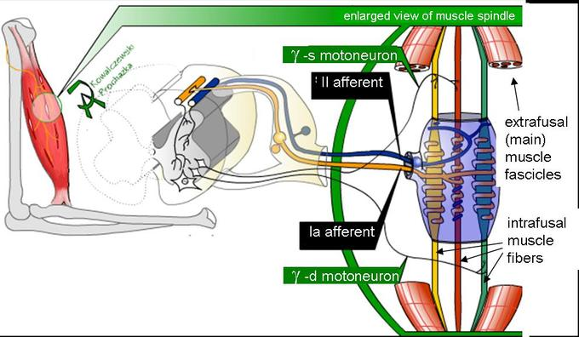
Muscle spindle: Mammalian muscle spindle showing typical position in a muscle (left), neuronal connections in spinal cord (middle), and expanded schematic (right). The spindle is a stretch receptor with its own motor supply consisting of several intrafusal muscle fibers. The sensory endings of a primary (group Ia) afferent and a secondary (group II) afferent coil around the non-contractile central portions of the intrafusal fibers.
The Golgi organ (also called Golgi tendon organ, tendon organ, neurotendinous organ or neurotendinous spindle) is a proprioceptive sensory receptor organ that is located at the insertion of skeletal muscle fibers onto the tendons of skeletal muscle. It provides the sensory component of the Golgi tendon reflex.
The Golgi organ should not be confused with the Golgi apparatus—an organelle in the eukaryotic cell —or the Golgi stain, which is a histologic stain for neuron cell bodies.
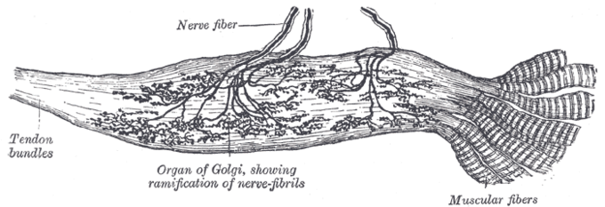
Golgi tendon organ: The Golgi tendon organ contributes to the Golgi tendon reflex and provides proprioceptive information about joint position.
The Golgi tendon reflex is a normal component of the reflex arc of the peripheral nervous system. In a Golgi tendon reflex, skeletal muscle contraction causes the agonist muscle to simultaneously lengthen and relax. This reflex is also called the inverse myotatic reflex, because it is the inverse of the stretch reflex.
Although muscle tension is increasing during the contraction, alpha motor neurons in the spinal cord that supply the muscle are inhibited. However, antagonistic muscles are activated.

Somatic Sensory Pathways
The somatosensory pathway is composed of three neurons located in the dorsal root ganglion, the spinal cord, and the thalamus. A somatosensory pathway will typically have three long neurons: primary, secondary, and tertiary. The first always has its cell body in the dorsal root ganglion of the spinal nerve.
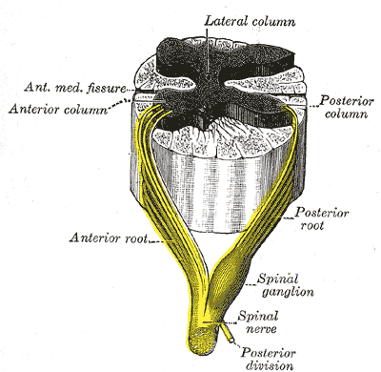
Dorsal root ganglion: Sensory nerves of a dorsal root ganglion are depicted entering the spinal cord.
The second has its cell body either in the spinal cord or in the brainstem; this neuron’s ascending axons will cross to the opposite side either in the spinal cord or in the brainstem. The axons of many of these neurons terminate in the thalamus, and others terminate in the reticular activating system or the cerebellum.
In the case of touch and certain types of pain, the third neuron has its cell body in the ventral posterior nucleus of the thalamus and ends in the postcentral gyrus of the parietal lobe.
In the periphery, the somatosensory system detects various stimuli by sensory receptors, such as by mechanoreceptors for tactile sensation and nociceptors for pain sensation. The sensory information (touch, pain, temperature, etc.,) is then conveyed to the central nervous system by afferent neurons, of which there are a number of different types with varying size, structure, and properties.
Generally, there is a correlation between the type of sensory modality detected and the type of afferent neuron involved. For example, slow, thin, unmyelinated neurons conduct pain whereas faster, thicker, myelinated neurons conduct casual touch.

