NAME: IHENSEKHIEN EBUNOLUWA PEARL MATRIC: 17/MHS01/151 DEPT: MEDICNE AND SURGERY (300L) COURSE: RENAL PHYSIOLOGY
- DESCRIBE THE PATHIOPHYSIOLOGY PROCESS OF RENAL FAILURE
When discussing the pathophysiology, renal structural and physiological characteristics, as well as the principles of renal tissue injury and repair should be taken into consideration.
Firstly, the rate of renal blood flow of approximately 400ml/100g of tissue per minute is much greater than that observed in other well perfused vascular beds such as heart, liver and brain. As a consequence, renal tissue might be exposed to a significantly quantity of any potentially harmful circulating agents or substances.
Second, glomerular filtration is dependent on rather high intra- and transglomerular pressure(even under physiologic conditions), rendering the glomerular capillaries vulnerable to hemodynamic injury, in contrast to other capillary beds. In line with this, Brenner and co workers indentified glomerular hypertension and hyperfiltration as major contributors to the progression of chronic renal failure.
Thirdly, glomerular filtration membrane has negatively charged molecules which serve as a barrier retarding aniomic macromolecules. With disruption in this electrostatic barrier, as is the case in many forms of glomerular injury, plasma protein gains access to the glomerular filtrate
Fourthly, the sequential organization of nephrons microvasculature (glomerular convolute and the peritubular capillary network) and the downstream position of the tubuli with respect to glomeruli, not only maintains the glomerulotubular injury to tubulointerstitial compartment in disease, exposing tubular epithelial cells to abnormal ultrafiltrate. As peritubular vasculature underlies glomerular circulation, some mediators of glomerular inflammatory reaction may overflow into the peritubular circulation contributing to the interstitial inflammatory reaction frequently recorded in glomerular disease. Moreover, any decrease in preglomerular or glomerular perfusion leads to decrease in peritubular blood flow, which, depending on the degree of hypoxia, entails tubulointersitial injury and tissue remodeling. Thus, the concept of the nephron as a functional unit applies not only to renal physiology, but also to the patophysiiology of renal failure.
In the fifth place, the glomerulus itself should also be regarded as a functional unit with each of its individual constituents, i.e. endothelial, mesangial, visceral and parietal epithelial cells- podocytes, and their extracellular matrix representing an integral part of the normal function. Damage to one will in part affect the other through different mechanisms, direct cell conncetions (e.g., gap junctions), soluble mediators such as chemokines, cytokines, growth factors and changes in matrix and basement membrane composition.
The main causes of renal injury are based on immunologic reactions9 initiated by immune complexes or immune cells), tissue hypoxia and ischaemia, exogenic agents like drugs, endogenous substances like glucose or paraproteins and others, genetic defects. Irresepective of the underlying cause glomerulosclerosis and tublointerstitial fibrosis are common to chronic renal failure.

- WITH AID OF DIAGRAM DESCRIBE THE TYPES OF DIALYSIS
Dialysis performs the function of the kidney if they’ve failed. According to the National kidney foundation, end-stage kidney failure occurs when the kidneys are performing at only 10-15% of their normal function. Dialysis is a treatment that filters and purifies the blood using a machine. This helps keep the fluids and electrolytes in balance when the kidney cant do their job. Dialysis has been used since 1940s to treat people with kidney problems.
Types
- Hemodialyis
This is the most common type of dialysis. This process uses an artificial kidney (hemodialyzer) to remove waste and extra fluid from the blood. The blood is removed from the body and filtered through the artificial kidney. The filtered blood is then returned to the body with the help of a dialysis machine. To get the blood to flow to the artificial kidney, the doctor performs surgery to create an entrance point (vascular access) into your blood vessels. There are 3 types of entrance points are:
Arteriovenous (AV) fistula: this type connects an artery and a vein. It’s the preferred option.
AV graft: this type is looped tube.
Vascular access catheter: this may be inserted into large vein in your neck.
Both the AV fistula and AV graft are designed for longterm dialysis treatments. People who receive AV fistulas are healed and ready to begin hemodialysis two or three months after their surgery. People who receive AV grafts are ready in 2 to 3 weeks. Catheters are designed for short term or temporary use. Hemodialysis treatments usually last 3 to 5 hours and are performed 3 times per week. However, hemodialysis treatment can also be completed in shorter, more frequent sessions. Most hemodialysis treatment are performed at a hospital, the length of treatmenmt usually depends on the body size, the amount of waste in the body, and the current state of health.
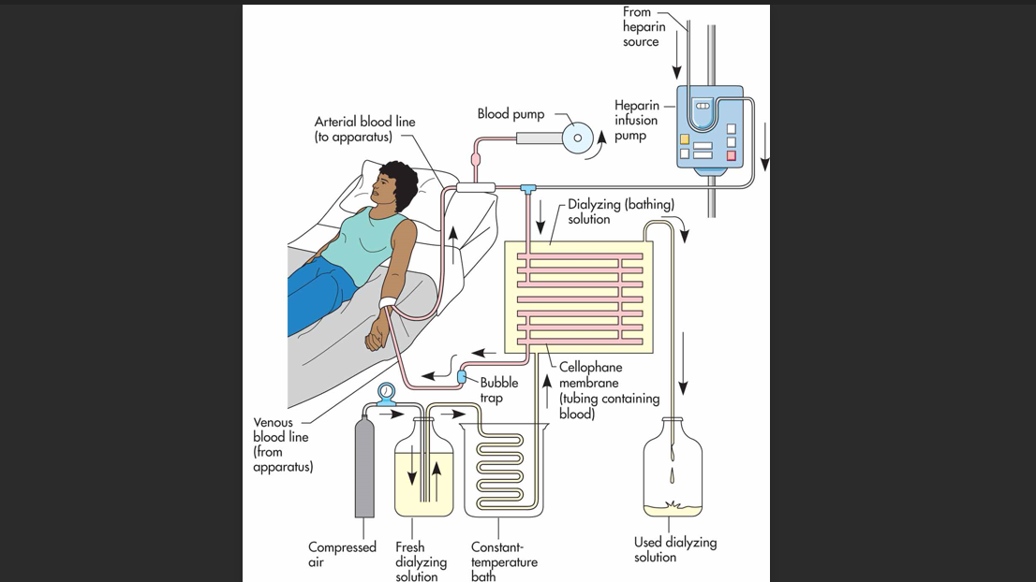

- Peritoneal Dialysis

It involves surgery to implant a peritoneal dialysis (PD) catheter into the abdomen. The catheter helps filter blood through the peritoneum. During treatment, a special fluid called dialysate flows into the peritoneum. The dialysate absorbs waste. Once the dialysate draws waste out of the bloodstream, its drained from your abdomen. This process takes a few hours and need to be repeated four six times per day. However, the exchange of fluids can be performed while the person sleeping or awake.There are different types of peritoneal dialysis. The main ones are;
Continuous ambulatory peritioneal dialysis (CAPD); in this, the abdomen is filled and drained multiple times a day. This method doesn’t require a machine and must be performed while awake
Continuous cycling peritoneal dialysis(CCPD); its uses a machine to cycle the fluid in and out of your abdomen. Its usually done at night while asleep.
Intermittent peritoneal dialysis (IPD); this treatment is usually performed in the hospital, though it may be performed at home. It uses the same machine as CCPD, but the process takes longer
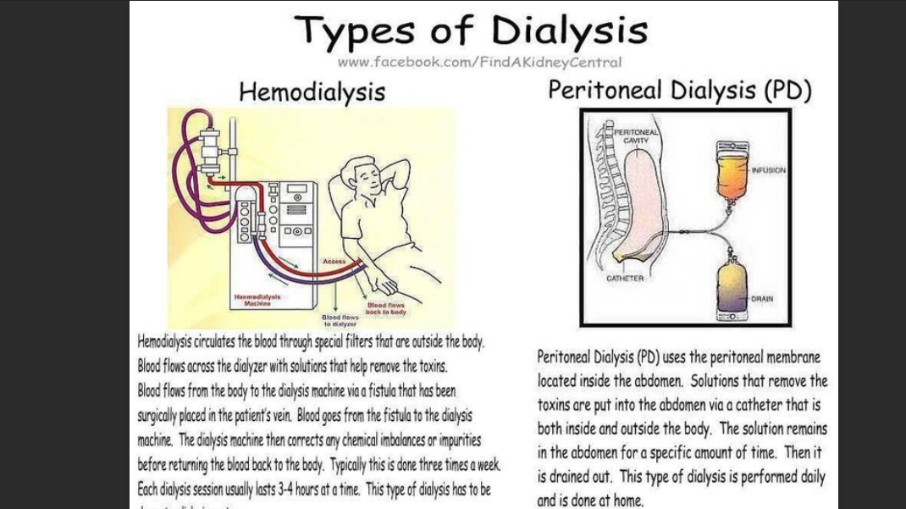

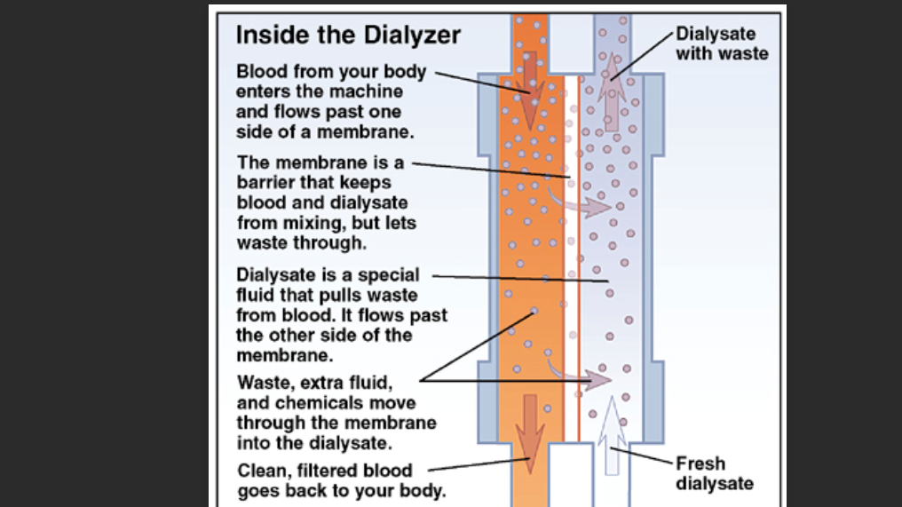

3.Continuous renal replacement therapy (CRRT)
This therapy is used primarily in the intensive care unit for people with acute kidney failure. Its also known as hemofiltration. A machine passes the blood through tubing. A filter then removes waste products and water. The blood is returned to the body, along with replacement fluid. This procedure is performed 12 to 24 hours a day

