NAME:PEARL EBUNOLUWA IHENSEKHIEN MATRIC: 17/MHS01/151 DEPT: MEDICINE AND SURGERY (300L) COURSE: NEURO HISTOLOGY ( SPECIAL SENSES ASSIGNMENT)
WITH THE AID OF A DIAGRAM, WRITE AN ESSAY ON THE HISTOLOGY OF AN ORGAN OF CORTI
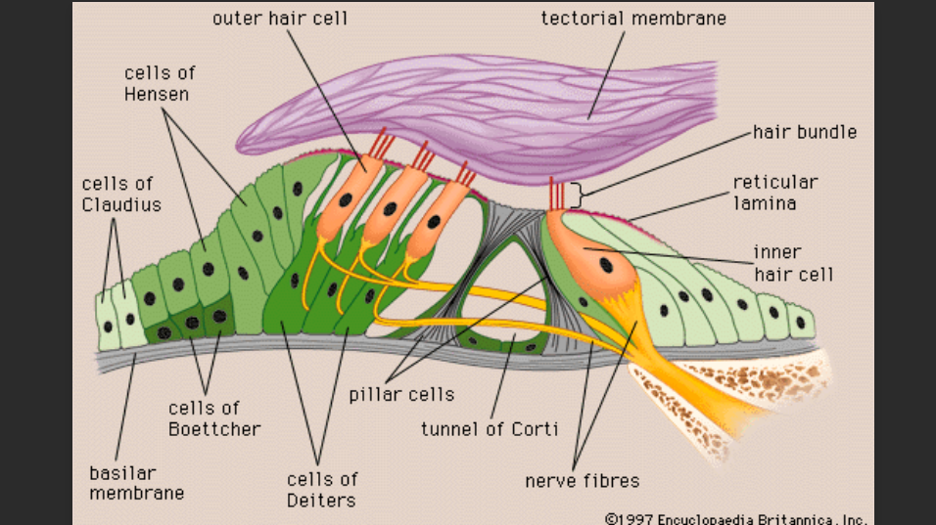

The organ of corti or spiral organ, where sound vibrations of different frequencies are detected, consists of hair cells and other epithelial structures supported by the basilar membrane. Here the sensory hair cells have precisely arranged V-shaped bundles of rigid stereocilia; each loses its single layer kinocilium during development. Two major types of hair cells are present:
- Outer hair cells, about 12,000 in total, occur in three rows near the saccule, increasing to five rows near the apex of the cochlea. Each columnar outer hair cell bears a V-shaped bundle of stereocilia
- Inner hair cells, are shorter and form a single row of about 3500 cells, each with a single more linear array of shorter stereocilia.
Both outer and inner hair cells have synaptic connections with afferent and efferent nerve ending, with the inner row of cells more heavily innervated. The cell bodies of the afferent bipolar neurons constitute the spiral ganglion located in the bony core of the modiolus. The two major types of columnar supporting cells are attached to the basilar membrane in the organ of corti.
Inner and outer phalangeal cells extend apical processes that intimately surround and support the basolateral parts of both inner and outer hair cells and the synaptic nerve ending. The apical ends of the phalangeal cells are joined to those of the hair cells by tight zonulae occluddens, forming an apical plate across the spiral organ through which the stereocilia bundles project into endolymph.
Pillar cells are stiffened by heavy bundles of keratin and outline a triangular space, the inner tunnel, between the outer and inner complexes of hair cells and phalangeal cells. The stiff inner tunnel also plays a role in sound transmission.
On the outer hair cells the tips of yhe tallest stereocilia are embedded in the gel-like tectorial membrane, an acellular layer that extends over the organ corti from the connective tissue around the modiolus. The tectorial membrane consists of fine bundles of collagen (type II,V,IX and XI) associated with proteoglycans and forms during the embryonic period from secretions of cells linning this region. By detecting minute movements of the stereocilia, hair cells in the spiral organ of corti act as mechanoelectrical transducers very much like those of the vestibular maculae described previously and mediate the sense of hearing. Sound waves collected by the external ear cause the tympanic membrane to vibrate, which moves the chain of middle ear ossicles and the oval window. The large size of the tympanic membrane compared to the oval window and the mechanical properties of the ossicle chain amplify the movements and allow optimal transfer of energy between air and perilymph, from sound waves to vibrations of the tissues and fluid-filled chambers.
Pressures waves within the perilymph begin at the oval window and move along the scala vestibule. Each pressure wave causes momentary displacement of the vestibular and /or basilar membranes and the endolymph surrounding the organ of corti. The width, rigidity, thickness, the outer physical properties of the basilar membranes and its organ of corti all vary in precise gradients along its length. This allows the region of maximal displacement to vary with the sound wave’s frequency, that is, the number of waves moving past a point per unit of time (measured in hertz) high frequency sounds displace the basilar membrane maximally near the oval window. Sounds of progressively lower frequency produce pressure waves that move farther along the scala vesibuli and displace the spiral organ at pounts farther from the oval window. The sounds of the lowest frequency that can be detected produce movement of the basilar membrane at the apex or helicotrema of the cochlea. After crossing the cochlear duct(scala media) and organ of corti, pressure waves are transferred to the scala tympani and exit the inner ear at the round window.
The main mechanoreceptors for the sense of hearing are the more heavily innervated inner hairs cells in the organ of corti. The outer hair cells, with their stereocilia tips embedded in the tectorial membrane, are depolarized when stereocilia are deformed, as described previously, for vestibular hair cells in the organ of corti, however, hair cell activities are more complex, allowing greater control on sensory reception. Depolarization of the outer hair cells causes these columnar cells to shorten very rapidly, an effect mediated by an unusual 80-KD transmembrane protein called prestin, abundant in the lateral cell membranes. Prestin undergoes voltage-dependent conformational change that affects the cytoskeleton, rapidly shortening the cells when the membrane is depolarized and elongating them again membrane hyperpolarization. Piston-like movements of the outer hair cells pull down the tectorial membrane against the stereocilia of the inner hair cells, causing depolarization of these cells which then send the signals to the brain for processing as sounds. This sequential role for outer and inner hair cells produces further cochlear amplification of the sound waves.

