Question.
- With the aid of a diagram, write an essay on the histology of an organ of Corti.

ANSWER.
- The organ of Corti is a specialized sensory epithelium that allows for the transduction of sound vibrations into neural signals. The organ of Corti itself is located on the basilar membrane. The organ of Corti rests on the basilar membrane and contains two types of hair cells: inner hair cells and outer hair cells. Inner hair cells transduce sound from vibrations to neural signals via the shearing action of their stereocilia. Outer hair cells serve a function as acoustic pre-amplifiers which improve frequency selectivity by allowing the organ of Corti to become attuned to specific frequencies, like those of speech or music. The fibrous tectorial membrane rests on top of the stereocilia or the outer hair cells. Mutations in a alpha-tectorin, which encodes a protein specific to the tectorial membrane, cause deafness.
Organ of Corti consists of different types of cells:
*Inner hair cells
*Outer hair cells
*Supporting cells

Inner Hair Cell
These cells are specialized in the mechanoelectrical transduction. There are almost 3500 cells disposed in one line along all the basilar membrane. They are connected to type I neuron peripheral fibers of spiral ganglion, these connection are very divergent (10/1). The luminal part of the cell is immerged in endolymph, the basal one is immerged in normal extracellular fluid. The luminal portion is formed by bundles of stereocilia(inner_ear), whose tips are connected by filamentous structures called tip-links.

Outer Hair Cell
These cells are acoustical pre-amplifiers. They are almost 12000, disposed in three parallel lines. These cells are connected to type II amyelinic neurons, the connections are very convergent. They have also an afference from superior olivary nucleus. They have contractile activity.

Supporting Cells
These cells are of four different types: Corti pillars, Hensen cells, Deiters cells and Claudius cells.

Endolymph
Endolymph fills the scala media and it is produced by stria vascularis.
Potassium secreted into the endolymph by the stria vascularis enters the hair cells through apical mechanosensitive channels. It is recycled back to the stria vascularis through supporting cells and fibrocytes of the spiral ligament for another round of secretion. Hair cells and stria vascularis are tied together in a "push-pull" or "pump-leak" balance that determines endocochlear potential (EP +85mV), endolymph composition and ultimately the sensivity and stability of hair cells and hearing over a lifetime.
The evolutionary strategy of using K receptors currents is due to the fact that it reduces metabolic requirements because it has a passive outflow from hair cells to the basal membrane, instead of active Na extrusion.
Endolymph has a particular ion concentration
Ion | Perilymph (mM) | Endolymph (mM)
Na | 154 | 1
K | 3 | 161
Cl | 128 | 131
There is a potential difference of -140 mV between endolymph and inner receptor.
A basolateral Na/K-ATPase pumps K and creates a Na gradient to drive K and Cl into the cell in a co-transport process. Chloride is recycled by basolateral Cl channels, and K is secreted apically by KCNQ1/KCNE1 K channels, which are open at the unusual apical membrane voltage of marginal cells (inside positive by about +10 mV). This allows for a net secretion into the endolymph in spite of its high K concentration.
KCNQ proteins have six transmembrane domains and a pore-forming P-loop. Mutations on KCNQ1 and KCNQ4 lead to deafness. Indeed KCNQ4 was mapped to human chromosome 1p34; it is one of over 30 loci for dominant deafness.
Hypoxia reduces endocochlear potential, due to a drop in metabolism and strial current; whereas a depletion of vascular K does not drop EP, showing that K comes from spiral ligament rather than from blood.

Clinical Significance.

Hearing loss
The organ of Corti can be damaged by excessive sound levels, leading to noise-induced impairment.
The most common kind of hearing impairment, sensorineural hearing loss, includes as one major cause the reduction of function in the organ of Corti. Specifically, the active amplification function of the outer hair cells is very sensitive to damage from exposure to trauma from overly-loud sounds or to certain ototoxic drugs. Once outer hair cells are damaged, they do not regenerate, and the result is a loss of sensitivity and an abnormally large growth of loudness (known as recruitment) in the part of the spectrum that the damaged cells serve.
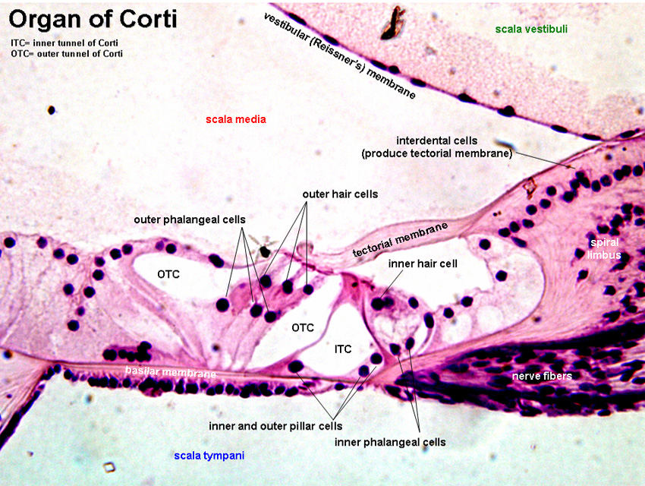
DIAGRAM OF THE ORGAN OF CORTI.

