NAME: NZEOCHA CHIAMAKA CATHERINE
DEPARTMENT: MEDICINE AND SURGERY
MATRIC NUMBER: 17/MHS01/216
COURSE CODE: ANA 305
COURSE TITLE: HISTOLOGY OF SPECIAL SENSES AND NEUROHISTOLOGY
QUESTION
With the aid of a diagram, write an essay on the histology of the organ of corti.

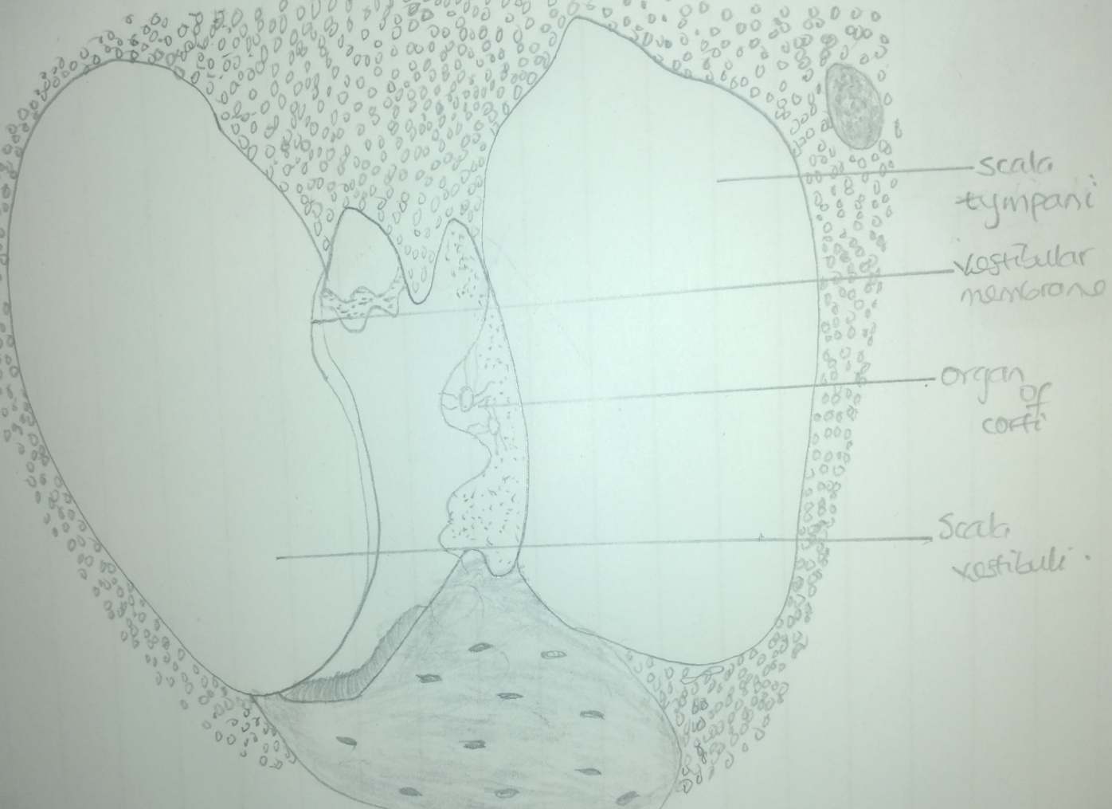
The organ of corti is also known as the spiral organ. It is the receptor organ for hearing and is located in the mammalian cochlea. The organ of corti is a highly varied strip of epithelial cells that allows for transduction of auditory signals into nerve impulses action potential. The transduction occurs through vibrations of structures in the inner ear causing displacement of cochlear fluid and movement of hair cells at the organ of corti to produce electrochemical signals.
The organ of corti is located in the scala media of the cochlea of the inner ear between the vestibular duct and the tympanic duct and is composed of mechanosensory cells also known as hair cells. It is also composed of a basilar membrane where, the hair cells are situated, containing three rows of outer hair cells and one row of inner hair cells. The hair cells are separated and supported by supporting cells called Deiters cell. There are some projections at the top of the hair cells, they are tiny fingerlike projections called stereocilia. They are arranged in a graduated fashion, with the shortest stereocilia on the outer rows and the longest at the center. This graduation being an important anatomic feature of the organ of corti allows the sensory cells to exhibit superior tuning capability.
The function of the organ of corti is mainly to change auditory signals and minimize the hair cells extraction of sound energy.

