ADEBARA FAITH INUMIDUN
17/SCI05/001
MEDICINE AND SURGERY
300 LEVEL
2019/2020

ASSIGNMENT TITLE: HISTOLOGY OF THE EAR
COURSE TITLE: HISTOLOGY OF SPECIAL SENSES AND NEUROHISTOLOGY
COURSE CODE: ANA 305

QUESTION:
With the aid of a diagram, write an essay on the histology of an organ of corti.

THE HISTOLOGY OF AN ORGAN OF CORTI
The ears serve as a vestibuloauditory system. Its tissues mediate the sense of equilibrium and hearing.
Anatomically speaking, the ear is made up of three main parts: -
- The external ear, which receives sound waves from the air
- The middle ear, in which sound waves are transmitted from air to fluids of the internal ear via a set of small bones
- The internal ear, in which these fluid movements are transduced to nerve impulses that pass via the acoustic nerve to the central nervous system. In addition to the auditory organ, or the cochlear, the internal ear also contains the vestibular organ that provides information to the brain regarding the position and movements of the head, thereby allowing the body to maintain equilibrium.

THE INNER EAR
The inner ear is in the form of a complex system of cavities, and is completely embedded within the petrous part of the temporal bone. Because of the complex shape of these intercommunicating cavities, the internal ear is also called the labyrinth.
The space bounded by bone is bony labyrinth and it houses the membranous labyrinth. The wall of the bony labyrinth is made up of bones that is denser than the surrounding bone; its inner surface is lined by periosteum. The wall of the membranous labyrinth is trilaminar – its outer layer is fibrous and is covered with peri-lymphatic cells; its middle layer is vascular; and the inner layer is composed of squamous or cuboidal epithelium. The space within the membranous labyrinth is filled by a fluid called the endolymph and the space between the membranous and bony labyrinth is filled by another fluid called the perilymph. These two fluids do not communicate with each other. Their separation and ionic differences are important for inner ear function. The perilymph has an ionic concentration similar to that of the extracellular fluid but contains little protein while the endolymph is characterized by high potassium ion and low sodium ion content, similar to that of cytosol.
The membranous labyrinth has 3 major divisions: -
- Two connected sacs called the utricle and the saccule
- The semicircular ducts continuous with the utricle
- The cochlear duct, which provides for hearing and is continuous with the saccule.
Each of these structures contain in its epithelial lining large areas with columnar mechanoreceptor cells, called hair cells, in specialized sensory regions, which are
- Two maculae of the utricule and saccule
- Three cristae ampullares in the enlarged ampullary regions of each semicircular duct
- The long spiral organ of corti in the cochlear duct
The entire membranous labyrinth is within the bony labyrinth, which includes the following regions:
- A central part called the vestibule (L. vestibulum, area for entering). It is an irregular cavity and houses the saccule ad utricle
- The vestibule is continuous posteriorly with three osseous semicircular canals. They enclose the semicircular ducts
- The vestibule is continuous anteriorly with the cochlea. It contains the cochlear duct.
The structures of the inner ear are designed to convert the mechanical energy transmitted in the form of waves into neuronal impulses (transduction) that can be interpreted as sound. Likewise, the inner ear also plays pivotal role in maintain postural balance and visual focus on a single object.

THE COCHLEA
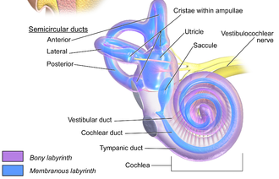
The cochlea is a spiraled, hollow, conical chamber of bone, in which waves propagate from the base (near the middle ear and oval window) to the apex (the top or center of the spiral).
The name cochlea derives form Greek word ‘cochlos’ meaning spiral or snail shaped.
The cochlea is the part of the inner ear involved in hearing. It is about 35mm long. It is thickest at the base (near the oval window) and gradually becomes thinner with each coil until it terminates centrally at the cochlear capula. The cochlear canal is covered by endosteum. It also communicates with the middle ear via the round window, which in life is covered by the secondary tympanic membrane.
The cochlear coils for about two and three-fourth turns around a bony core called the modiolus. This modiolus contains blood vessels and surrounds the cell bodies of the acoustic branch of the eight cranial nerve (vestibulocochlear nerve) in the large spiral or cochlear ganglion.
A thin, delicate bony ledge, called the spiral lamina, projects from the modiolus into the cochlear canal. This bony protection partially divides the cochlear canal into two parts.

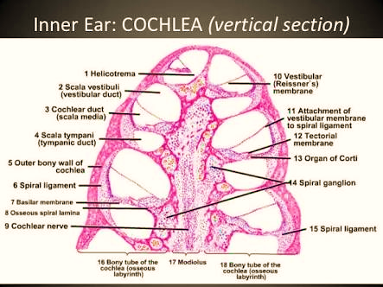

The cochlear canal is divided into 3 chambers or scalae
- Scala vestibuli (or vesticular duct)
- Scala media (or cochlear duct)
- Scala tympani (or tympanic duct)

SV= scala vestibuli
B= basilar membrane
STV= stria vascularis
CD= cochlear duct
SO= spiral organ
ST= scala tympani
SG= spiral ganglion

- The Scala media (or cochlear duct) forms the middle compartment. It is filled with endolymph that the stereocilia of the hair cells project into. It is a triangular space between the basilar and vestibular membranes. The cochlear duct is continuous with the saccule and ends at the apex of the cochlear. This duct represents the membranous labyrinth of the cochlear.
- The scala vestibuli (or vestibular duct) is larger than the cochlear duct, it is the part above the cochlear duct and vestibular membrane. When traced posteriorly, it becomes continuous with the vestibule. At the apex of the cochlea, it becomes continuous with the tympanic duct. The vestibular duct contains perilymph.
- The Scala tympani (or tympanic duct) also contains perilymph. It lies inferior to the cochlear duct and basilar membrane. When traced posteriorly, the tympanic duct reaches the round window.
Separating the cochlear duct from the vestibular duct is the very thin Reissner’s membrane (or vestibular membrane), which is lined on each side by simple squamous epithelium. Extensive tight junctions occur within between cells of this membrane to block ion diffusion between the perilymph and endolymph.
The tympanic duct is separated from the cochlear duct mainly by the fibroelastic basilar membrane. The basilar membrane determines the mechanical wave propagation properties of the cochlea partition.
The vestibular and tympanic ducts communicate with each other at the apex of the cochlea via small opening called helicotrema. This continuation at the helicotrema allows fluid being pushed into the vestibular duct by the oval window to exit via movement in the tympanic duct and deflection of the round window. Since the fluid is nearly incompressible and the bony walls are rigid, it is essential for the conserved fluid volume to exit somewhere.
THE COCHLEAR DUCT
The cochlear duct is a part of the membranous labyrinth shaped as a spiral tube. It contains the hair cells and other structures that allow auditory function, such as the spiral organ of Corti.
The cochlear duct is bounded on 3 sides by the Basilar membrane, Reissner’s membrane, and the Stria vascularis. The Stria vascularis is a specialized epithelium located on the lateral wall of the cochlear duct. The region is called because it is the only epithelium in the body that has capillaries within the thickness of the epithelium. Th epithelium of the Stria vascularis is stratified, having 3 layers of cells, and It produces the endolymph that fills the cochlear duct.
THE SPIRAL ORGAN OF CORTI

The spiral organ od Corti is the specialized end organ in the membranous labyrinth of the cochlear, the cochlear duct. It is so called because (like other structures in the cochlea) it extends in a spiral manner through the turns of the cochlea.
The organ of Corti is where sound vibrations of different frequencies are detected.
In sections it is seen to be placed on the basilar membrane and to be made up of epithelial cells that are arranged in a complicated manner. The cells are divisible into the true receptor cells or hair cells, and supporting cells which are given different names depending on their location.
The organ of Corti consists of the following structures
- Basilar membrane
- True receptor cells or hair cells
- Other epithelial structures such as the Phalangeal cells (of Dieter), Pillar cells, Cells of Hensen, Cells of Claudius.
- The tectorial membrane or membrana tentoria
- Tunnel of Corti / Inner tunnel / Cuniculum internum
- A narrow space called the Cuniculum externum
- A third space called the Cuniculum medium

BASILAR MEMBRANE
It serves as the basement membrane of which the organ of Corti is placed.

THE TRUE RECEPTOR CELLS OR HAIR CELLS
They are columnar or piriform mechanoreceptor cells. The hair cells are so called because of the presence of stereocilia at their apical ends.
The sensory hair cells in the organ of Corti have precisely arranged ‘V’ shaped bundles of rigid stereocilia. Each hair cell loses its single larger kinocilium during development.
Two major types of hair cells are present:
- Outer hair cells
- Inner hair cells
General characteristics of the hair cells
The hair cells are distinctively shorter than rod cells.
Both the outer and inner hair cells have synaptic connections with afferent and efferent nerve endings, with the inner row of cells more highly innervated. The cell bodies of the afferent bipolar neurons constate the spiral ganglion located in the bony core of the modiolus.
The apical surface of each hair cell is thickened to form a cuticular plate the edges of which are attached to neighboring cells.
With the EM the ‘hair’ of hair cells is seen to be similar to microvilli. Each hair has a covering of plasma membrane within which there is a core of microfilaments. Each hair is cylindrical over most of its length, but it is much narrowed at its base. The hair can, therefore, bend easily at this site.
The hair on each hair cell are arranged in a definite manner. When viewed from ‘above’ they are seen to be arranged in the form of the letter ‘V’ or ‘U’.
Each limb of the ‘V’ has three rows of hairs. The hairs in the three rows are of unequal height being tallest in the ‘outer’ row, intermediate in the middle row, and shortest in the ‘inner’ row.
The ‘V’ formed by the hairs of various hair cells are all in alignment, the apex of the ‘V’ pointing towards the ‘outer’ wall of the cochlear canal. At the point corresponding to the apex of the ‘V’ there is a centriole lying just under the apical cell membrane, but a true kinocilium is not present (unlike hair cells of ampullary crests).

Differences between the outer and inner hair cells
The outer hair cells are about 12,000 in total and the inner hair cells are about 3,500.
The outer hair cells occur in three rows near the saccule, increasing to five rows near the apex of the cochlea; while inner hair cells form a single row.
The inner hair cells are piriform and relatively short while the outer hair cells are cylindrical and longer.
The lower end of each outer hair cell fits into a depression on the upper end of a phalangeal cell; but the inner hair cells do not have such a relationship.
The ‘hair’ of the outer hair cells is somewhat longer and more slender than those on inner hair cells.
The cells of the inner hair cells have a more linear array of shorter stereocilia giving it a look of a shallow ‘U’ rather than a ‘V’ as seen in the outer hair cells.
In all hair cells, the apex of the ‘V’ (formed by the rows of hair) points towards the ‘outer’ wall of the cochlear canal (i.e., away from the modiolus). The direction of the ‘V’ is sometimes described in relation to the tunnel of Corti. In the inner hair cells, the ‘V’ points towards the tunnel, while in the case of the outer hair cells, it points away from the tunnel. The direction of the ‘V’ is of functional importance. Like hair cells of the maculae and cristae, those of the cochlea are polarized. Bending of stereocilia towards the apex of the ‘V’ causes depolarisation, while the reverse causes hyperpolarisation. Ionic gradients associated with depolarisation and hyperpolarisation are maintained because apices of hair cells and surrounding cells are tightly sealed by occluding junctions.
The inner hair cells provide the main neural output of the cochlea. The outer hair cells, instead, mainly receive neural input from the brain, which influences their motility as part of the cochlea's mechanical pre-amplifier. The input to the Outer hair cell is from the olivary body via the medial olivocochlear bundle.
OTHER EPITHELIAL STRUCTURES
- Rod cells/Pillar cells
Each rod cell (or pillar cell) has a broad base (or foot plate, or crus) that rests on the basilar membrane; an elongated middle part (rod or scapus); and an expanded upper end called the head or caput.
The bases of the rod cells are greatly expanded and contain their nuclei. The bases of the inner and outer rod cells meet each other forming the base of the tunnel of Corti.
The heads of these cells also meet at the apex of the tunnel. Here, a convex prominence on the head of the outer rod cell fits into a concavity on the head of the inner rod cell. The uppermost parts of the heads are expanded into horizontal plates called the phalangeal processes. These processes join similar processes of neighbouring cells to form a continuous membrane called the reticular lamina.
The pillar cells are stiffened by heavy bundles of keratin.
- Phalangeal cells
The inner and outer phalangeal cells extend apical processes that intimately surround and support the basolateral parts of both the inner and outer hair cells ad the synaptic nerve endings.
The apical ends of phalangeal cells are joined to those of the hair cells by tight zonulae occludens, forming an apical plate across the spiral organ of Corti, through which the stereocilia bundles project into the endolymph.
The outer phalangeal cells support the outer hair cells. They lie lateral to the outer rod cells. Their bases rest on the basilar membrane and a greater part of the apex forms a cup-like depression into which the base of an outer hair cell fits.

- Cells of Hensen
To the outer side of the outer hair cells and the phalangeal cells, there are tall supporting cells (cells of Hensen).

- Cells of Claudius
Still more externally, the outer spiral sulcus is lined by cubical cells (cells of Claudius).

THE TECTORIAL MEMBRANE/MEMBRANA TENTORIA
The cells of the spiral organ are covered from above by a gelatinous mass called the membrana tectoria or tectorial membrane.
The tectorial membrane is an acellular layer that extends over the organ of Corti from the connective tissue around the modiolus.
It consists of fine bundles of collagen (type II, V, IX and XI) associated with proteoglycans and forms during the embryonic period from secretion of cells lining this region.
TUNNEL OF CORTI/INNER TUNNEL/CUNICULUM INTERNUM
The cells of the spiral organ enclose a triangular cavity called the tunnel of Corti (or Cuniculum internum). The tunnel of Corti is a triangular space between the outer and inner complexes of hair cells and phalangeal cells.
The base of the tunnel lies over the basilar membrane.
It has a sloping inner wall that is formed by inner rod cells; and a sloping outer wall that is formed by outer rod cells.
CUNICULUM EXTERNUM
A narrow space the Cuniculum externum intervenes between the outermost hair cells and the cells of Hensen.

CUNICULUM MEDIUM
A third space, the Cuniculum medium (or space of Nuel) lies between the outer rod cell and the outer hair cells.
The spaces are filled with perilymph (or cortilymph).

MECHANISM OF HEARING
By detecting minute movements of the stereocilia, hair cells in the spiral organ of Corti act as mechanoelectrical transducers and mediate the sense of hearing.
The cochlea is filled with a watery liquid, the endolymph, which moves in response to the vibrations coming from the middle ear via the oval window. As the fluid moves, the cochlear partition (basilar membrane and organ of Corti) moves; thousands of hair cells sense the motion via their stereocilia, and convert that motion to electrical signals that are communicated via neurotransmitters to many thousands of nerve cells. These primary auditory neurons transform the signals into electrochemical impulses known as action potentials, which travel along the auditory nerve to structures in the brainstem for further processing.

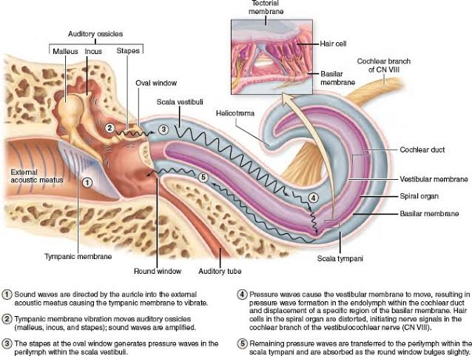

- Sound waves travelling through air are collected by the external ear. They pass into the external acoustic meatus (ear canal) and cause the tympanic membrane (ear drum) to vibrate.
- Tympanic membrane vibration moves the auditory ossicles.
- The stapes (stirrup) ossicle bone of the middle ear generates pressure waves in the perilymph within the vestibular duct. The stapes transmits the vibrations to the oval window, which vibrates the perilymph in the vestibular duct. The larger size of the tympanic membrane compared to the oval window and the mechanical properties of the ossicle chain amplify the movements and allow optimal transfer of energy between air and perilymph, from sound waves to vibrations of the tissues and fluid-filled chambers.
- Pressure waves cause the vestibular membrane to move, resulting in pressure wave formation in the endolymph within the cochlear duct and displacement of a specific region of the basilar membrane.
- The organ of corti vibrates, due to outer hair cells, further amplifying the vibrations. Inner hair cells are then displaced by the vibrations in the fluid, and depolarize by an influx of potassium ions via their tip-link connected channels. The distortion of the hair cells initiates a nerve signal in the cochlear branch of the eight cranial nerve (vestibulocochlear nerve).
- The width, rigidity, thickness, degree of stiffness and other physical properties of the basilar membrane and its organ of Corti all vary in precise gradient along its length. This allows the region of maximal displacement to vary with the sound waves’ frequency, that is, the number if waves moving past a point per unit time (measured in Hertz, Hz).
- The basilar membrane is stiffest nearest its beginning at the oval window, where the stapes introduces the vibrations coming from the tympanic membrane. Since its stiffness is high there, it only high frequency vibrations to move the basilar membrane and thus the hair cells.
- The farther a wave travels towards the cochlea's apex (the helicotrema), the less stiff the basilar membrane is; thus lower frequencies travel down the tube, and the less-stiff membrane is moved most easily by them where the reduced stiffness allows: that is, as the basilar membrane gets less and less stiff, waves slow down and it responds better to lower frequencies. So, sounds of progressively lower frequency produce pressure waves that move farther along the vestibular duct and displace the spiral organ at a point farther from the oval window.
In addition, in mammals, the cochlea is coiled, which has been shown to enhance low-frequency vibrations as they travel through the fluid-filled coil. This spatial arrangement of sound reception is referred to as tonotopy.
- For very low frequencies (below 20 Hz), the waves propagate along the complete route of the cochlea all the way to the helicotrema. Very low frequencies that can be detected produce movement of the basilar membrane at the apex or helicotrema of the cochlea. Frequencies this low still activate the organ of Corti to some extent but are too low to elicit the perception of a pitch.
Higher frequencies do not propagate to the helicotrema, due to the stiffness-mediated tonotopy.
- After crossing the cochlear duct and spiral organ at these various points, pressure waves are transferred to the tympanic duct and exit the inner ear at the round window.
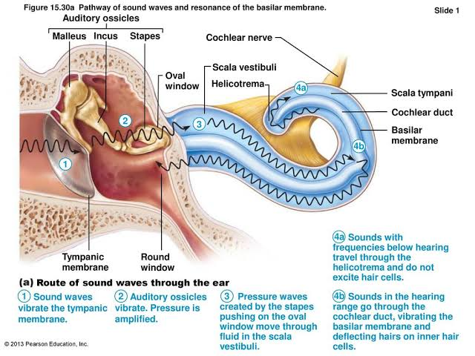
The true receptors for the sense of hearing are the more heavily innervated inner hair cells of the cochlea's spiral organ. The outer hair cells, with the ends of their stereocilia embedded in the tectorial membrane, are depolarized when these mechanotransducers are deflected. Depolarization of the outer hair cells very rapidly produces a slight shortening of these columnar cells, which is mediated by an unusual transmembrane protein called prestin (It. presto, very fast) abundant in the lateral cell membranes. Prestin undergoes a voltage-dependent conformational change which affects the cytoskeleton, with the cells rapidly becoming shorter when the membrane is depolarized and elongating with membrane hyperpolarization. Piston-like movements of the outer hair cells produce vibrations of the tectorial membrane against the stereocilia of the nearby inner hair cells, amplifying the signals that these cells then send to the CNS for processing as sounds.

CLINICAL ANATOMY
- DEAFNESS
Deafness can result from many factors, which usually fall into two categories:
- Conductive hearing loss involves various problems in the middle ear which can reduce conduction of vibrations by the chain of ossicles from the tympanic membrane to the oval window. A common example is otosclerosis, in which scar-like lesions develop on the bony labyrinth near the stapes which inhibit its movement of the oval window. Infection of the middle ear (otitis media) is common in young children, usually progressing from an upper respiratory infection, and can reduce sound conduction due to fluid accumulation in that cavity.
- Sensorineural deafness can be congenital or acquired and due to defects in any structure or cell from the cochlea to auditory centers of the brain, but commonly involves loss of hair cells or nerve degeneration.

- COCHLEAR IMPLANTS
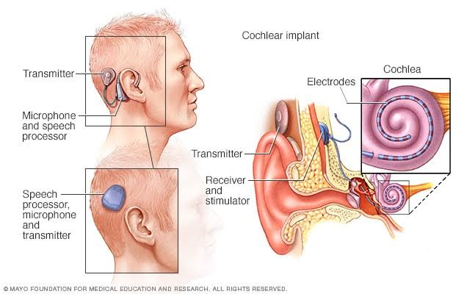
Some hearing loss patients e.g. some types of sensorineural deafness can be helped by cochlear implants. These consist of a small device worn behind the ear which contains a microphone, a speech processor to filter extraneous sounds, and a transmitter that sends electrical impulses to a receiver implanted under the skin of that region. The receiver is connected to a small cable with many electrodes. The cable is inserted into the internal ear and threaded into the Scala tympani along the wall containing branches of the cochlear nerve.
Sounds of various frequencies transmit signals to a receiver implanted in the bone of the skull and attached to the array of electrodes that stimulate nerve branches appropriate for those frequencies. The electrical signals are sent to the brain where they are interpreted as sounds.
Cochlear implants do not restore normal hearing but can provide the deaf patient with a usable range of sounds that allows understanding of speech and the potential for direct participation in speech.
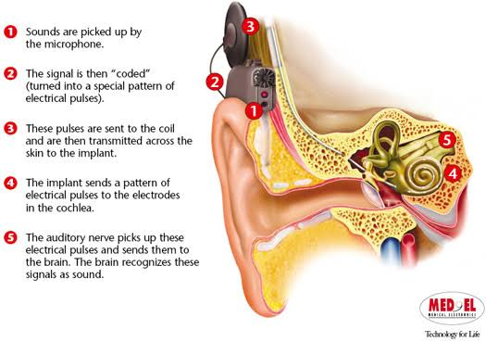

- A very strong movement of the basilar membrane due to very loud noise may cause hair cells to die. This is a common cause of partial hearing loss and is the reason why users of firearms or heavy machinery often wear earmuffs or earplugs.

- Otoacoustic emissions are due to a wave exiting the cochlea via the oval window, and propagating back through the middle ear to the eardrum, and out the ear canal, where it can be picked up by a microphone. Otoacoustic emissions are important in some types of tests for hearing impairment, since they are present when the cochlea is working well, and less so when it is suffering from loss of outer hair cells activity.

