IMOUKHUEDE LOVE EHIMWENMA
17/MHS01/158

ORGAN OF CORTI

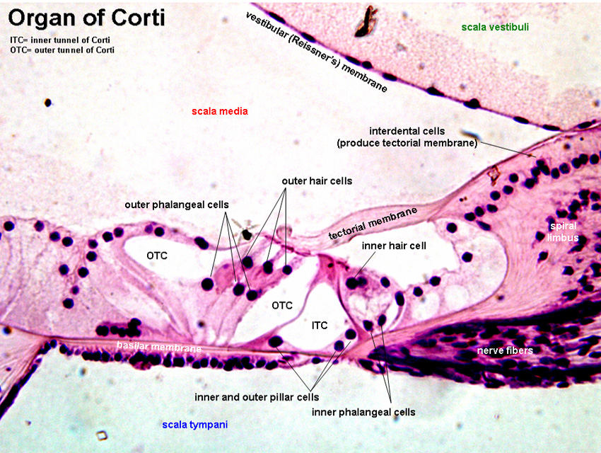
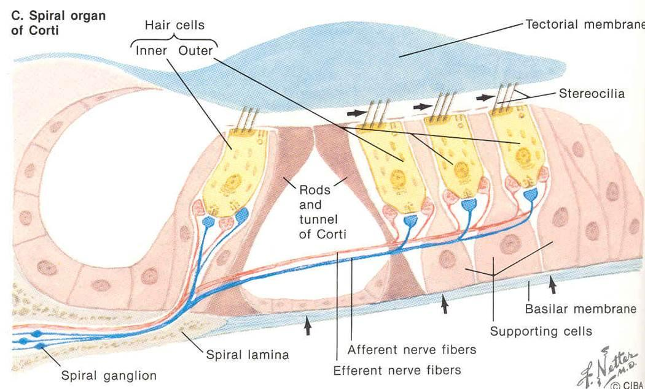

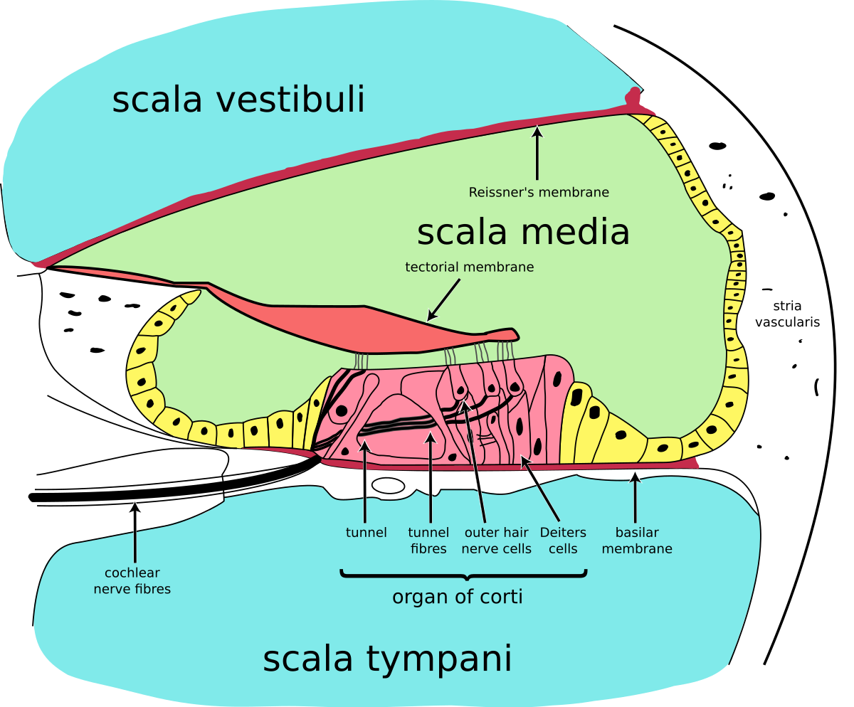

The organ of Corti, or spiral organ, is the receptor organ for hearing and is located in the mammalian cochlea. This highly varied strip of epithelial cells allows for transduction of auditory signals into nerve impulses' action potential. The organ of Corti itself is located on the basilar membrane. The organ of Corti rests on the basilar membrane and contains two types of hair cells: inner hair cells and outer hair cells. Inner hair cells transduce sound from vibrations to neural signals via the shearing action of their stereocilia. Outer hair cells serve a function as acoustic pre-amplifiers which improve frequency selectivity by allowing the organ of Corti to become attuned to specific frequencies, like those of speech or music.

Clinical significance
Hearing loss
The organ of Corti can be damaged by excessive sound levels, leading to noise-induced impairment. The most common kind of hearing impairment, sensorineural hearing loss, includes as one major cause the reduction of function in the organ of Corti. Specifically, the active amplification function of the outer hair cells is very sensitive to damage from exposure to trauma from overly-loud sounds or to certain ototoxic drugs. Once outer hair cells are damaged, they do not regenerate, and the result is a loss of sensitivity and an abnormally large growth of loudness in the part of the spectrum that the damaged cells serve.

