NAME: IDOWU ABIGAIL OLUMIDE
COURSE: ANA 305
LEVEL: 300L
MATRIC NO: 17/MHS01/147
DEPT: MBBS
COLLEGE : MHS
ASSIGNMENT
With the aid of a diagram, write an essay on the histology of an organ of corti
ANSWER

Organ of Corti

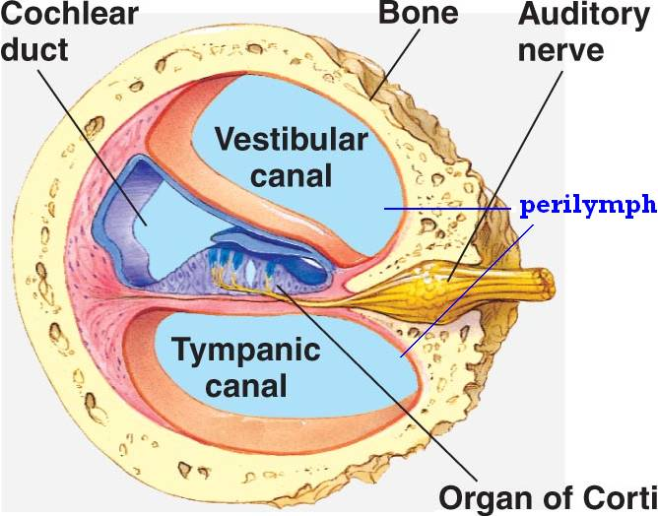

DEFINITION
The Organ of Corti is a part of the cochlea and it mediates the sense of hearing transducing pressure waves to action potentials. This structure is localized in the scala media and it is formed by a series of hair cells, nervous terminations of spiral ganglion and supporting cells.The organ of Corti is a specialized sensory epithelium that allows for the transduction of sound vibrations into neural signals. The organ of Corti itself is located on the basilar membrane. The organ of Corti rests on the basilar membrane and contains different types of hair cells:
i.Inner hair cells
ii. Outer hair cells.
iii. Supporting cells
- Inner hair cells; transduce sound from vibrations to neural signals via the shearing action of their stereocilia.
- Outer hair cells serve a function as acoustic pre-amplifiers which improve frequency selectivity by allowing the organ of Corti to become attuned to specific frequencies, like those of speech or music. The fibrous tectorial membrane rests on top of the stereocilia or the outer hair cells. Mutations in a alpha-tectorin, which encodes a protein specific to the tectorial membrane, cause deafness.
- Supporting cells ;These cells are of four different types: Corti pillars, Hensen cells, Deiters cells and Claudius cells.

GROSS ANATOMY
The scala media, or cochlear duct, is located between scala tympani and scala vestibuli and it is filled with endolymph. This structure is delimited by the basilar membrane and Reissner’s membrane. The Organ of Corti covers the basilar membrane and it is under the tectorial membrane, an acellular gel into which hair cell stereocilia are immersed. The peripheral process of acoustic nerve fibers provides synaptic connections between hair cells and cochlear nucleus.
The upper portion of the cochlear duct is formed by the stria vascularis, which contains numerous capillary loops and small blood vessels and produces endolymph.

Hair Cells : Hair cells get their name from the long stereocilia that extend from their surface toward the tectorial membrane. We recall that immobile stereocilia are actually more closely related to microvilli than they are to cilia, which is motile. When vibrations cause the movement of perilymph and endolymph in the cochlea, the hair cells move relative to the tectorial membrane and either depolarize or hyperpolarize (depending upon the direction of their movement). This change in electric potential is transmitted to the sensory nerves that synapse with the hair cells.

SENSE OF HEARING : The role of the sense of hearing is translating pressure waves of perilymph and endolymph to electrical signal and acoustic sensation.

Endolymph : Endolymph fills the scala media and it is produced by stria vascularis. Endolymph has a particular ion concentration

ABNORMALITIES
1. Deafness: is a partial or total inability to hear.
2. AHL is the age-related hearing loss, also known as presbycusis. Many K channels, like KCNQ1, were found to be down-regulated in stria vascularis with aging. Moreover a reduced KCNQ4 current may lead to a slow degenerative process. Although in some cases the EP is maintained and this is a paradoxical phenomenon, it would appear that this is attributable to the SV which may generate a much lower current to establish a new balance for potassium influx and efflux at a relatively lower level. It is not clear if an atrophied stria vascularis could recover sufficient function by up-regulating these potassium transporters expression to maintain a normal endocochlear potential.

