NAME: OGWUEGBU U. CHARLES
MATRICULATION NUMBER: 17/MHS03/025
DEPARTMENT: MBBS
COURSE: HISTOLOGY OF SPECIAL SENSES AND NEUROHISTOLOGY
COURSE CODE: ANA305
ASSIGNMENT
With the aid of a diagram, write an essay on the histology of an organ of Corti
ANSWER
ORGAN OF CORTI
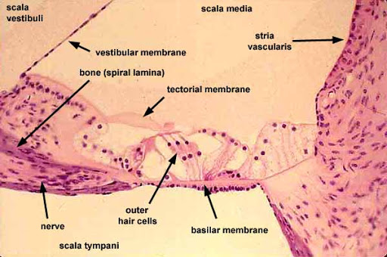
The organ of corti is also known as SPIRAL ORGAN. It is the receptor for hearing, evolving from the basilar papillae, lying on the basement membrane. It is located in the mammalian COCHLEA (in the scala media of cochlea of inner ear between the vestibular duct and the lymphatic duct). This strip of epithelial cells allows for the TRANSDUCTION of auditory signals to neural impulses. This transduction occurs via:
- Vibration of structures i.e. ossicles causing the displacement of cochlear fluid.
- Movement of hair cells at organ of corti to produce electrochemical signal.
Organ of corti was discovered by an Italian anatomist ALFONSO GIACOMO GASPARE CORTI in 1851. It is composed of mechanosensory cells known as HAIR CELLS, which is of two types; The Outer Hair Cells (OHC) and The Inner Hair Cells (IHC). Strategically positioned on basilar membrane of organ of corti are three rows of outer hair cells and one row of inner hair cells, which are separated and supported by cells known as DEITER/PHARYNGEAL CELLS. On these hair cells are presence of STEREOCILIA.
- INNER HAIR CELLS: These cells transduce sound from vibrations to neural signals via the shearing action
- OUTER HAIR CELLS: These cells serve the function of acoustic preamplifiers which improve frequency selectivity by allowing the organ of corti to become attuned with various specific frequencies, like those of speech and music.
A fibrous tectorial membrane rests on top the stereo cilia of outer hair cells.
CLINICAL CORRELATE:
- DEAFNESS/HEARING IMPAIRMENT:
Mutation in alpha-tectorin, which encodes a protein specific to the tectorial membrane, resulting in deafness or it could be as a result of excessive sound levels damaging the organ of corti, resulting in NOISE-INDUCED IMPAIRMENT/LOSS.

