JEGEDE FOLASHADE

17/MHS01/168

MEDICINE AND SURGERY

300 LEVEL

RENAL PHYSIOLOGY

ASSIGNMENT
With the aid of a diagram, write an essay on the histology of an organ of Corti
ANSWER
The organ of Corti also known as spiral organ is a specialized sensory epithelium that allows for the transduction of sound vibrations into neural signals. It is located in the inner ear, on the surface of basilar membrane in the cochlear duct.
The organ of Corti contains two types of hair cells also known as mechanosensory cells, connected to the sensory fibers of cranial nerve VIII (vestibulocochlear nerve), they are: the inner hair cells and the outer hair cells. The inner hair cells transduce sound from vibrations to neural signals via the shearing action of their stereocilia. They are about 3,500 in total, each with a single more linear array of shorter stereocilia than the outer hair cells. Outer hair cells serve as acoustic pre-amplifiers which improve frequency selectivity by allowing the organ of Corti to become attuned to specific frequencies, like those of speech or music. There are about 12,000 in total, occur in three rows near the saccule, increasing to five rows near the apex of cochlear. Each columnar outer hair cell bears a V-shaped bundle of stereocilia.
Both outer and inner hair cells have synaptic connections with afferent and efferent nerve endings, with the inner row of cells more heavily innervated. The cell bodies of the afferent bipolar neurons constitute the spiral ganglion located in the bony core of modiolus.
Two major types of columnar supporting cells are attached to the basilar membrane in the organ of Corti.
- Inner and outer pharyngeal cells: They extend apical processes that intimately surround and support the basolateral parts of both inner and outer hair cells and the synaptic nerve endings. The apical ends of phalangeal cells are joined to those of the hair cells by tight zonulae occludens, forming the apical plate across the spiral organ through which the stereocilia bundles project into endolymph
- Pillar cells: They are stiffened by heavy bundles of keratin and outline a triangular space, the inner tunnel, between the outer and inner complexes of hair cells and phalangeal cells. The stiff inner tunnel also plays a role in sound transmission.
On the outer hair cells the tips of the tallest stereocilia are embedded in the gel-like tectorial membrane, an acellular layer that extends over the organ of Corti from the connective tissue around the modiolus.
By detecting movements of the stereocilia, hair cells in the spiral organ of Corti act as mechanoelectrical transducers very much like those of the vestibular maculae and mediate sense of hearing.
The main mechanoreceptors for the sense of hearing are the more heavily innervated inner hair cells in the organ of Corti. The outer hair cells, with their stereocilia tips embedded in the tectorial membrane are depolarized when stereocilia are deformed, for vestibular hair cells. In the organ of Corti, however, hair cell activities are more complex, allowing greater control on sensory reception.
Depolarization of the outer hair cell causes the columnar cells to shorten very rapidly, an effect mediated by an unusual transmembrane protein called prestin abundant in the lateral cell membranes. Prestin undergoes a voltage-dependent conformational change that affects the cytoskeleton, rapidly shortening the cells when the membrane is depolarized and elongating them with membrane hyperpolarization. Piston-like movements of the outer hair cells pilldown the tectorial membrane against the stereocilia of the inner hair cells, causing depolarization of these cells which then send the signals to the brain for processing as sounds. This sequential role for outer and inner hair cells produces further cochlear amplification of the sounds.
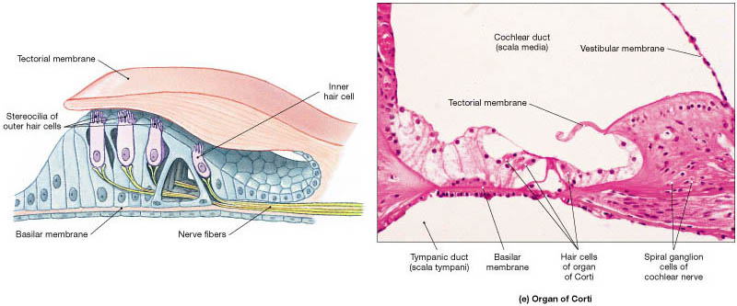
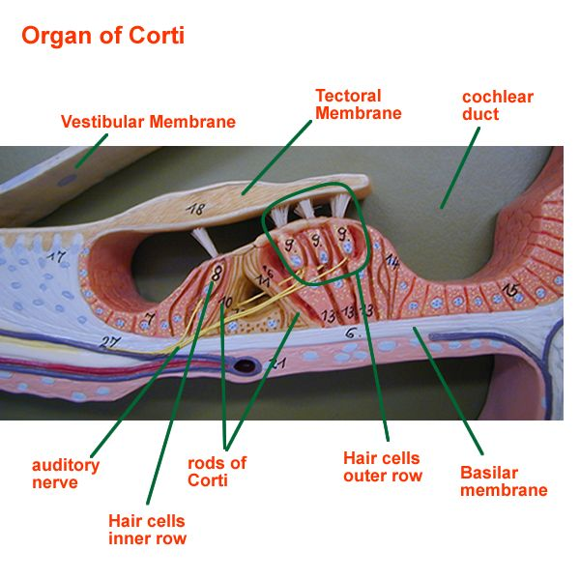
Clinical Significance
- Hearing loss: The organ of Corti can be damaged by excessive sound levels, leading to noise-induced impairment. The most common kind of hearing impairment, sensorineural hearing loss, includes as one major cause the reduction of function in the organ of Corti. Specifically, the active amplification function of the outer hair cells is very sensitive to damage from exposure to trauma from overly-loud sounds or to certain ototoxic drugs. Once outer hair cells are damaged, they do not regenerate, and the result is a loss of sensitivity and an abnormally large growth of loudness (known as recruitment) in the part of the spectrum that the damaged cells serve.

