NEUROHISTOLOGY
Write on the organ of Corti.
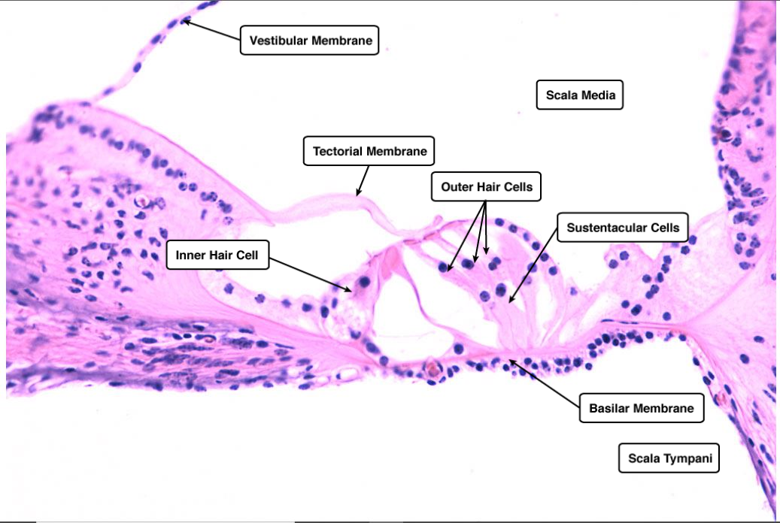
The organ of Corti is a specialized sensory epithelium that allows for the transduction of sound vibrations into neural signals (senses mechanical vibration of incoming sound and converts it to action potentials). The organ of Corti rests on the basilar membrane and contains two types of hair cells: inner hair cells and outer hair cells. Inner hair cells transduce sound from vibrations to neural signals via the shearing action of their stereocilia. Outer hair cells serve a function as acoustic pre-amplifiers which improve frequency selectivity by allowing the organ of Corti to become attuned to specific frequencies, like those of speech or music. The fibrous tectorial membrane rests on top of the stereocilia or the outer hair cells. Mutations in a alpha-tectorin, which encodes a protein specific to the tectorial membrane, cause deafness.
The outer hair cells are arranged in three parallel rows, whereas the inner hair cells are in a single row. At their apical end, the hair cells are provided with stereocilia in a typical ‘W’ pattern. The organ of Corti is overlain by the gel-like tectorial membrane, which is indirectly connected to the osseous spiral lamina through the spiral limbus. Only the stereocilia of the outer hair cells appear to be in contact with the tectorial membrane. Shearing movements between the basilar membrane with the sensory epithelium and the tectorial membrane cause receptor potentials to be produced in the hair cells, by means of deflections of their stereocilia. The inner hair cells act as the primary receptor cell, whereas the outer hair cells act as motor cells that can convert membrane potential into a mechanical force.
Outer Hair Cells
The outer hair cells surrounded by outer phalangeal cells (supporting cells called Deiter’s cells that comprise 75–80% of all hair cells). The outer hair cells are cylindrically shaped and possess a large spherical nucleus located at the neural pole. There are three rows of outer hair cells that are characterized by having several cisterns of endoplasmic reticulum distinctly located under the cellular membrane in a laminar fashion extending from the nucleus up to the apical pole. The apices of these cells and their phalangeal cells are joined together to form the reticular membrane (also called reticular lamina or apical cuticular plate) that separates endolymph in the scala media from underlying corticolymph and perilymph of the scala tympani. At the cuticular end, three rows of stereocilia arise forming a typical W-shaped configuration. Outer hair cells account for only 5-10% of the sensory input into the auditory system from the cochlear nerve, but are contacted by a large number of efferent nerve terminals originating in the olivocochlear bundle. The primary function of outer hair cells is actually to contract when stimulated (either by deflection of their stereocilia caused by movement of the basilar membrane or from these efferent synapses), thus "pulling" on the tectoral membrane thereby stimulating the inner hair cells. This essentially "tunes" the organ of Corti to be more or less sensitive to particular sound frequencies.
Inner Hair Cells
The IHCs are flask-shaped with a globular cell soma tapering into a thinner elongated neck. Their nucleus is rounded and located halfway along the length of the cells, so dividing them into two topographic domains. At the basal end are found synaptic contacts from afferent cochlear nerve fibers, hence this pole is also referred to as the neural pole. The neural pole receives about 90–95% of all afferent contacts with cochlear nerve fibers. The apical pole is characterized by a bundle of stereocilia in nearly straight rows and is synapse free. They detect deflection of the basilar membrane.
Supporting cells
The most conspicuous supporting cells in the organ of Corti are the inner and outer pillar cells. They form the triangular shaped tunnel of Corti between the inner and outer hair cells which is filled with perilymph-like fluid called corticolymph.
Innervation
There are two types of nerve fibers connecting to the organ of Corti: afferent and efferent fibers The afferent fibers convey impulses to the cochlear nuclear complex, whereas the efferent fibers convey impulses from the superior olivary complex to the organ of Corti.
There are two subtypes of afferent fibers. The thick myelinated fibers arising from the bipolar type I spiral ganglion cells innervating the inner hair cells, and the thin unmyelinated fibers arising from monopolar type II spiral ganglion cells innervating outer hair cells. Several type I afferent fibers converge onto single inner hair cell, whereas a single type II afferent fibers terminate onto several outer hair cels.
There are also two systems of efferent fibers: the lateral efferent system (lateral olivocochlear system; LOC) that innervates afferent fibers under the inner hair cells and the medial efferent system (medial olivocochlear system; MOC) that innervates the outer hair cells. They belong to the olivocochlear system (part of the descending auditory pathway section)
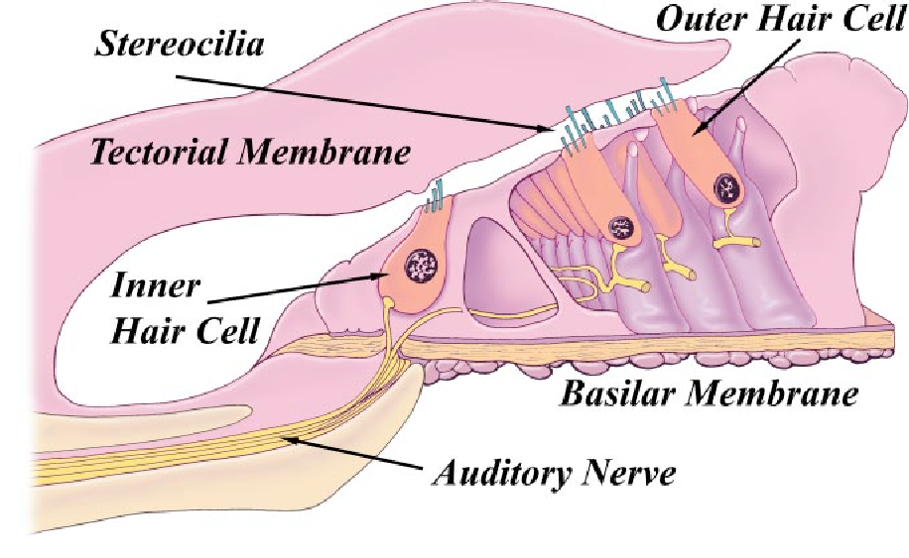
Clinical Anatomy
Disruption of any part of the process by which sound waves are transduced into input into the auditory portion of the CNS will result in "deafness." Damage to the eardrum or ossicles results in so-called "conduction" deafness whereby sound waves are no longer transmitted into the inner ear. In this instance, a patient would NOT be able to hear a tuning fork held near the pinna, and the loss of hearing would extend across the entire range of frequencies. However, placing the stem of the fork on a bony part of the skull (e.g. the mastoid process) would then transmit vibrations directly to the inner ear (via the bone) where they could then be "heard."
Loss of components within the cochlea results in sensorineural deafness which is more frequency-specific (i.e. the patient will not be able to hear specific pitches depending on the location of the damage in the cochlea). Loss of OUTER HAIR CELLS in a particular region of the cochlea would result in a "threshold shift" whereby sound of a particular frequency could still be detected (because the inner hair cells are still intact), but it would have to be LOUDER to make up for the fact that there are no outer hair cells to help stimulate the inner hair cells. This type of hearing loss can be compensated by a hearing aid.
Loss of INNER HAIR CELLS in a particular region of the cochlea would result in an almost complete inability to detect specific frequencies regardless of how loud they are. Loss of SPIRAL GANGLION CELLS would have a similar effect since these are the cells that actually project into the CNS. In both cases, the deafness could only be corrected with a cochlear implant.

