NAME: WECHIE CHIOMA JOY
MATRIC NO: 17/MHS01/321
COURSE: ANA305 ( histology)
DEPARTMENT: MBBS

QUESTIONS ANSWERS
- With the aid of diagram, write an essay on the history of an organ of corti.
ANSWER
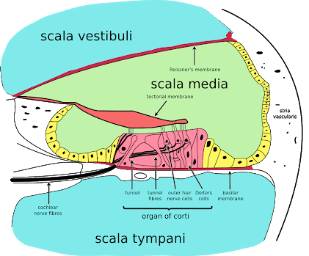
Organ of corti or spiral organ is where sound vibrations of different frequencies are detected. It consists of hair cells and other epithelial structures supported by the basilar membrane. The sensory hair cells have precisely arranged V shaped bundles of rigid stereocilia, each loses its single larger kinocilium during development. Two major types of hair cells are present; the outer hair cells (which are conspicuous on this image) and the inner hair cells which are less conspicuous here, located above the tip of the bony spiral lamina.
- Outer hair cells; about 12,000 in total, occur in three rows near the saccule, increasing to five rows near the apex of the cochlea. Each columnar outer hair cell bears a V shaped bundle of stereocilia.
- Inner hair cells are shorter and form a single row of about 3500 cells, each with a single more linear array of shorter stereocilia.
Both outer and inner hair cells have synaptic connections with afferent and efferent nerve endings, with inner row of cells more heavily innervated. The cells bodies of the afferent bipolar neurons constitute the spiral ganglion located in the bony core of the modiolus.
Two major types of columnar supporting cells are attached to the basilar membrane in the organ of corti. The inner and outer phalangeal cells and the pillar cells. When the basilar membrane flexes in responds to sound waves (i.e., sound), the hair cells move relative to the tectorial membrane, causing stimulatory deflection of the apical ends of the hair cells.
Functions
The function of the organ of Corti is to change (transduce) auditory signals and minimise the hair cells’ extraction of sound energy. It is the auricle and middle ear that act as mechanical transformers and amplifiers so that the sound waves end up with amplitudes 22 times greater than when they entered the ear.
Clinical significance
Hearing loss:- The organ of Corti can be damaged by excessive sound levels, leading to noise-induced impairment. The most common kind of hearing impairment, sensorineural hearing loss, includes as one major cause the reduction of function in the organ of Corti.

