Name: Ayenor E. Christabel
Department: Medicine and Surgery
Matric No: 17/Mhs01/076
Question
With the aid of a diagram, write an essay on the histology of an organ of Corti.
The organ of Corti is a specialized sensory epithelium that is part of the cochlea that allows for the transduction of sound vibrations into neural signals. This structure is localized in the scala media and it is formed by a series of hair cells, nervous terminations of spiral ganglion and supporting cells. The fluid environment for the organ of corti is endolymph which fills the scala media and is secreted by cells of the stria vascularis. The organ of Corti itself is located and rests on the basilar membrane which supports the basal ends of the hair cells in the organ of corti. The apical ends of hair cells touch the tectorial membrane, a shelf of jelly that is supported immovably on the spiral lamina.
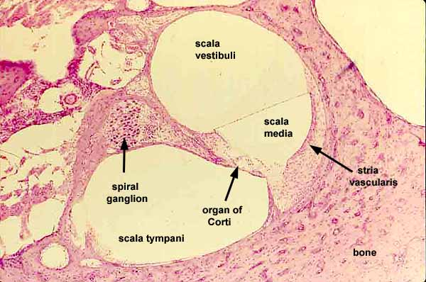
Types of hair cells
a.) Inner hair cell:- These cells are specialized in the mechanoelectrical transduction. They transduce sound from vibrations to neural signals via the shearing action of their stereocilia. They are connected to type I neuron peripheral fibers of spiral ganglion, these connection are very divergent (10/1). The luminal part of the cell is immerged in endolymph, the basal one is immerged in normal extracellular fluid. The luminal portion is formed by bundles of stereocilia (inner ear), whose tips are connected by filamentous structures called tip-links.
b.) Outer hair cells:- serve a function as acoustic pre-amplifiers which improve frequency selectivity by allowing the organ of Corti to become attuned to specific frequencies, like those of speech or music. The fibrous tectorial membrane rests on top of the stereocilia or the outer hair cells. These cells are connected to type II amyelinic neurons, the connections are very convergent. They have also an afference from superior olivary nucleus. They have contractile activity.
c.) Supporting Cells
These cells are of four different types: Corti pillars, Hensen cells, Deiters cells and Claudius cells
