17/Mhs06/049
Obikpo Chisom E.
MBBS
300 level
Ana 305
Histology of special senses and neurohistology
Histology of the ear

With the aid of a diagram, wrote an essay on the histology of an organ of corti

Organ of Corti
The spiral organ of corti is so called because (like other structures in the cochlea) it extends in a spiral manner through the turns of the cochlea. The organ of Corti is a specialized sensory epithelium that allows for the transduction of sound vibrations into neural signals. The organ of Corti itself is located on the basilar membrane. It rests on the basilar membrane and contains two types of hair cells: inner hair cells and outer hair cell alongside some supporting cells.
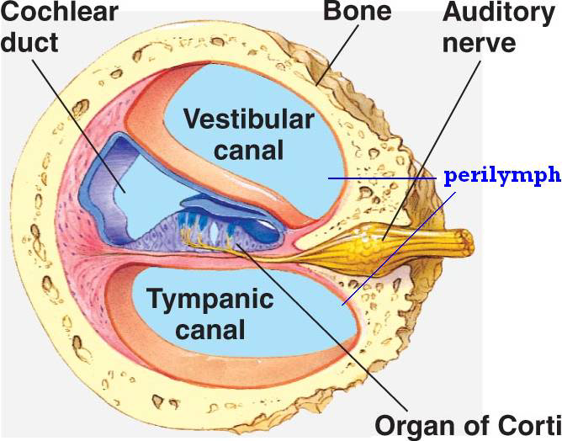

The organ of Corti is overlain by the gel-like tectorial membrane, which is indirectly connected to the osseous spiral lamina through the spiral limbus. Only the stereocilia of the outer hair cells appear to be in contact with the tectorial membrane. Mutations in a alpha-tectorin, which encodes a protein specific to the tectorial membrane, cause deafness.
The Organ of Corti is a part of the cochlea and it mediates the sense of hearing transducing pressure waves to action potentials. This structure is localized in the scala media and it is formed by a series of hair cells, nervous terminations of spiral ganglion and supporting cells. The Organ of Corti consists of different types of cells:
*Inner hair cells
*Outer hair cells
*Supporting cells
The cells of the organ of corti enclose a triangular cavity called the tunnel of corti. The base of the tunnel lies over the nasal membrane. It has a sloping inner wall formed by internal rod cells and a sloping outer wall formed by external rod cells. To the internal side of the inner rod cells there is a single row of inner hair cells. The inner hair cells is supported by tall cells lining the tympanic lip of the internal spiral sulcus. On the outer side of each external rod cell there are about three to four rows of outer hair cells. The outer hair cells do not rest directly on the basilar membrane but are supported by the phalangeal cells of Dieters which rest on the basilar membrane.

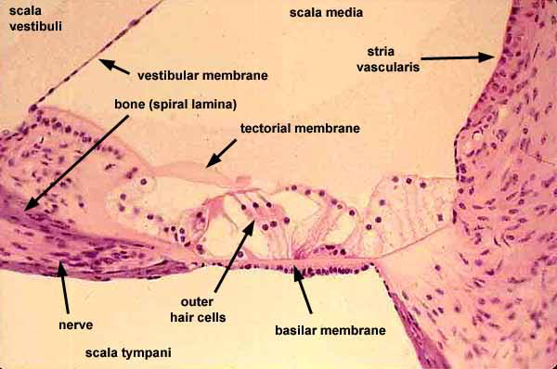

Inner Hair Cells

These cells are specialized in the mechanoelectrical transduction. Inner hair cells transduce sound from vibrations to neural signals via the shearing action of their stereocilia There are almost 3500 cells disposed in one line along all the basilar membrane. They are connected to type I neuron peripheral fibers of spiral ganglion, these connection are very divergent. The luminal part of the cell is immersed in endolymph, the basal one is immersed in normal extracellular fluid. The luminal portion is formed by bundles of stereocilia(inner ear), whose tips are connected by filamentous structures called tip-links.

The inner hair cells are flask-shaped with a globular cell soma tapering into a thinner elongated neck. Their nucleus is rounded and located halfway along the length of the cells, so dividing them into two topographic domains. At the basal end are found synaptic contacts from afferent cochlear nerve fibers, hence this pole is also referred to as the neural pole. The neural pole receives about 90–95% of all afferent contacts with cochlear nerve fibers.
The apical pole is characterized by a bundle of stereocilia in nearly straight rows and is synapse free.

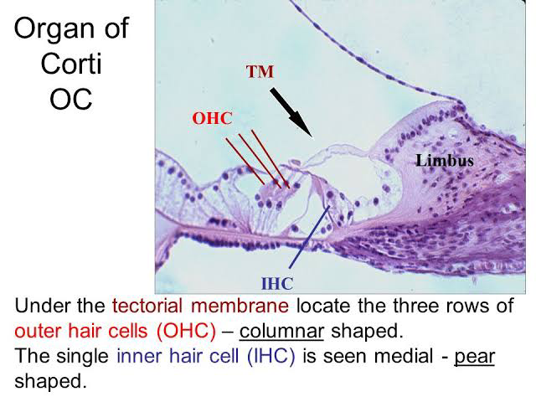

Outer Hair Cells

These cells are acoustical pre-amplifiers. Outer hair cells serve a function as acoustic pre-amplifiers which improve frequency selectivity by allowing the organ of Corti to become attuned to specific frequencies, like those of speech or music.They are almost 12000, disposed in three parallel lines. These cells are connected to type II amyelinic neurons, the connections are very convergent. They have also an afference from superior olivary nucleus. They have contractile activity.
The outer hair cells rest on the supporting cells (called Dieter’s cells) that comprise 75–80% of all hair cells. They are cylindrically shaped and possess a large spherical nucleus located at the neural pole. Outer hair cells are characterized by having several cisterns of endoplasmic reticulum distinctly located under the cellular membrane in a laminar fashion extending from the nucleus up to the apical pole. At the cuticular end, three rows of stereocilia arise forming a typical W-shaped configuration). As opposed to the inner hair cells, outer hair cells only receive 5–10% of the afferent innervation from the cochlear nerve, but are contacted by a large number of efferent nerve terminals originating in the olivocochlear bundle.

Supporting Cells

These cells are of four different types: Corti pillars, Hensen cells, Dieters cells and Claudius cells.

The most conspicuous supporting cells in the organ of Corti are the inner and outer pillar cells. They form the tunnel of Corti between the inner hair cells and outer hair cells . These cells rest upon the basilar membrane.

Hensen cells are one of the supporting columnar cells between the outer hair cells and the cells of Claudius in the organ of Corti

Claudius cells are considered as supporting cells within the organ of Corti in the cochlea. These cells extend from Hensen's cells to the spiral prominence epithelium, forming the outer sulcus. They are in direct contact with the endolymph of the cochlear duct. These cells are sealed via tight junctions that prevent flow of endolymph between them.

Dieters cells also known as phalangeal cells are supporting cells which are described as having an elongated body, spanning from the basilar membrane to the reticular lamina, and holding the base of the outer hair cells at their cup-shaped middle regions.

