NAME; NWOYE CHINONYELUM
MATRIC NUMBER: 17/MHS01/212
HISTOLOGY ASSIGNMENT
LEVEL; 300LVL
- WITH THE AID OF A DIAGRAM, WRITE AN ESSAY ON THE HISTOLOGY OF AN ORGAN CORTI.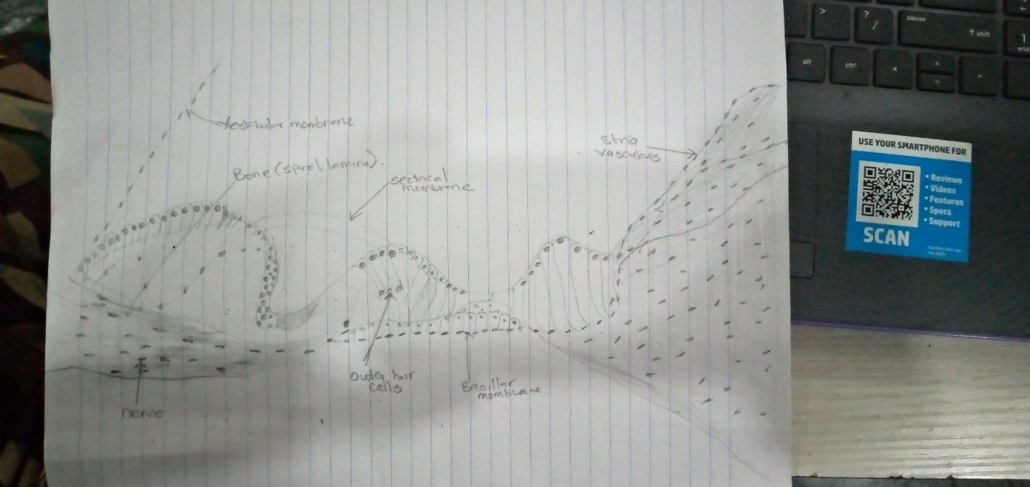

The organ of Corti is a specialized sensory epithelium that allows for the transduction of sound vibrations into neural signals. The organ of Corti itself is located on the basilar membrane. The organ of Corti rests on the basilar membrane and contains two types of hair cells: inner hair cells and outer hair cells. Inner hair cells transduce sound from vibrations to neural signals via the shearing action of their stereocilia. Outer hair cells serve a function as acoustic pre-amplifiers which improve frequency selectivity by allowing the organ of Corti to become attuned to specific frequencies, like those of speech or music. The fibrous tectorial membrane rests on top of the stereocilia or the outer hair cells. Mutations in an alpha-tectorin, which encodes a protein specific to the tectorial membrane, cause deafness.

  - Organ of Corti consists of different types of cells:
Inner
Outer hair cells
Supporting cell

- INNER HAIR CELLS:
These cells are specialized in the mechanoelectrical transduction. There are almost 3500 cells disposed in one line along all the basilar membrane. They are connected to type I neuron peripheral fibers of spiral ganglion; these connections are very divergent (10/1). The luminal part of the cell is immerged in endolymph, the basal one is immerged in normal extracellular fluid. The luminal portion is formed by bundles of stereocilia (inner ear), whose tips are connected by filamentous structures called tip-links.

- OUTER HAIR CELLS:
These cells are acoustical pre-amplifiers. They are almost 12000, disposed in three parallel lines. These cells are connected to type II a myelinic neurons, the connections are very convergent. They have also an afference from superior olivary nucleus. They have contractile activity.

Supporting Cells

These cells are of four different types: Corti pillars, Hensen cells, Deiters cells and Claudius cells.

Endolymph
Endolymph fills the Scala media and it is produced by stria vascularis.
Potassium secreted into the endolymph by the stria vascularis enters the hair cells through apical mechanosensitive channels. It is recycled back to the stria vascularis through supporting cells and fibrocytes of the spiral ligament for another round of secretion. Hair cells and stria vascularis are tied together in a "push-pull" or "pump-leak" balance that determines endocochlear potential (EP +85mV), endolymph composition and ultimately the sensitivity and stability of hair cells and hearing over a lifetime. The evolutionary strategy of using K receptors currents is due to the fact that it reduces metabolic requirements because it has a passive outflow from hair cells to the basal membrane, instead of active Na extrusion. Endolymph has a particular ion concentration.
Ion Perilymph (mM) Endolymph (mM)
Na 154 1
K 3 161
Cl 128 131

There is a potential difference of -140 mV between endolymph and inner receptor.
A basolateral Na/K-ATPase pumps K and creates a Na gradient to drive K and Cl into the cell in a co-transport process. Chloride is recycled by basolateral Cl channels, and K is secreted apically by KCNQ1/KCNE1 K channels, which are open at the unusual apical membrane voltage of marginal cells (inside positive by about +10 mV). This allows for a net secretion into the endolymph in spite of its high K concentration.
KCNQ proteins have six transmembrane domains and a pore-forming P-loop. Mutations on KCNQ1 and KCNQ4 lead to deafness. Indeed, KCNQ4 was mapped to human chromosome 1p34; it is one of over 30 loci for dominant deafness. Hypoxia reduces endocochlear potential, due to a drop-in metabolism and stria current; whereas a depletion of vascular K does not drop EP, showing that K comes from spiral ligament rather than from blood.

SENSE OF HEARING
The role of the sense of hearing is translating pressure waves of perilymph and endolymph to electrical signal and acoustic sensation

Mechanism of transduction

- Deflection: tip-links open K channels and k enters the cell
- Depolarization: Ca enters the cell through voltage-dependent channels
- Higher Ca concentration: K extrusion toward basolateral portion and Glutamate release in synaptic cleft. Action potential along acoustic nerve (VIII)
CLINICAL CORRELATIONS
Disruption of any part of the process by which sound waves are transduced into input into the auditory portion of the CNS will result in "deafness." Damage to the eardrum or ossicles results in so-called "conduction" deafness whereby sound waves are no longer transmitted into the inner ear. In this instance, a patient would NOT be able to hear a tuning fork held near the pinna, and the loss of hearing would extend across the entire range of frequencies. However, placing the stem of the fork on a bony part of the skull (e.g. the mastoid process) would then transmit vibrations directly to the inner ear (via the bone) where they could then be "heard."
Loss of components within the cochlea results in sensorineural deafness which is more frequency-specific (i.e. the patient will not be able to hear specific pitches depending on the location of the damage in the cochlea). Loss of OUTER HAIR CELLS in a particular region of the cochlea would result in a "threshold shift" whereby sound of a particular frequency could still be detected (because the inner hair cells are still intact), but it would have to be LOUDER to make up for the fact that there are no outer hair cells to help stimulate the inner hair cells. This type of hearing loss can be compensated by a hearing Loss of INNER HAIR CELLS in a particular region of the cochlea would result in an almost complete inability to detect specific frequencies regardless of how loud they are. Loss of SPIRAL GANGLION CELLS would have a similar effect since these are the cells that actually project into the CNS. In both cases, the deafness could only be corrected with a cochlear implant. Deafness is a partial or total inability to hear. Deafness is a partial or total inability to hear. AHL is the age-related hearing loss, also known as presbycusis. Many K channels, like KCNQ1, were found to be down-regulated in stria vascularis with aging. Moreover, a reduced KCNQ4 current may lead to a slow degenerative process. Although in some cases the EP is maintained and this is a paradoxical phenomenon, it would appear that this is attributable to the SV which may generate a much lower current to establish a new balance for potassium influx and efflux at a relatively lower level. It is not clear if an atrophied stria vascularis could recover sufficient function by up-regulating these potassium transporters expression to maintain a normal endocochlear potential.

