MATRIC NO: 17/MHS01/275
NAME: Osubor Stephanie
COURSE: ANA 305

HISTOLOGY OF THE ORGAN OF CORTI
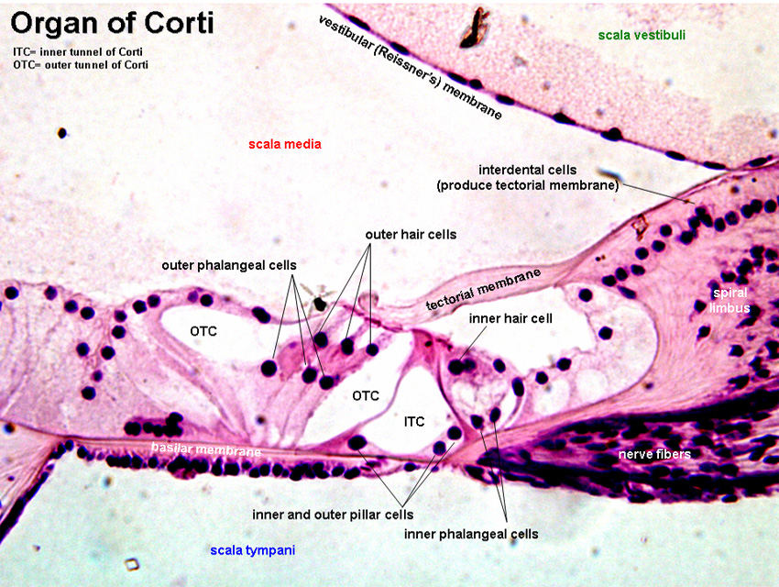
The organ of Corti is a specialized sensory epithelium that allows for the transduction of sound vibrations into neural signals. It is a part of the cochlea and it mediates the sense of hearing transducing pressure waves to action potentials. The organ of Corti itself is located in and rests on the basilar membrane. It is localized in the scala media and it is formed by a series of hair cells, nervous terminations of spiral ganglion and supporting cells.
Organ of Corti consists of different types of cells:
- Hair Cells (mechanosensory cells). Projecting from the tops of the hair cells are tiny finger like projections called stereocilia, which are arranged in a graduated fashion with the shortest stereocilia on the outer rows and the longest in the center. This gradation is thought to be the most important anatomic feature of the organ of Corti because this allows the sensory cells superior tuning capability. The 2 hair cells are:
a) One row of Inner hair cells
b) Three rows of Outer hair cells
- Supporting cells
Inner Hair Cells
These cells are specialized in the mechanoelectrical transduction. There are almost 3500 cells disposed in one line along all the basilar membrane. They are connected to type I neuron peripheral fibers of spiral ganglion, these connection are very divergent (10/1). The luminal part of the cell is immerged in endolymph, the basal one is immerged in normal extracellular fluid. The luminal portion is formed by: bundles of stereocilia (inner ear), whose tips are connected by filamentous structures called tip-links. Inner hair cells transduce sound from vibrations to neural signals via the shearing action of their stereocilia.
Outer Hair Cells
These cells are acoustic pre-amplifiers, which improve frequency selectivity by allowing the organ of Corti to become attuned to specific frequencies, like those of speech or music. They are almost 12000, disposed in three parallel lines. These cells are connected to type II amyelinic neurons, the connections are very convergent. They have also an afference from superior olivary nucleus. They have contractile activity.
Supportiong Cells
They separate and support the inner and outer hair cells. These cells are of four different types: Corti pillars, Hensen cells, Deiters cells (phalangeal cells) and Claudius cells.
Endolymph fills the scala media and it is produced by stria vascularis.
The fibrous tectorial membrane rests on top of the stereocilia or the outer hair cells. Mutations in a alpha-tectorin, which encodes a protein specific to the tectorial membrane, which causes deafness.

