NAME: NWAOKEZI DESIRE OGOCHUKWU
MATRIC No.: 17/MHS01/206
DEPARTMENT: MEDICINE AND SURGERY
COURSE: NEUROHISTOLOGY (ANA 305)
DATE: 23RD JUNE, 2020.

Assignment
With the aid of a diagram, write an essay on the histology of the organ of corti.
Organ of Corti

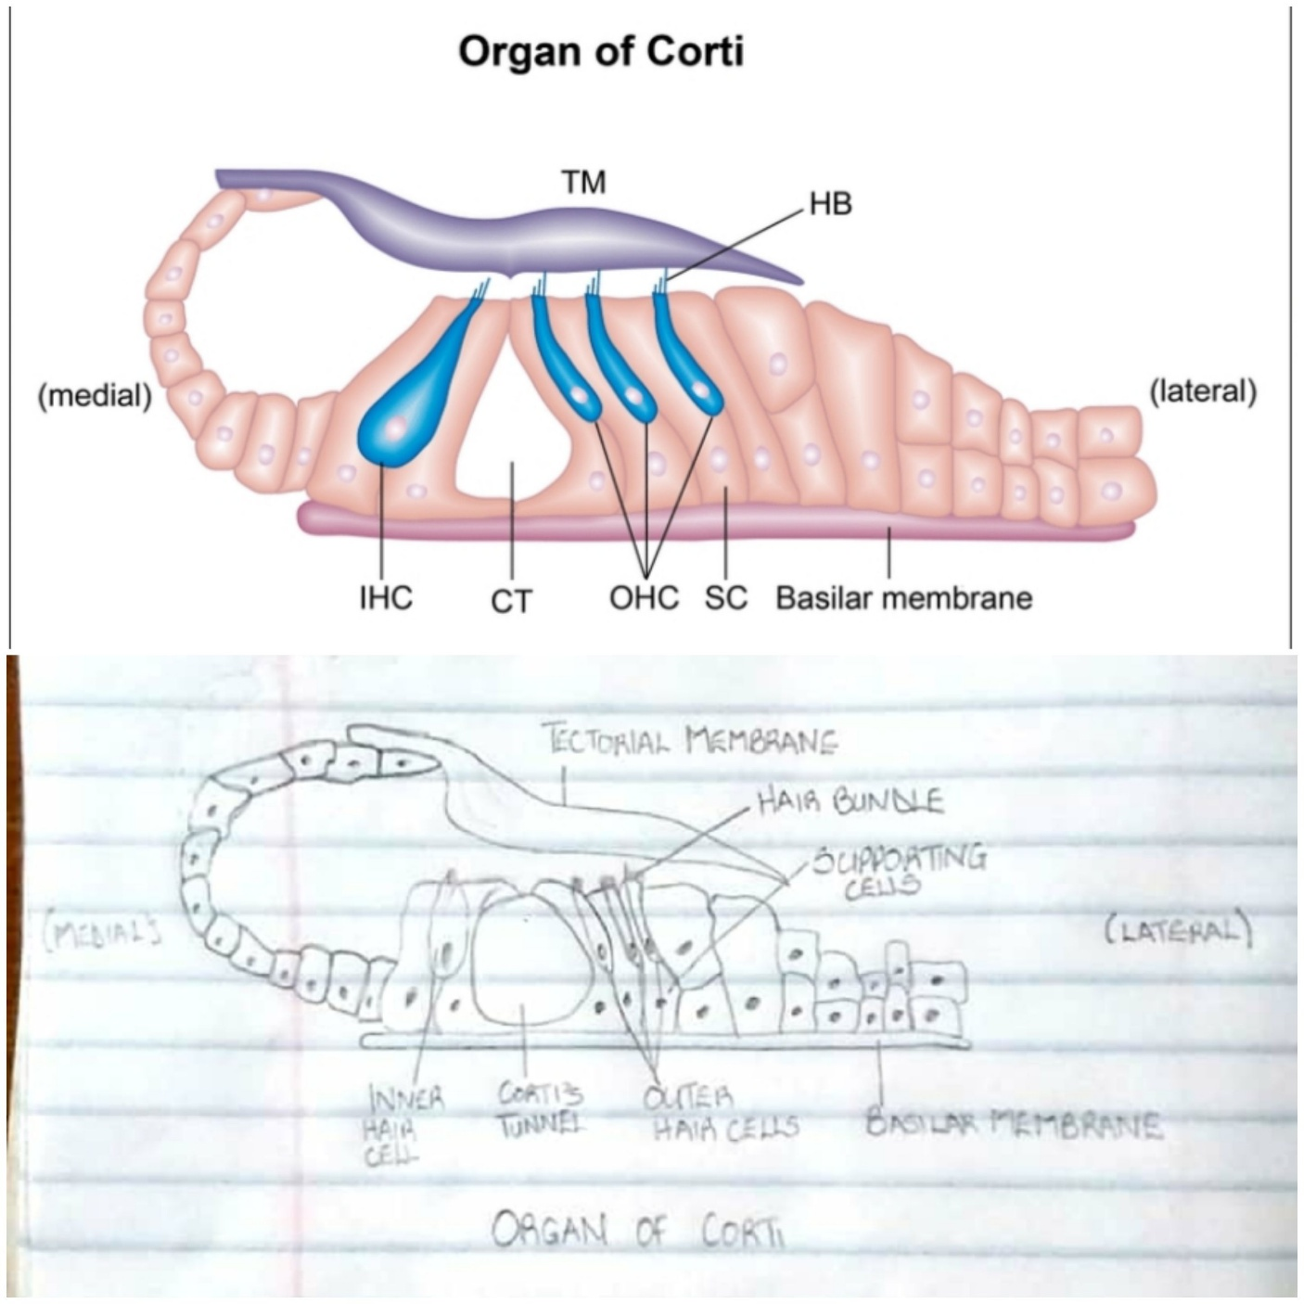
The organ of corti is an organ of inner ear located within the cochlea which contributes to audition. It is a specialized sensory epithelium that allows for the transduction of sound vibrations into neural signals. The organ of corti has two types of hair cells which includes three rows of outer hair cells and one row of inner hair cells. Vibrations caused by sound waves bend the stereocilia on the hair cells via an electromechanical force. The hair cells convert mechanical energy that is transmitted to the central nervous system via the auditory nerve to facilitate audition.
Function of the organ of corti
The primary function of the organ of corti is the transduction of auditory signals and to minimize the hair cells’ extraction of sound energy.
Cochlea amplification; the organ of corti is capable of modulating the auditory signal. The outer hair cells can amplify the signal through electromotility while they increase movement of the basilar and tectorial membranes and therefore increasing deflection of stereocilia in the inner hair cells. The motor protein plays an important role in cochlea amplification by changing the shape based on the voltage potential inside the hair cells. When the cell is depolarized, prestin shortens and pulls the basilar membrane and increasing how much the membrane is deflected, creating a more intense effect on the inner hair cells. When the cell hyperpolarizes prestin lengthens and eases tension on the inner hair cells, which decreases the neural impulses to the brain. In this way, the hair cell itself is able to modify the auditory signal before it even reaches the brain.
Structure of the organ of corti
The organ of corti is an organ of the inner ear contained within the scala media of the cochlea. It resides on the basilar membrane, a stiff membrane separating the scala tympani and scala media. The scala media is a cavity within the cochlea that contains endolymph which has a high potassium concentration. The endolymph helps to regulate to regulate the electrochemical impulses of the auditory hair cells.
The organ of corti is composed of;
- Supporting Cells; also called Dieters or Phalangeal cells.
- Mechanosensory Hair Cells; arranged in rows of inner and outer hair cells. Three rows of outer hair cells and a single row of inner hair cells which are separated by supporting cells.
The hair cells present in the organ of corti have stereocilia that attach to the tectorial membrane. Shifts between the tectorial and basilar membranes move the stereocilia and activates or deactivates receptors on the hair cells surface.
Inner Hair Cells; they function primarily as sensory organ for audition. They provide input to 95% of the auditory nerve fibers that project to the brain.
Outer Hair Cells; these are the input centers. They receive descending inputs from the brain to assist with the modulation of inner hair cell function.
The inner and outer hair cells are distinctly different in structure, they both have stereocilia on the apical surface, and however the arrangement of the stereocilia and their connection to the tectorial membrane are different. The outer hair cells alter the stiffness of the organ of corti through a motor protein, prestin, located on the lateral membrane of these cells.

