NNANNA NANCY
17/MHS01/203
MBBS
300 LEVEL
HISTOLOGY OF THE EAR
HISTOLOGY OF THE SPECIAL SENSES AND NEUROHISTOLOGY
ANA 305

QUESTION: Write an essay on the histology of the organ of corti with the aid of a diagram.

ANSWER:

The Organ of Corti is a part of the cochlea and it mediates the sense of hearing transducing pressure waves to action potentials. This structure is localized in the scala media and it is formed by a series of hair cells, nervous terminations of spiral ganglion and supporting cells.

The organ of Corti is a specialized sensory epithelium that allows for the transduction of sound vibrations into neural signals. The organ of Corti itself is located on the basilar membrane. The organ of Corti rests on the basilar membrane and contains two types of hair cells: inner hair cells and outer hair cells. Inner hair cells transduce sound from vibrations to neural signals via the shearing action of their stereocilia. Outer hair cells serve a function as acoustic pre-amplifiers which improve frequency selectivity by allowing the organ of Corti to become attuned to specific frequencies, like those of speech or music. The fibrous tectorial membrane rests on top of the stereocilia or the outer hair cells.

Organ of Corti consists of different types of cells:
*Inner hair cells
*Outer hair cells
*Supporting cells

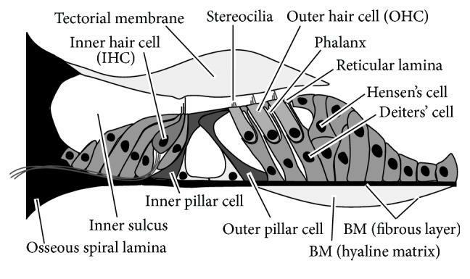

Inner Hair Cell
These cells are specialized in the mechanoelectrical transduction. There are almost 3500 cells disposed in one line along all the basilar membrane. They are connected to type I neuron peripheral fibers of spiral ganglion, these connection are very divergent (10/1). The luminal part of the cell is immerged in endolymph, the basal one is immerged in normal extracellular fluid. The luminal portion is formed by bundles of stereocilia(inner_ear), whose tips are connected by filamentous structures called tip-links.

Outer Hair Cell
These cells are acoustical pre-amplifiers. They are almost 12000, disposed in three parallel lines. These cells are connected to type II amyelinic neurons, the connections are very convergent. They have also an afference from superior olivary nucleus. They have contractile activity

Supporting Cells
These cells are of four different types: Corti pillars, Hensen cells, Deiters cells and Claudius cells.

Corti pillars : The most conspicuous supporting cells in the organ of Corti are the inner and outer pillar cells. They form the tunnel of Corti between the inner hair cells and outer hair cells. These cells rest upon the basilar membrane.

Hensen's cells : They are a layer of tall cells arranged in the organ of Corti in the cochlea, which are part of the supporting cells lie on the outer hair cells. The shape of Hensen's cells are various in different position of cochlea, they appear as a single layer of cells in the basal coil while appear as cuboidal form in the apical surface. They contain nuclei and microvilli but are limiting of plasma membrane, they are also lack of endoplasmic reticulum and have few mitochondria. In the apical surface, there are free enlarged poles found in the Hensen's cells, the cytoplasm of the cells is a little more dense in the apical surface than the cells in the basal coil. The enlarged poles in the cells which nearly fill the cytoplasm are lipid droplets, which are noticeable at the third and forth turns of the cochlea, the lipid droplets are thought to have relation with auditory process.The phagosomes found in the cells are another characteristic of the Hensen's cells, indicating that they have a function of phagocytosis. Hensen's cells have rigid cytoskeletons which are responsible to maintain the structure of the organ of Corti during sound exposure.

Deiters' cells : Deiters' cells, also known as phalangeal cells or cells of Deiters, are a cell type found within the inner ear. They contain both micro-filaments and micro-tubules which run from the basilar membrane to the reticular membrane of the inner ear.
These cochlear supporting cells include a somatic part, with its cupula, and a phalangeal process, which links the Deiters soma to the reticular lamina. The part of the phalanx which is included in the reticular lamina is the apex of the phalanx (phalangeal apex).

Claudius cells : They are considered as supporting cells within the organ of Corti in the cochlea. These cells extend from Hensen's cells to the spiral prominence epithelium, forming the outer sulcus. They are in direct contact with the endolymph of the cochlear duct. These cells are sealed via tight junctions that prevent flow of endolymph between them. Boettcher cells are located immediately under Claudius cells in the lower turn of the cochlea.
Claudius cells are named after German anatomist, Friedrich Matthias Claudius (1822–1869).

CLINICAL APPLICATIONS:

Sensorineural hearing loss is the most commonly reported cause of auditory deficits. This type of hearing loss often results from exposure to either loud sounds or ototoxic drugs. Exposure to loud noises causes the vibrational shift between the tectorial and basilar membranes to increase. This shift can damage the stereocilia of the outer hair cells. When damage occurs to the outer hair cells, the stiffness of the organ of Corti decreases which in turn increases vibrational forces on the inner hair cells. Damage to the outer hair cells decreases the protection of inner hair cells and causes them to become more sensitive. Over time, the inner hair cells will also become damaged and audition affected.
Aminoglycoside antibiotics are an example of ototoxic drugs. These drugs are K+ channel blockers. As such, they block the ability of both inner and outer hair cells to depolarize. These types of drugs can also change the concentration of ions within the perilymph which can lead to damage or death of both inner and outer hair cells; destruction of the hair cells causes permanent auditory deficits because they do not regenerate.

