NAME: SALISU FAROUK
MATRIC NO.: 17/MHS01/293
HISTOLOGY OF SPECIAL SENSES (ANA 305) ASSIGNMENT
The organ of Corti, or spiral organ, is the receptor organ for hearing and is located in the mammalian cochlea. This highly varied strip of epithelial cells allows for transduction of auditory signals into nerve impulses’ action potential. Transduction occurs through vibrations of structures in the inner ear causing displacement of cochlear fluid and movement of hair cells at the organ of Corti to produce electrochemical signals.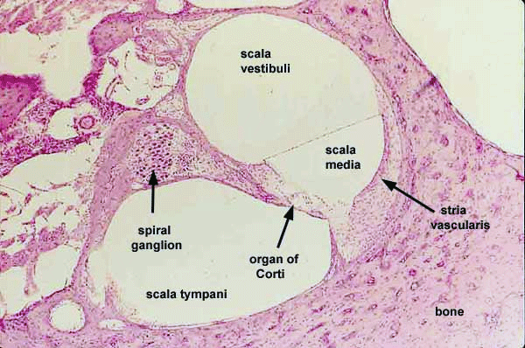
Structure of the Organ of Corti
The organ of Corti is located in the scala media of the cochlea of the inner ear between the vestibular duct and the tympanic duct and is composed of mechanosensory cells, known as hair cells. The organ of Corti contains:
- A single row of inner hair cells (IHCs), they are about 3,500 in total.
- Three rows of outer hair cells (OHCs) that have stereocilia (but no kinocilium) on their apical border and synapse with bipolar neurons of the cochlear (spiral) ganglion of CN VIII. The OHCs are about 12,000 in total.
The outer hair cells are in contact with a gelatinous mass called the tectorial membrane rich in tectorin.
- Supporting cells:
- Pillar cells: These are tall cells with wide bases and apical ends that are attached to basilar membrane. The central portions are deflected to form the walls of inner tunnel; apical portion contact each other.
- Phalangeal cells: Outer phalangeal cells tall columnar cells that are attached to basilar membrane. Apical portions are cup-shaped to support the basilar portions of outer hair cells along with efferent and afferent nerve fibers. They do not reach the free surface of organ of Corti. Outer phalangeal cells have the space of Nuel: a fluid-filled gap around unsupported regions of the outer hair cells. Inner phalangeal cells are located deep to the innel pillar cells and they completely surround the inner hair cells

- Border cells: These are slender cells that support inner aspects of the organ of Corti. They delineate the inner border of the organ of Corti.
- Cells of Hansen: These are cells that define the outer border. They are located b/w outer phalangeal cells and cells of Claudius.
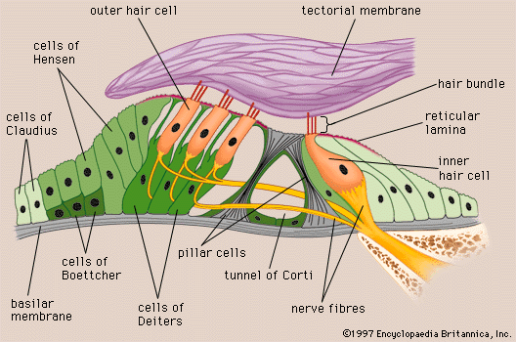
Functions of Organ of Corti
The function of the organ of Corti is to change auditory signals and minimize the hair cells’ extraction of sound energy. It is the auricle and middle ear that act as mechanical transformers and amplifiers so that the sound waves end up with amplitudes 22 times greater than when they entered the ear. By detecting minute movements of the stereocilia, hair cells in the spiral organ of Corti act as mechanoelectrical transducers. Sound waves collected by the external ear cause the tympanic membrane to vibrate, which moves the chain of middle ear ossicles and the oval window. The large size of the tympanic membrane compared to the oval window and the mechanical properties of the ossicle chain amplify the movements and allow optimal transfer of energy between air and perilymph, from sound waves to vibrations of the tissues and fluid-filled chambers.
Pressure waves within the perilymph begin at the oval window and move along the scala vestibuli. Each pressure wave causes momentary displacement of the vestibular and/or basilar membranes and the endolymph surrounding the organ of Corti. The width, rigidity, thickness, and other physical properties of the basilar membrane and its organ of Corti all vary in precise gradients along its length. This allows the region of maximal displacement to vary with the sound waves’ frequency, that is, the number of waves moving past a point per unit of time (measured in hertz). High-frequency sounds displace the basilar membrane maximally near the oval window. Sounds of progressively lower frequency produce pressure waves that move farther along the scala vestibuli and displace the spiral organ at points farther from the oval window. The sounds of the lowest frequency that can be detected produce movement of the basilar membrane at the apex or helicotrema of the cochlea. After crossing the cochlear duct (scala media) and organ of Corti, pressure waves are transferred to the scala tympani and exit the inner ear at the round window. The organ of Corti is also capable of modulating the auditory signal. The outer hair cells (OHCs) can amplify the signal through a process called electromotility where they increase movement of the basilar and tectorial membranes and therefore increase deflection of stereocilia in the IHCs.
A crucial piece to this cochlear amplification is the motor protein prestin, which changes shape based on the voltage potential inside of the hair cell. When the cell is depolarized, prestin shortens, and because it is located on the membrane of OHCs it then pulls on the basilar membrane and increasing how much the membrane is deflected, creating a more intense effect on the inner hair cells (IHCs). When the cell hyperpolarizes prestin lengthens and eases tension on the IHCs, which decreases the neural impulses to the brain. In this way, the hair cell itself is able to modify the auditory signal before it even reaches the brain.
Clinical Significance
The organ of Corti can be damaged by excessive sound levels, leading to noise-induced impairment.
The most common kind of hearing impairment, sensorineural hearing loss, includes as one major cause the reduction of function in the organ of Corti. Specifically, the active amplification function of the outer hair cells is very sensitive to damage from exposure to trauma from overly-loud sounds or to certain ototoxic drugs. Once outer hair cells are damaged, they do not regenerate, and the result is a loss of sensitivity and an abnormally large growth of loudness (known as recruitment) in the part of the spectrum that the damaged cells serve.
Some types of sensorineural deafness can be treated by a cochlear implant. A small cable with a series of electrodes is threaded into the scala tympani, with the electrodes along the wall containing branches of the cochlear nerve. A device containing a microphone, a speech processor to filter extraneous sounds, and a transmitter is worn behind the external ear. Sounds of various frequencies transmit signals to a receiver implanted in a bone of the skull and attached to the array of electrodes that stimulate nerve branches appropriate for those frequencies. The neural impulses are interpreted in the brain as sounds. Cochlear implants do not restore normal hearing but can provide a range of sounds that allows understanding of speech

