NAME: NWAOLISA CHIOMA SUCCESS
MATRIC NUMBER: 17/MHS01/207
COURSE CODE: ANA 305
DEPARTMENT: MBBS
LEVEL: 300
Question
With the aid of diagram, write an essay on the histology of the of corti
Answer
The organ of Corti, named after Alfonso Corti who first described it, is the sensorineural organ of the cochlea. It is composed of sensory cells called hair cells, nerve fibers that connect to them, and supporting structures. This highly varied strip of epithelial cells allows for transduction of auditory signals into nerve impulses' action potential. Transduction occurs through vibrations of structures in the inner ear causing displacement of cochlear fluid and movement of hair cells at the organ of Corti to produce electrochemical signals.
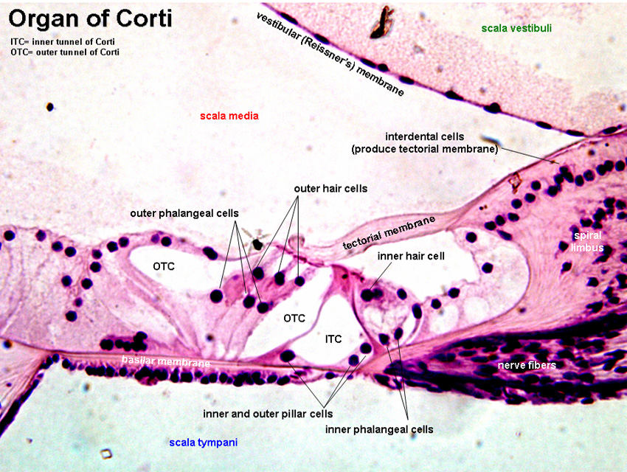

Structure
The organ of Corti is located in the scala media of the cochlea of the inner ear between the vestibular duct and the tympanic duct and is composed of mechanosensory cells, known as hair cells. Strategically positioned on the basilar membrane of the organ of Corti are three rows of outer hair cells (OHCs) and one row of inner hair cells (IHCs). Separating these hair cells are supporting cells: Deiters cells, also called phalangeal cells, which separate and support both the OHCs and the IHCs. Projecting from the tops of the hair cells are tiny finger like projections called stereocilia, which are arranged in a graduated fashion with the shortest stereocilia on the outer rows and the longest in the center. This gradation is thought to be the most important anatomic feature of the organ of Corti because this allows the sensory cells superior tuning capability.
Function
The function of the organ of Corti is to change (transduce) auditory signals and minimise the hair cells’ extraction of sound energy.
The organ of Corti is also capable of modulating the auditory signal. The outer hair cells (OHCs) can amplify the signal through a process called electromotility where they increase movement of the basilar and tectorial membranes and therefore increase deflection of stereocilia in the IHCs.
Development
The organ of Corti, in between the scala tympani and the scala media, develops after the formation and growth of the cochlear duct. The inner and outer hair cells then differentiate into their appropriate positions and are followed by the organization of the supporting cells. The topology of the supporting cells lends itself to the actual mechanical properties that are needed for the highly specialized sound-induced movements within the organ of Corti.
Development and growth of the organ of Corti relies on specific genes, many of which have been identified in previous research (SOX2, GATA3, EYA1, FOXG1, BMP4, RAC1 and more), to undergo such differentiation. Specifically, the cochlear duct growth and the formation of hair cells within the organ of Corti. Mutations in the genes expressed in or near the organ of Corti before the differentiation of hair cells will result in a disruption in the differentiation, and potential malfunction of, the organ of Corti.
Clinical significance
Hearing loss
The organ of Corti can be damaged by excessive sound levels, leading to noise-induced impairment. The most common kind of hearing impairment, sensorineural hearing loss, includes as one major cause the reduction of function in the organ of Corti. Specifically, the active amplification function of the outer hair cells is very sensitive to damage from exposure to trauma from overly-loud sounds or to certain ototoxic drugs. Once outer hair cells are damaged, they do not regenerate, and the result is a loss of sensitivity and an abnormally large growth of loudness (known as recruitment) in the part of the spectrum that the damaged cells serve.

