NAME: ADENIYI-OSO OLUWAPELUMI
MATRIC NO: 17/MHS01/020
DEPARTMENT: MEDICINE AND SURGERY
COUSRE TITLE: HISTOLOGY OF SPECIAL SENSE AND NEUROHISTOLOGY.

ASSIGNMENT.
With the aid of a diagram write an essay on the histology of an organ of corti.

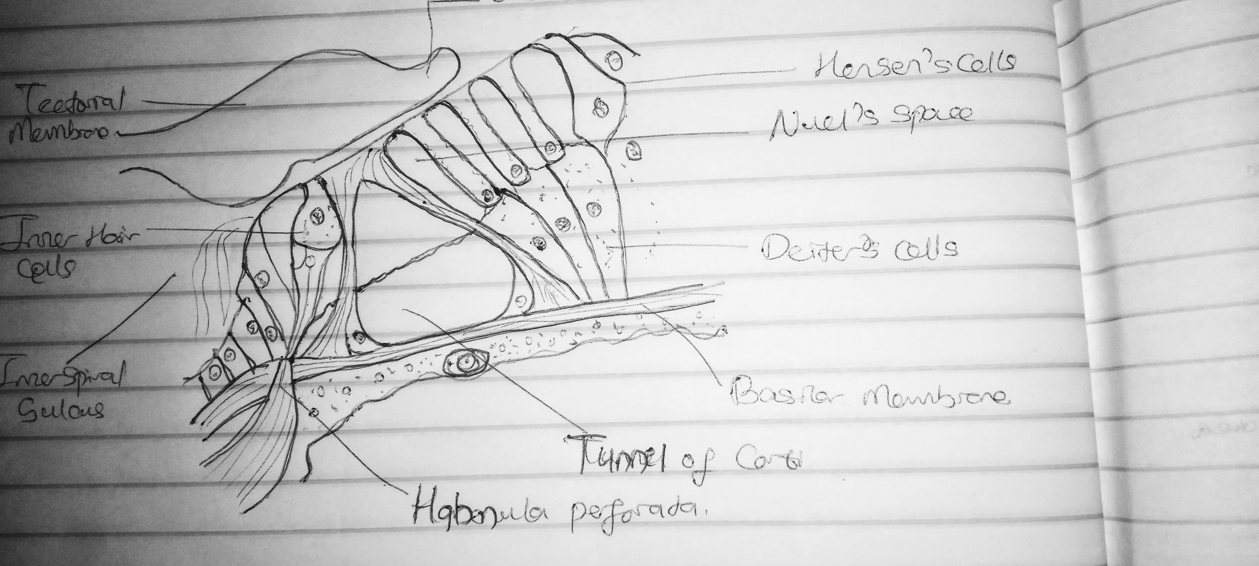

THE ORGAN OF CORTI
The organ of Corti is the sensorineural organ of the cochlea. It consist of sensory cells called hair cells consist of two kind of hair cells, nerve fibers that connect to them in a complex arrangement.

Functions of the organ of corti as asequence in producing a soft sound.
- Sound waves transmitted by the perilymph, make the basilar membrane vibrate up an down. Passive tonotopy mobilises the basilar membrane from the base (High sound) to the apex(low sound) of the cochlear
- Stereocilia of the Outer hair cells embedded to the tectorial membrane, bend when the basilar menbrane rises, causing the Outer hair cells to depolarise
- Depolarised outer hair cells react by contracting. Due to the close link between the outer hair cells, the basilar membrane, and the reticular lamina, this active mechanism creates energy that amplifies the initial vibration, that play a role in active frequency filtering.
- The Inner hair cells is excited , probably via the direct contact with Hensen’s stripe within the tectorial membrane.
- The synapses between the Inner hair cells and the auditory nerve fibre is activated and a message is sent to the brain.

Parts of the Organ of Corti.
- The outer hair cells surrounded by outer phalangeal cells. There are three rows of outer hair cells. The apices of these cells and their phalangeal cells are joined together to form the reticular membrane (also called reticular lamina or apical cuticular plate) that separates endolymph in the scala media from underlying corticolymph and perilymph of the scala tympani. Lateral to the outer hair cells and phalangeal cells are other support cells, but you don't need to worry about knowing their specific types. Note that outer hair cells account for only ~5-10% of the sensory input into the auditory system. The primary function of outer hair cells is actually to contract when stimulated, thus "pulling" on the tectoral membrane thereby stimulating the inner hair cells.

- Outer and inner pillar cells outline a triangular shaped tunnel, called the inner tunnel, which is filled with perilymph-like fluid called corticolymph.

- The inner hair cells are in a single row close to the inner pillar cells (you may see more than one inner cell nucleus because of the thickness of the section). Note that the inner hair cells account for ~90-95% of the sensory input into the auditory system.

- The organ of Corti is overlaid by a gelatinous tectorial membrane (produced and maintained by the columnar cells found atop the spiral limbus just medial to the organ of Corti).

- Nerve fibers enter the organ of Corti through openings in a shelf of bone extending from the modiolus like the thread of a screw. The nerve fibers pass between supporting cells to synapse with the hair cells.

