NAME: AJAYI EMMANUEL OLUWASEGUN
MATRICULATION NUMBER: 17/MHS01/039
DEPARTMENT: MEDICINE AND SURGERY

THE HISTOLOGY OF THE ORGAN OF CORTI
The organ of Corti, or spiral organ, is the receptor organ for hearing and is located in the mammalian cochlea in the inner ear. Surrounded in potassium-rich filled endolymph, it lies on the basilar membrane at the base of the scala media/cochlear duct between the scala tympani (below), and the scala vestibuli (above). The spiral organ is a specialized sensory epithelial structure that allows for transduction of auditory signals into nerve impulses ‘action potential’.
Transduction occurs through vibrations of structures in the inner ear causing displacement of cochlear fluid and movement of hair cells at the organ of Corti to produce electrochemical signals sent through the auditory nerve (CN VIII) and into the auditory cortex of the brain.
Italian anatomist Alfonso Giacomo Gaspare Corti (1822 – 1876) discovered the spiral organ in 1851. The structure evolved from the basilar papilla and is crucial for mechanotransduction in mammals.

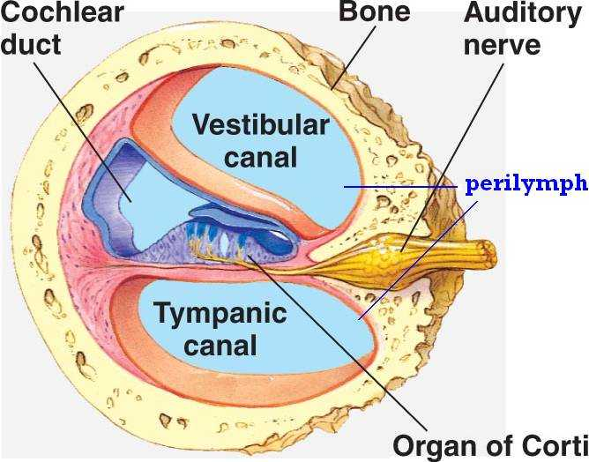
The organ of Corti in the mammalian inner ear
Strategically positioned on the basilar membrane of the organ of Corti are;
- Three rows of outer hair cells
- One row of inner hair cells
- Supporting cells

Inner Hair Cells
These cells are specialized in the mechanoelectrical transduction. There are almost 3500 cells disposed in one line along the whole basilar membrane. They are connected to Type I neuron peripheral fibers of spiral ganglion, the connections are very divergent. The luminal part of the cell is immerged in endolymph; the basal part in normal extracellular fluid. The luminal portion is formed by bundles of stereocilia, whose tips are connected by filamentous structures called tip-links.

Outer Hair Cells
These cells serve a function of acoustic pre-amplifiers which improve frequency selectivity by allowing the spiral organ to become attuned to specific frequencies, like those of speech or music. They are about 12000, disposed in three parallel lines. They are connected to Type II amyelinic neurons, the connections are very convergent. They have also afference from superior olivary nucleus. They have contractile activity. These cells are in contact with a gelatinous mass called the tectorial membrane, rich in tectorin.

Supporting Cells
Separating the hair cells are the supporting cells. They are of four different types :
- Inner and Outer Pillar cells
  - Tall cells with wide bases and apical ends that are attached to the basilar membrane.
  - The central portions are deflected to form the walls of inner tunnel; apical ends contact each other
- Phalangeal cells
  - Outer phalangeal cells
    - Tall, columnar cells that are attached to the basilar membrane
    - Apical portions are cup-shaped to support the basilar portions of outer hair cells along with efferent and afferent nerve fibers.
    - Do not reach the free surface of the spiral organ
  - Inner phalangeal cells
    - Located deep to the inner pillar cells
    - Completely surround the inner hair cells
- Border cells
  - Delineate the inner border of the organ of Corti
  - Slender cells that support inner aspects of the organ of Corti
- Cells of Hensen
  - Define the outer border
  - Located between outer phalangeal cells and the border cells

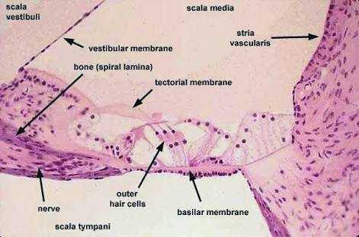
Histological view of the organ of Corti

CLINICAL SIGNIFICANCE
Hearing Loss – The organ of Corti can be damaged by excessive sound levels, leading to noise-induced impairment.
The most common kind of hearing impairment, sensorineural hearing loss, includes as one major cause of reduction in function in the organ of Corti.

