The organ of Corti is contained within the scala media. It is a long strip of tissue that extends the length of the scala media, from the base of the cochlea to its apex.
The fluid environment for the organ of Corti is endolymph, which fills the scala media. (Endolymph is secreted by cells of the stria vascularis.) Within the complex strip of tissue that comprises the organ of Corti are specialized sensory hair cells. The entire complex (the whole organ of Corti) rests on the basilar membrane. This basilar membrane supports the basal ends of the hair cells in the organ of Corti. The apical ends of hair cells touch the tectorial membrane, a "shelf" of jelly that is supported immovably on the spiral lamina. When the basilar membrane flexes in respond to sound waves (i.e., pressure waves delivered to inner-ear fluid by the middle-ear ossicles), the organ of Corti, including its hair cells, also moves. Thus, when the basilar membrane is moved by pressure waves (i.e., sound), the hair cells move relative to the tectorial membrane, causing stimulatory deflection of the apical ends of the hair cells.

The Organ of Corti is a part of the cochlea and it mediates the sense of hearing transducing pressure waves to action potentials.
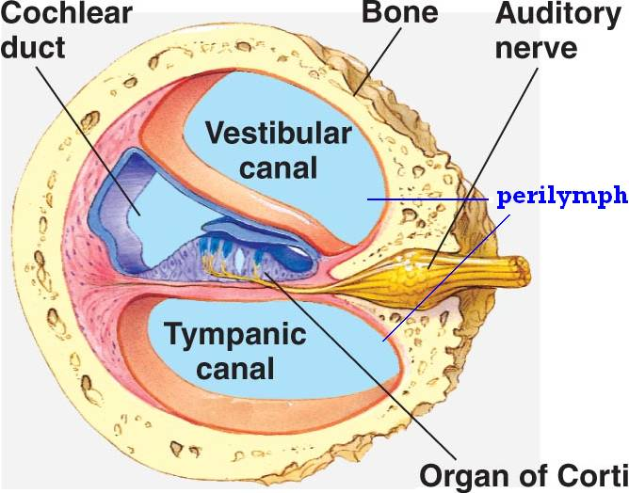

HISTOLOGY
Organ of Corti consists of different types of cells:
*Inner hair cells
*Outer hair cells
*Supporting cells
Inner Hair Cell
These cells are specialized in the mechanoelectrical transduction. There are almost 3500 cells disposed in one line along all the basilar membrane. They are connected to type I neuron peripheral fibers of spiral ganglion, these connection are very divergent (10/1). The luminal part of the cell is immerged in endolymph, the basal one is immerged in normal extracellular fluid. The luminal portion is formed by bundles of stereocilia(inner_ear), whose tips are connected by filamentous structures called tip-links.
The inner hair cells are in a single row close to the inner pillar cells (you may see more than one inner cell nucleus because of the thickness of the section). Note that the inner hair cells account for ~90-95% of the sensory input into the auditory system.
The outer hair cells surrounded by outer phalangeal cells. There are three rows of outer hair cells. The apices of these cells and their phalangeal cells are joined together to form the reticular membrane (also called reticular lamina or apical cuticular plate) that separates endolymph in the scala media from underlying corticolymph and perilymph of the scala tympani. Lateral to the outer hair cells and phalangeal cells are other support cells, Note that outer hair cells account for only ~5-10% of the sensory input into the auditory system. The primary function of outer hair cells is actually to contract when stimulated, thus "pulling" on the tectoral membrane thereby stimulating the inner hair cells ( see animation (link is external)).
Outer and inner pillar cells outline a triangular shaped tunnel, called the inner tunnel, which is filled with perilymph-like fluid called corticolymph.

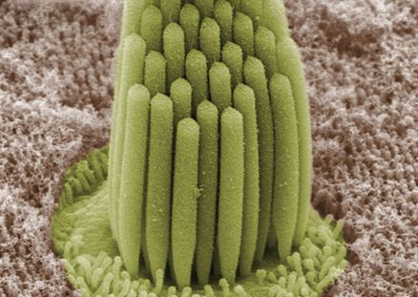
Outer Hair Cell
These cells are acoustical pre-amplifiers. They are almost 12000, disposed in three parallel lines. These cells are connected to type II amyelinic neurons, the connections are very convergent. They have also an afference from superior olivary nucleus. They have contractile activity.

Supporting Cells
These cells are of four different types: Corti pillars, Hensen cells, Deiters cells and Claudius cells.

