NAME: AMECHI IHUOMA
MATRIC NOS: 17/MHS01/056
COURSE: ANA 305
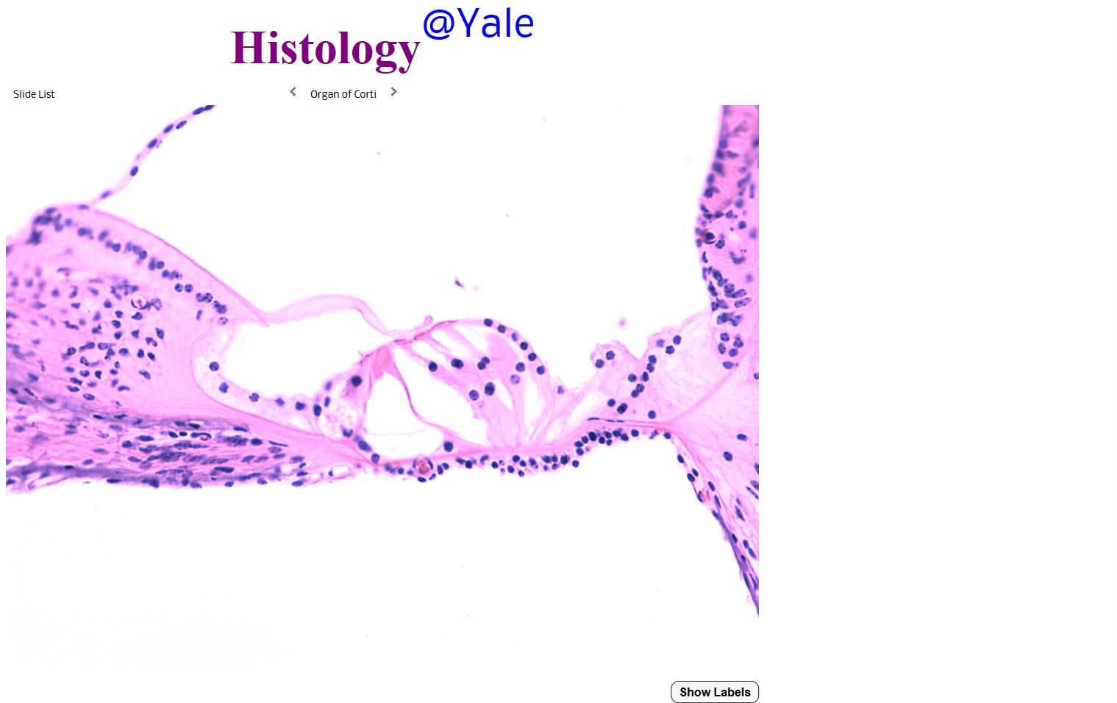

Organ Of Corti
The organ of Corti is a specialized sensory epithelium that allows for the transduction of sound vibrations into neural signals. The organ of Corti itself is located on the basilar membrane. The organ of Corti rests on the basilar membrane and contains two types of hair cells: inner hair cells and outer hair cells. Inner hair cells transduce sound from vibrations to neural signals via the shearing action of their stereocilia. Outer hair cells serve a function as acoustic pre-amplifieers which improve frequency selectively by allowing the organ of Corti to become attuned to specific frequencies, like those of speech or music. The fibrous tectorial membrane rests on top of the stereocilia or the outer hair cells. Mutations in alpha-tectorin, which encodes a protein specific to the tectorial membrane, cause deafness.

