**NAME: KOTUN MUHAMMAD OLADIMEJI**

**MATRIC NUMBER: 18/MHS02/101**

**DEPARTMENT: NURSING**

**COURSE CODE: PHS212**

**COURSE TITLE: PHYSIOLOGY**

**ASSIGNMENT TITLE: SPECIAL SENSES**

**ASSIGNMENT**

**MENTION ANY TWO DEFFECT OF THE EYE**

The ability to see is called **vision.** It is also called **eyesight.** Sometimes the eye of a person cannot focus the image of an object on the retina properly. In such cases the vision of a person becomes blurred and he cannot see either the distant objects or nearby objects (or both) clearly and comfortably. The person is said to have a defect of vision. The defects of vision are also known as defects of eye.

**MYOPIA(**nearsightedness or shortsightedness**)**

This is a defect of vision in which far objects appear blurred but near objects are seen clearly. The image is focused in front of the retina rather than on it usually because the eyeball is too long or the refractive power of the eye’s lens too strong. Myopia can be corrected by wearing glasses/contacts with concave lenses these help to focus the image on the retina.

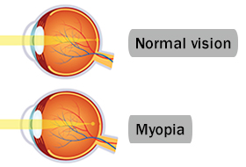

Those who suffer from **myopia** can see near objects clearly, but not the far away objects. The light that comes from far away objects, as the following image shows, focuses in front of retina, rather than on the retina, that leads to a blurry image of the object in question. The structure of your [**eye**](https://www.webmd.com/eye-health/ss/slideshow-eye-conditions-overview) is to blame. When your eyeball is too long or the cornea -- the protective outer layer of your eye -- is too curved, the light that enters your eye won’t focus correctly. Images focus in front of the retina, the light-sensitive part of your eye, instead of directly on the retina. This causes blurred [**vision**](https://www.webmd.com/eye-health/default.htm). Doctors call this a refractive error.

**High**[**myopia**](https://www.webmd.com/eye-health/healthy-vision-as-you-age-14/quiz-checklist/default.htm)**:** It’s a more serious form of the condition, where the eyeball grows more than it is supposed to and becomes very long front to back. Besides making it hard to see things at a distance, it can also raise your chance of having other conditions like a [detached retina](https://www.webmd.com/eye-health/eye-health-retinal-detachment), [cataracts](https://www.webmd.com/eye-health/cataracts/), and [glaucoma](https://www.webmd.com/eye-health/glaucoma-eyes).

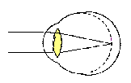

**Degenerative myopia:** Also called pathological or malignant myopia, it is a rare type you usually inherit from your parents. Your eyeball gets longer very quickly and causes severe myopia, usually by the teenage or early adult years. This type of myopia can get worse far into adulthood. Besides making it hard to see things at a distance, you may have a higher chance of having a detached retina, abnormal [blood](https://www.webmd.com/heart/anatomy-picture-of-blood) vessel growth in the eye (choroid neovascularization), and [glaucoma](https://www.webmd.com/eye-health/video/glaucoma).

**Symptoms**

Chances are the only symptom is that more distant objects are blurred. You may also notice:

[Headaches](https://www.webmd.com/migraines-headaches/default.htm)

Squinting

Eye strain

[Eye fatigue](https://www.webmd.com/eye-health/eye-fatigue-causes-symptoms-treatment) when you try to see objects more than a few feet away

Children with myopia often have trouble reading the blackboard at school.

**The defect of eye called myopia (or short-sightedness) is caused**

(**1) Due to high converging power of eye-lens (because of its short focal length)**

In an eye suffering from myopia, the ciliary muscles attached to the eye-lens do not relax sufficiently to make the eye-lens thinner to reduce its converging power. So, due to the greater converging power of the eye-lens in myopic eye, the image of a distant object is formed in front of the retina and hence the eye cannot see it clearly.

**(2) Due to eye-ball being too long**

In the eye suffering from myopia, the eye-ball is too long due to which the retina is at a larger distance from the eye-lens. This condition also results in the formation of the image of a distant object in front of the retina (even though the eye-lens may have correct converging power)

The parallel rays of light coming from the distant object O (at infinity) are converged to form an image in front of the retina due to which the eye cannot see the distant object clearly.The image is formed in front of the retina either due to high converging power of eye lens or due to eye ball being too long.

The far point of eye having myopia (or short-sightedness) is at point F which is less than infinity. The rays of light coming from the person’s far point F can just be focused by his eye on the retina. If the distant object can be made to appear as if it were at the far point F of this eye, then the eye can see it clearly. This is done by putting a concave lens in front of the eye.

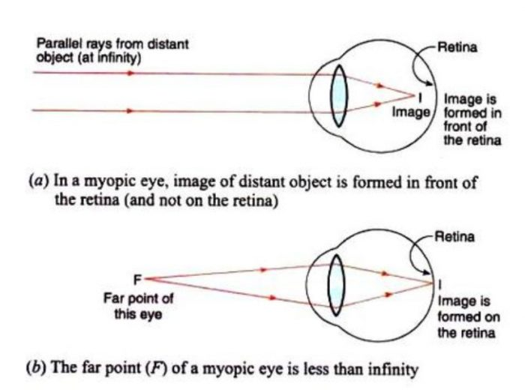

**Diagnosis and Treatment**

An [eye exam](https://www.webmd.com/eye-health/eye-tests-exams) can show you if you’re myopic. Glasses, contacts, or refractive surgery can usually correct the problem.

When you have myopia, your prescription for glasses or [contact lenses](https://www.webmd.com/eye-health/contact-lenses-colored-soft-hard-toric-bifocal) will be a negative number. The more negative the number, the stronger your lenses will be. For example, -3.00 is stronger than -2.50.

Your prescription helps the eye focus light on your retina. That clears up your [vision](https://www.webmd.com/eye-health/ss/slideshow-healthier-eyes).

Eye surgery can improve your vision so much you may no longer need to wear glasses or contacts. The most common procedures for myopia are:

**Photorefractive keratectomy:** Also called PRK, this surgery uses a laser to sculpt the middle layer of your cornea. That flattens the cornea’s curve and lets light rays focus closer to or on your retina.

[**LASIK**](https://www.webmd.com/eye-health/lasik-laser-eye-surgery) : This is the most common surgery for myopia. The surgeon uses a laser or another tool to create a thin flap on the top layer of your cornea. He sculpts the cornea with another laser and moves the flap back into place.

In the case of high myopia, special contacts or atropine eyedrops have been found to be effective in slwing the progression. In some cases, your doctor may suggest catarct or clear lens replacement surgery.

**ASTIGMATISIM**

This defect is when the light rays do not all come to a single focal point on the retina, instead some focus on the retina and some focus in front of or behind it. This is usually caused by a non-uniform curvature of the cornea. A typical symptom of astigmatism is if you are looking at a pattern of lines placed at various angles and the lines running in one direction appear sharp whilst those in other directions appear blurred. Astigmatism can usually be corrected by using a special spherical cylindrical lens; this is placed in the out-of-focus axis.

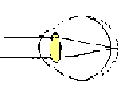

Those who suffer from **astigmatism** cannot see objects clearly, when the light from certain parts falls on the retina and the rest falls on either behind the retina or in front of it. This is caused by the irregular curvature of the cornea.

[Astigmatism](https://www.webmd.com/eye-health/astigmatism-eyes) is a condition in which your [eye](https://www.webmd.com/eye-health/picture-of-the-eyes) isn’t completely round. Almost all of us have it to some degree.

Ideally, an eyeball is shaped like a perfectly round ball. Light comes into it and bends evenly, which gives you a clear view. But if your [eye](https://www.webmd.com/eye-health/ss/slideshow-eye-conditions-overview) is shaped more like a football, light gets bent more in one direction than another. That means only part of an object is in focus. Things at a distance may look blurry and wavy.

It’s common to have astigmatism along with [nearsightedness](https://www.webmd.com/eye-health/nearsightedness-myopia) (myopia) or [farsightedness](https://www.webmd.com/eye-health/farsightedness)(hyperopia). These three conditions are called refractive errors because they involve how your eyes bend (refract) light.

**Astigmatism Symptoms**

[**Symptoms of astigmatism**](https://www.webmd.com/eye-health/understanding-astigmatism-symptoms)**may include:**

Blurry or distorted [**vision**](https://www.webmd.com/eye-health/default.htm)

Eyestrain

[**Headaches**](https://www.webmd.com/migraines-headaches/migraines-headaches-basics)

[**Trouble seeing**](https://www.webmd.com/eye-health/vision-basics) at night

**Astigmatism Causes**

Most people are born with it, but experts don’t know why. You can also get it after an [eye](https://www.webmd.com/eye-health/eye-assessment/default.htm) injury, an eye disease, or surgery.

Rarely, a condition called [**keratoconus**](https://www.webmd.com/eye-health/eye-health-keratoconus) can cause astigmatism by making the clear front part of your eye (your cornea) thinner and more cone-shaped. You’ll probably need contacts (but not glasses) to see clearly.

You can’t get astigmatism from reading in low light or sitting too close to the TV.

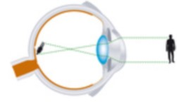

**Astigmatism Treatment**

Glasses or contacts can correct almost all cases of astigmatism. But if you have only a slight astigmatism and no other vision problems, you may not need them.

**There are two treatments for the common levels of astigmatism:**

**Corrective lenses.** That means glasses or contacts. If you have astigmatism, your doctor will probably prescribe a special type of soft [**contact lenses**](https://www.webmd.com/eye-health/contact-lenses-colored-soft-hard-toric-bifocal) called toric lenses. They can bend light more in one direction than the other. If your case is more severe, you might get gas-permeable rigid contact lenses for a procedure called orthokeratology. You wear the lenses while you sleep, and they reshape your cornea. You’ll need to keep wearing the lenses to hold this new shape, but you won’t have to wear them as often.

**Refractive surgery.** Laser surgery also changes the shape of your cornea. Types of refractive surgery include [**LASIK**](https://www.webmd.com/eye-health/lasik-laser-eye-surgery) and PRK. You’ll need to have otherwise healthy eyes with no retina problems or corneal scars.

Irregular astigmatism is far less common and is linked to problems with your cornea, the front part of the eye. Keratoconus is one example