NAME: KOTUN MUHAMMAD OLADIMEJI
MATRIC NUMBER: 18/MHS02/101
DEPARTMENT: NURSING
COURSE CODE: PHS212
COURSE TITLE: PHYSIOLOGY
ASSIGNMENT TITLE: SPECIAL SENSES
ASSIGNMENT
DISCUSS THE SOMATOSENSORY PATHWAYS
The somatosensory system is a part of the sensory nervous system. The somatosensory system is a complex system of sensory neurons and neural pathways that responds to changes at the surface or inside the body.
The axons (as afferent nerve fibers) of sensory neurons connect with, or respond to, various receptor cells. These sensory receptor cells are activated by different stimuli such as heat and nociception, giving a functional name to the responding sensory neuron, such as a thermoreceptor which carries information about temperature changes. Other types include mechanoreceptors, chemoreceptors, and nociceptors which send signals along a sensory nerve to the spinal cord where they may be processed by other sensory neurons and then relayed to the brain for further processing. Sensory receptors are found all over the body including the skin, epithelial tissues, muscles, bones and joints, internal organs, and the cardiovascular system.
Somatic senses are sometimes referred to as somesthetic senses, with the understanding that somesthesis includes the sense of touch, proprioception (sense of position and movement), and (depending on usage) haptic perception.
SOMATOSENSORY PATHWAYS
The somatosensory systems’ anatomy in this module will review the major somatosensory pathways including the posterior columns-medial lemniscal pathway, spinothalamic tract and other anterolateral pathways, and somatosensory cortex. In addition, brainstem and spinal cord mechanisms of pain modulation will be addressed. Finally, the organization of the thalamus, serving as the major relay for sensory and other information traveling to the cortex will be reviewed.
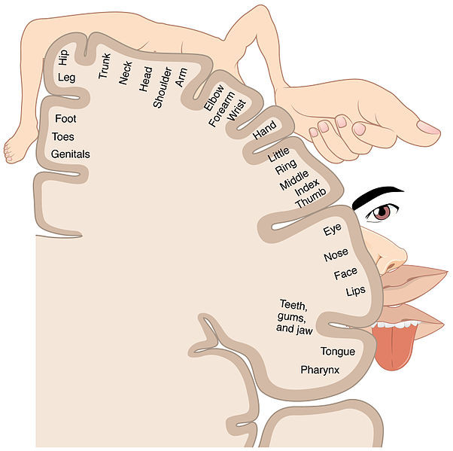

Main Somatosensory Pathways. The term somatosensory refers to bodily sensations of touch, pain, temperature, vibration, and proprioception (limb or joint position sense). The posterior column-medial lemniscal pathway conveys proprioception, vibration sense, and fine, discriminative touch. The anterolateral (or ventrolateral) pathways, include the spinothalamic tract and other associated tracts, convey pain, temperature sense, and crude touch. Since some aspects of touch sensation are carried by both pathways, touch sensation is not eliminated completely in isolated lesions to either pathway.
A somatosensory pathway will typically have three neurons:[13] first-order, second-order, and third-order.

1. The first-order neuron is a type of pseudounipolar neuron and always has its cell body in the dorsal root ganglion of the spinal nerve with a peripheral axon innervating touch mechanoreceptors and a central axon synapsing on the second-order neuron. If the somatosensory pathway is in parts of the head or neck not covered by the cervical nerves, the first-order neuron will be the trigeminal nerve ganglia or the ganglia of other sensory cranial nerves).
2. The second-order neuron has its cell bodyeither in the spinal cord or in the brainstem. This neuron's ascending axons will cross (decussate) to the opposite side either in the spinal cord or in the brainstem.
3. In the case of touch and certain types of pain, the third-order neuron has its cell body in the ventral posterior nucleus of the thalamus and ends in the postcentral gyrus of the parietal lobe in the primary somatosensory cortex (or S1).
Photoreceptors, similar to those found in the retinaof the eye, detect potentially damaging ultraviolet radiation (ultraviolet A specifically), inducing increased production of melanin by melanocytes.[14]Thus tanning potentially offers the skin rapid protection from DNA damage and sunburn caused by ultraviolet radiation (DNA damage caused by ultraviolet B). However, whether this offers protection is debatable, because the amount of melanin released by this process is modest in comparison to the amounts released in response to DNA damage caused by ultraviolet B radiation

