NAME: Opute Ruth Adaeze
MATRIC NUMBER: 17/mhs01/270
COURSE: Histology of the Special Senses

Question: With the aid of diagram, describe the organ of corti

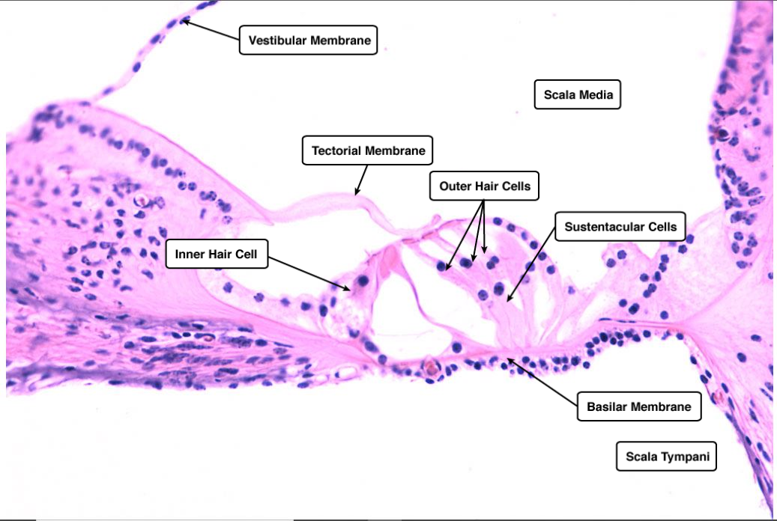

The Organ of Corti is an organ of the inner ear located within the cochlea which contributes to hearing. The Organ of Corti includes three rows of outer hair cells and one row of inner hair cells. Vibrations caused by sound waves bend the stereocilia on these hair cells via an electromechanical force. The primary function of the organ of Corti is the transduction of auditory signals. Sound waves enter the ear via the auditory canal and cause vibration of the tympanic membrane. Movement of the tympanic membrane causes subsequent vibrations within the ossicles, the three bones of the middle ear which transfer the energy to the cochlea through the oval window. As the oval window moves, waves transfer to the perilymph fluid inside the scala tympani and then the scala vestibule of the cochlea. When fluid moves through these structures, the basilar membrane, located between the scala media and scala tympani, shifts respectively to the tectorial membrane.
The organ of Corti is an organ of the inner ear contained within the scalamedia of the cochlea. It resides on the basilar membrane, a stiff membrane separating the scala tympani and scala media. The scala media is a cavity within the cochlea that contains endolymph, a fluid which has a high potassium ion concentration. The endolymph helps to regulate the electrochemical impulses of the auditory hair cells. The Corti is composed of both supporting cells and mechanosensory hair cells. The arrangement of mechanosensory cells are into inner and outer hair cells along rows. There is a single row of inner hair cells and three rows of outer hair cells which are separated by the supporting cells. The supporting cells are also named Dieters or phalangeal cells.
Inner hair cells function primarily as the sensory organs for audition. They provide input to 95% of the auditory nerve fibers that project to the brain. The stiffness and size of the hair cell arrangement throughout the cochlea enable hair cells to respond to a variety of frequencies from low to high. Cells at the apex to respond to lower frequencies while hair cells at the base of the cochlea, near the oval window, respond to higher frequencies, which creates a tonotopic gradient throughout the cochlea.
While inner hair cells are the output center of the cochlea, the outer hair cells are the input center. They receive descending inputs from the brain to assist with the modulation of inner hair cell function (i.e., modulating tuning and intensity information). Unlike other regions of the brain, the modulation of inner hair cells by outer hair cells is not electrical but mechanical. Activation of outer hair cells changes the stiffness of their cell bodies; this manipulates the resonance of perilymph fluid movement within the scala media and allows for fine-tuning of inner hair cell activation.
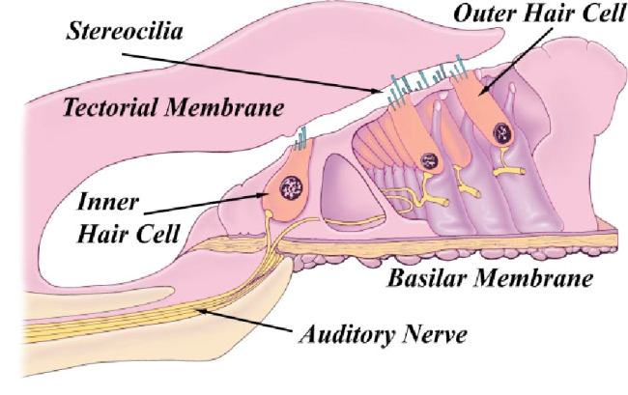
Inner and outer hair cells are distinctly different in structure. Both types of hair cells have stereocilia on the apical surface; however, the arrangement of sterocilia and their connection to the tectorial membrane are distinctly different. For both types of hair cells, the mechanical bending of the sterocilia opens potassium channels at the tips of the sterocilia that allow hyperpolarization of the cells. The tallest of the stereocilia of outer hair cells are embedded into the tectorial membrane. These stereocilia get displaced as the basilar membrane moves with the tectorial membrane. The stereocilia of inner hair cells are free-floating. Movement of the viscous perilymph fluid provides the mechanical force to open these channels.

