Name: Nwapa Bernard Ukachukwu
Matric Number: 17/MHS01/209
Assignment Title: Histology of Ear
Course Title: Histology of Special Senses and Neurohistology
Course Code: ANA 305
College: Medicine and Health Sciences (MHS)
Department: Medicine and Surgery (MBBS)
Level: 300 level
Assignment Question
- With the aid of a diagram, write an essay on the histology of an organ of corti
Answers
- Histology of an Organ of Corti
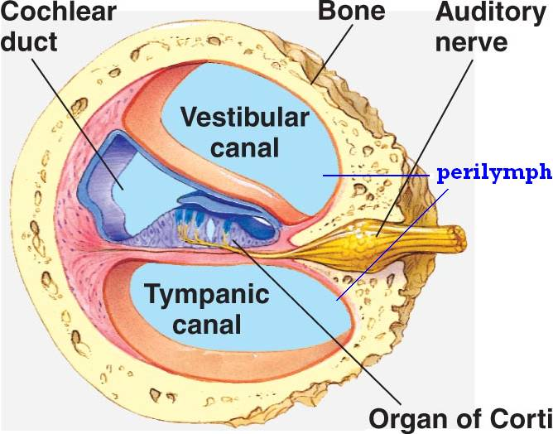
DEFINITION
The Organ of Corti is a part of the cochlea and it mediates the sense of hearingtransducing pressure waves to action potentials. This structure is localized in the scala media and it is formed by a series of hair cells, nervous terminations of spiral ganglion and supporting cells.
GROSS ANATOMY
The scala media, or cochlear duct, is located between scala tympani and scala vestibuli and it is filled with endolymph. This structure is delimited by the basilar membrane and Reissner’s membrane. The Organ of Corti covers the basilar membrane and it is under the tectorial membrane, an acellular gel into which hair cell stereocilia are immersed. The peripheral process of acoustic nerve fibers provides synaptic connections between hair cells and cochlear nucleus.
The upper portion of the cochlear duct is formed by the stria vascularis, which contains numerous capillary loops and small blood vessels and produces endolymph.
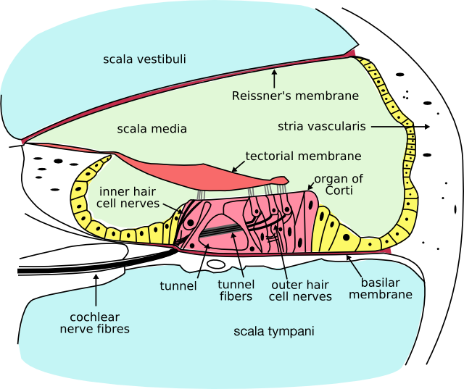

HISTOLOGY
Organ of Corti consists of different types of cells:
*Inner hair cells
*Outer hair cells
*Supporting cells
Inner Hair Cell
These cells are specialized in the mechanoelectrical transduction. There are almost 3500 cells disposed in one line along all the basilar membrane. They are connected to type I neuron peripheral fibers of spiral ganglion, these connection are very divergent (10/1). The luminal part of the cell is immerged in endolymph, the basal one is immerged in normal extracellular fluid. The luminal portion is formed by bundles of stereocilia(inner_ear), whose tips are connected by filamentous structures called tip-links.
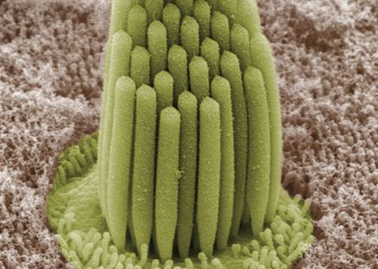
Outer Hair Cell
These cells are acoustical pre-amplifiers. They are almost 12000, disposed in three parallel lines. These cells are connected to type II amyelinic neurons, the connections are very convergent. They have also an afference from superior olivary nucleus. They have contractile activity.
Supporting Cells
These cells are of four different types: Corti pillars, Hensen cells, Deiters cells and Claudius cells.

Endolymph
Endolymph fills the scala media and it is produced by stria vascularis.
Potassium secreted into the endolymph by the stria vascularis enters the hair cells through apical mechanosensitive channels. It is recycled back to the stria vascularis through supporting cells and fibrocytes of the spiral ligament for another round of secretion. Hair cells and stria vascularis are tied together in a "push-pull" or "pump-leak" balance that determines endocochlear potential (EP +85mV), endolymph composition and ultimately the sensivity and stability of hair cells and hearing over a lifetime.
The evolutionary strategy of using K receptors currents is due to the fact that it reduces metabolic requirements because it has a passive outflow from hair cells to the basal membrane, instead of active Na extrusion.
Endolymph has a particular ion concentration
Ion | Perilymph (mM) | Endolymph (mM)
Na | 154 | 1
K | 3 | 161
Cl | 128 | 131
There is a potential difference of -140 mV between endolymph and inner receptor.
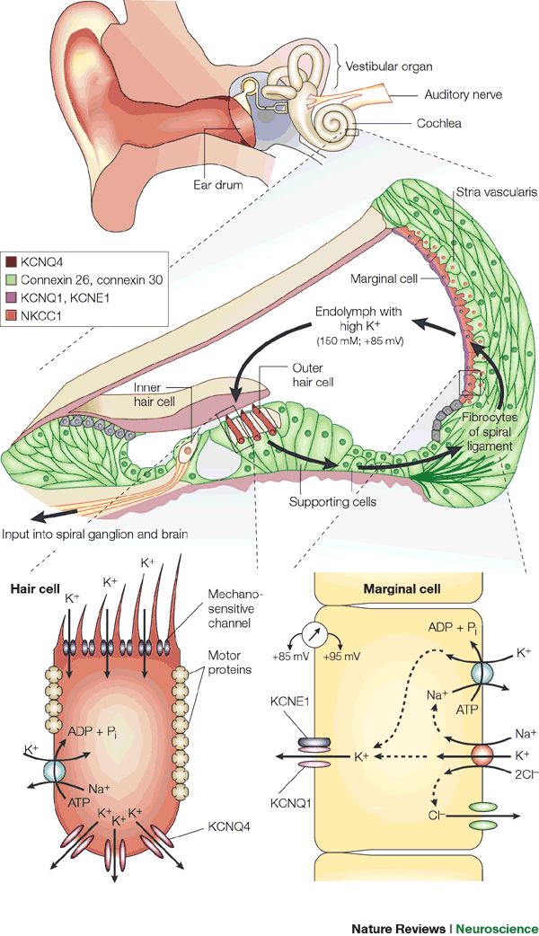
A basolateral Na/K-ATPase pumps K and creates a Na gradient to drive K and Cl into the cell in a co-transport process. Chloride is recycled by basolateral Cl channels, and K is secreted apically by KCNQ1/KCNE1 K channels, which are open at the unusual apical membrane voltage of marginal cells (inside positive by about +10 mV). This allows for a net secretion into the endolymph in spite of its high K concentration.
KCNQ proteins have six transmembrane domains and a pore-forming P-loop. Mutations on KCNQ1 and KCNQ4 lead to deafness. Indeed KCNQ4 was mapped to human chromosome 1p34; it is one of over 30 loci for dominant deafness.
Hypoxia reduces endocochlear potential, due to a drop in metabolism and strial current; whereas a depletion of vascular K does not drop EP, showing that K comes from spiral ligament rather than from blood.
SENSE OF HEARING
The role of the sense of hearing is translating pressure waves of perilymph and endolymph to electrical signal and acoustic sensation.
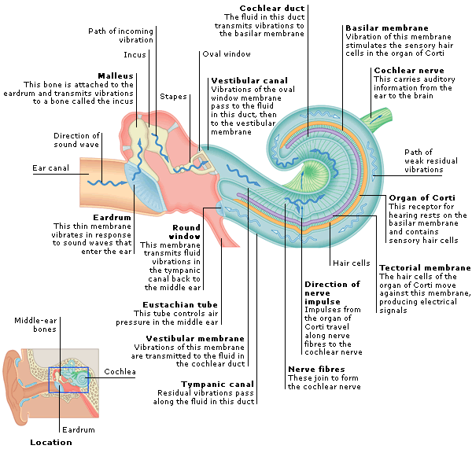

Mechanism of transduction
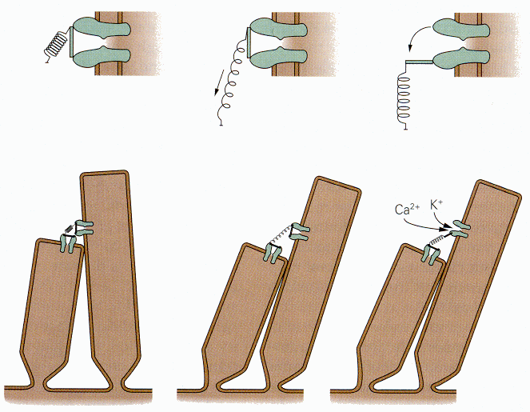
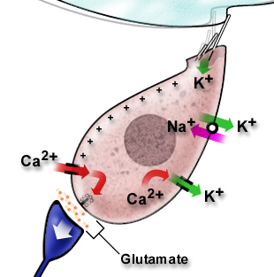
- Deflection: tip-links open K channels and k enters the cell
- Depolarization: Ca enters the cell through voltage-dependet channels
- Higher Ca concentration: K extrusion toward basolateral portion and Glutamate release in synaptic cleft
- Action potential along acoustic nerve (VIII)

ABNORMALITIES
- Deafness is a partial or total inability to hear.
- AHL is the age-related hearing loss, also known as presbycusis. Many K channels, like KCNQ1, were found to be down-regulated in stria vascularis with aging. Moreover a reduced KCNQ4 current may lead to a slow degenerative process. Although in some cases the EP is maintained and this is a paradoxical phenomenon, it would appear that this is attributable to the SV which may generate a much lower current to establish a new balance for potassium influx and efflux at a relatively lower level. It is not clear if an atrophied stria vascularis could recover sufficient function by up-regulating these potassium transporters expression to maintain a normal endocochlear potential.
- Sensorineural hearing loss is the most commonly reported cause of auditory deficits. This type of hearing loss often results from exposure to either loud sounds or ototoxic drugs. Exposure to loud noises causes the vibrational shift between the tectorial and basilar membranes to increase. This shift can damage the stereocilia of the outer hair cells. When damage occurs to the outer hair cells, the stiffness of the organ of Corti decreases which in turn increases vibrational forces on the inner hair cells. Damage to the outer hair cells decreases the protection of inner hair cells and causes them to become more sensitive. Over time, the inner hair cells will also become damaged and audition affected.Aminoglycoside antibiotics are an example of ototoxic drugs. These drugs are K+ channel blockers. As such, they block the ability of both inner and outer hair cells to depolarize. These types of drugs can also change the concentration of ions within the perilymph which can lead to damage or death of both inner and outer hair cells; destruction of the hair cells causes permanent auditory deficits because they do not regenerate.

