Name: Etuk Esther Emmanuel
Matric no.: 17/mhs01/124
Level: 300lvl
Department: Medicine and Surgery
College: Medicine and Health Sciences
Assignment Title: Special senses assignment
Course Title: Histology of Special Senses and Neurohistology
Course Code: ANA 305
Question
With the aid of a diagram, write an essay on the histology of an organ of Corti.
Answer
THE ORGAN OF CORTI
The organ of Corti, named after Alfonso Corti who first described it, is the sensorineural organ of the cochlea. It is composed of sensory cells called hair cells, nerve fibers that connect to them, and supporting structures. The organ of Corti is an organ of the inner ear contained within the scala media of the cochlea. It resides on the basilar membrane, a stiff membrane separating the scala tympani and scala media. It is spread like a ribbon along the entire length of basilar membrane. It is situated on the basilar membrane in one of the three compartments of the Cochlea. It contains four rows of hair cells which protrude from its surface. Above them is the tectoral membrane which can move in response to pressure variations in the fluid- filled tympanic and vestibular canals.
The most striking feature of the organ of Corti is the arch, or tunnel, of Corti, formed by two rows of pillar cells, or rods. The pillar cells furnish the major support of this structure. They separate a single row of larger, pear-shaped inner hair cells from three or more rows of smaller, cylindrical outer hair cells. There are some 16,000 -20,000 of the hair cells distributed along the basilar membrane which follows the spiral of the cochlea. It is made up of epithelial cells that are arranged in a complicated manner. The cells are divisible into the true receptor cells or hair cells, and supporting elements which are given different names depending on their location. The hair cells of the organ of Corti are arranged in four rows along the length of the basilar membrane. Individual hair cells have multiple strands called stereocilia. There may be 16,000 - 20,000 such cells. The sensitive hair cells of the organ of Corti may have about 100 tiny stereocilia which in the resting state are leaning on each other in a conical bundle. In response to the pressure variations in the Cochlea produced by sound, the stereocilia may dance about wildly and send electrical impulses to the brain. The hair cells are divided into the inner and outer hair cells.
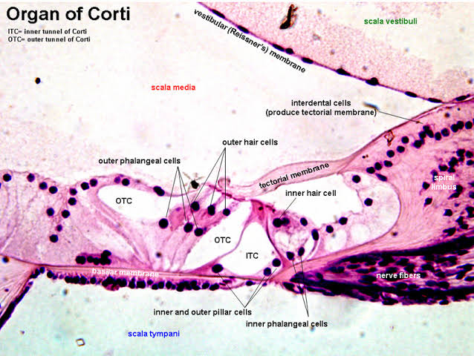
The Organ of Corti

Inner hair cells are specialized in the mechanoelectrical transduction. There are almost 3500 cells disposed in one line along all the basilar membrane. They are connected to type I neuron peripheral fibers of spiral ganglion, these connection are very divergent (10/1). The luminal part of the cell is immerged in endolymph, the basal one is immerged in normal extracellular fluid. The luminal portion is formed by bundles of streocilia (inner_ear), whose tips are connected by filamentous structures called tip-links. Outer Hair cells are acoustical pre-amplifiers. They are almost 12000, disposed in three parallel lines. These cells are connected to type II amyelinic neurons, the connections are very convergent. They have also an afference from superior olivary nucleus. They have contractile activity.
The inner hair cells are supported and enclosed by the inner phalangeal cells, which rest on the thin outer portion, called the tympanic lip, of the spiral limbus. On the inner side of the inner hair cells and the cells that support them is a curved furrow called the inner sulcus. This is lined with more or less undifferentiated cuboidal cells.

Each outer hair cell is supported by a phalangeal cell of Deiters, or supporting cell, which holds the base of the hair cell in a cup-shaped depression. Beyond the hair cells and the Deiters’ cells are three other types of epithelial cells, usually called the cells of Hensen, Claudius, and Boettcher.
Inner hair cells transduce sound from vibrations to neural signals via the shearing action of their stereocilia. Outer hair cells serve a function as acoustic pre-amplifiers which improve frequency selectivity by allowing the organ of Corti to become attuned to specific frequencies, like those of speech or music. The fibrous tectorial membrane rests on top of the stereocilia or the outer hair cells. Mutations in a alpha-tectorin, which encodes a protein specific to the tectorial membrane, cause deafness.

